

**ADVANCES IN DATA SCIENCE/ARCHITECTURE**

**Machine Learning As A Service**

**(MLaaS)**

**REPORT**

BY

MEGHA SINGH

SNEHA MALSHETTI

Contents

What is Machine learning? 4

Why use Machine learning? 4

Different platforms for Machine learning as service 5

Architecture 5

Microsoft Azure ML as Service 6

Architecture 6

Perdition and model Analysis 6

Amazon ML as Service 17

Architecture 17

Perdition and model Analysis 18

BIG ML as service 10

Architecture 10

Perdition and model Analysis 10

H2O ML as Service 12

Architecture 12

Perdition and model Analysis 13

IBM Watson ML as Service 14

Architecture 15

Predition and model Analysis 15

Project Summary 19

Comparison of various Services 20

Citation 23

1. What is Machine learning?

Machine learning is a data science technique that allows computers to use existing data to forecast future behaviors, outcomes, and trends. Using machine learning, computers learn without being explicitly programmed.

Applications of Machine Learning:

* Forecasts or predictions from machine learning can make apps and devices smarter.
* When you shop online, machine learning helps recommend other products you might like based on what you've purchased.
* When your credit card is swiped, machine learning compares the transaction to a database of transactions and helps detect fraud. When your robot vacuum cleaner vacuums a room, machine learning helps it decide whether the job is done.
  1. Why use Machine learning on cloud?

Cloud Machine Learning Engine enables model training, model deployment, and prediction, three important parts of the larger machine learning workflow.

**Work flow for Machine learning on cloud** 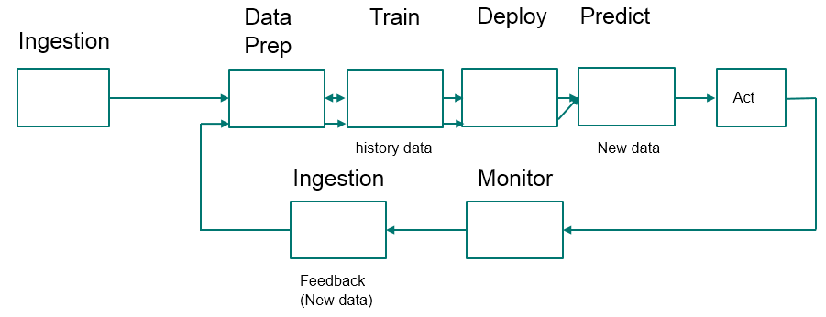

* **Data exploration** is the process of gathering information about a large and often unstructured data set in order to find characteristics for focused analysis.
* **Data mining** refers to automated data exploration.
* **Descriptive analytics** is the process of analyzing a data set in order to summarize what happened.
* **Predictive analytics** is the process of building models from historical or current data in order to forecast future outcomes.

### **Supervised and unsupervised learning**

* **Supervised learning** algorithms are trained with labeled data - in other words, data comprised of examples of the answers wanted.
* **Unsupervised learning** is used on data with no labels, and the goal is to find relationships in the data. For instance, you might want to find groupings of values

### **Model training and evaluation:** A machine learning model is an abstraction of the question you are trying to answer or the outcome you want to predict. Models are trained and evaluated from existing data.

#### **Evaluation data :**Once you have a trained model, evaluate the model using the remaining test data. It can tell whether your model predicts accurately.

* 1. Different platforms for Machine learning as service

1. **Amazon Machine learning:** helps developers create predictive models to build smart applications. Start generating predictions for your applications today
2. **IBM Machine learning: IBM** Watson **Machine Learning** is built on **IBM's** proven analytics platform, making it easy for developers and data scientists to make smarter decisions, solve tough problems, and improve user outcomes
3. **H20 Machine Learning**
4. **Microsoft Azure ML**
5. **BigML** goal is to create a machine learning service extremely easy to use and seamless to integrate.
6. Microsoft Azure ML as Service

## What is Machine Learning in the Microsoft Azure cloud?

Azure Machine Learning is a cloud predictive analytics service that makes it possible to quickly create and deploy predictive models as analytics solutions.

You can work from a ready-to-use library of algorithms, use them to create models on an internet-connected PC, and deploy your predictive solution quickly

Azure Machine Learning not only provides tools to model predictive analytics, but also provides a fully managed service you can use to deploy your predictive models as ready-to-consume web services.

* 1. Architecture

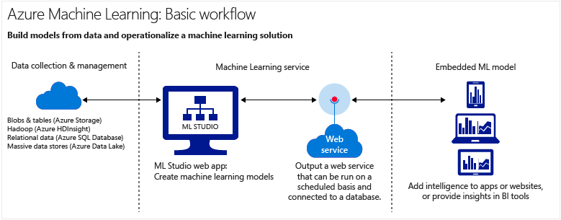

* 1. Create Data Science Experiment in Azure Machine Learning

Analytical model that predicts the price of an automobile based on different variables such as make and technical specifications.

You **create a model**, **train the model**, and **score and test the model**.

When your model is ready, you can publish it as a **web service** so that others can send it new data and get predictions in return.

To start with the Azure ML the following steps are followed:

**To create a workspace**

Sign in to the [Azure portal](https://portal.azure.com/)

1. Click **+New**
2. Select **Intelligence + analytics**, click **Machine Learning Workspace**, then click **Create**
3. Enter your workspace information
4. Click **Create**

Once the workspace is deployed, you can open it in Machine Learning Studio.

1. Browse to Machine Learning Studio at <https://studio.azureml.net/>.
2. Select your workspace in the upper-right-hand corner.

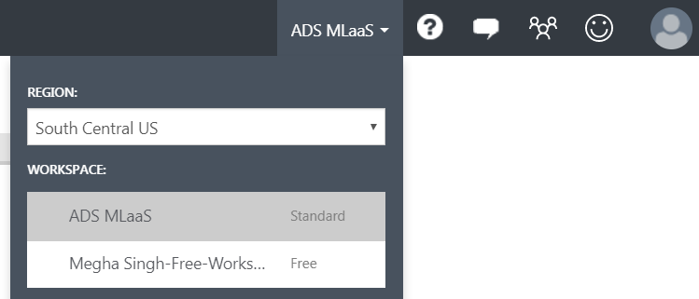

* 1. Preparation of Data

**Five steps to create an experiment**

In this machine learning tutorial, you'll follow five basic steps to build an experiment in Machine Learning Studio to create, train, and score your model:

* **Create a model**
  + [Step 1: Get data](https://docs.microsoft.com/en-us/azure/machine-learning/machine-learning-create-experiment#step-1-get-data)

Either upload from Local or use Azure dataset or import using http url link OR Add Dataset to your project

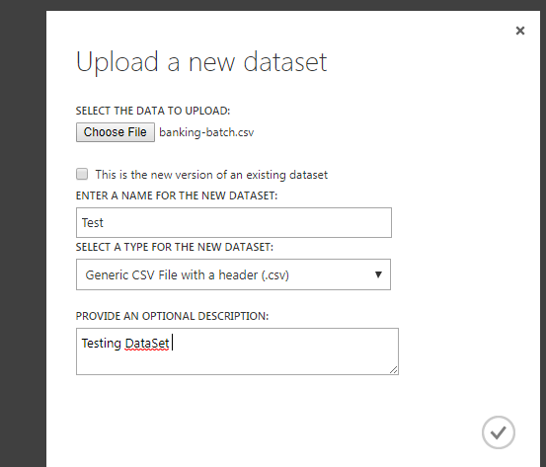 OR 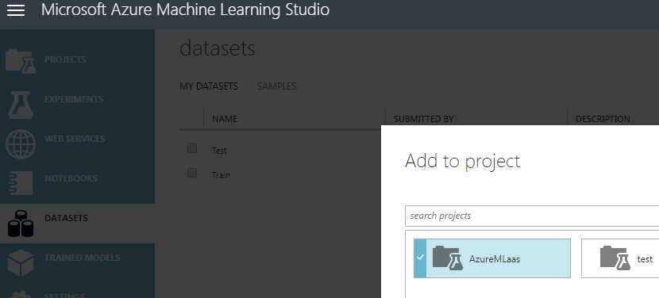

Once the dataset is imported rightclick on dataset and choose visualization:

**Click the output port and select "Visualize"**

Here we need to make loan prediction for a person on the basis of various other parameters:

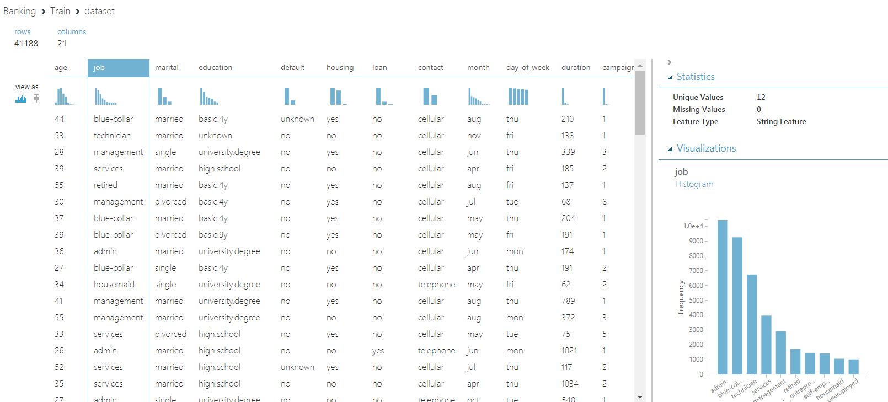

* + [Step 2: Prepare the data](https://docs.microsoft.com/en-us/azure/machine-learning/machine-learning-create-experiment#step-2-prepare-the-data)
  + A dataset usually requires some preprocessing before it can be analyzed. For example, you might have noticed the missing values present in the columns of various rows.
  + These missing values need to be cleaned so the model can analyze the data correctly. In our case, we'll remove any rows that have missing values.
  + First we add a module that removes the **euribor3m** column completely, and then we add another module that removes any row that has missing data.

Launch column selector from properties

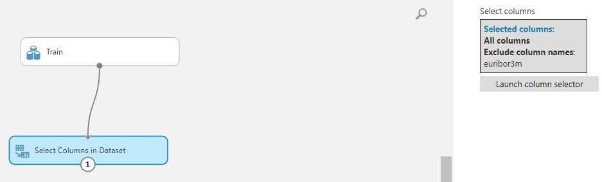

Now select all the columns you want to remove from the dataset.

**Launch the column selector and exclude the "** **euribor3m" column**

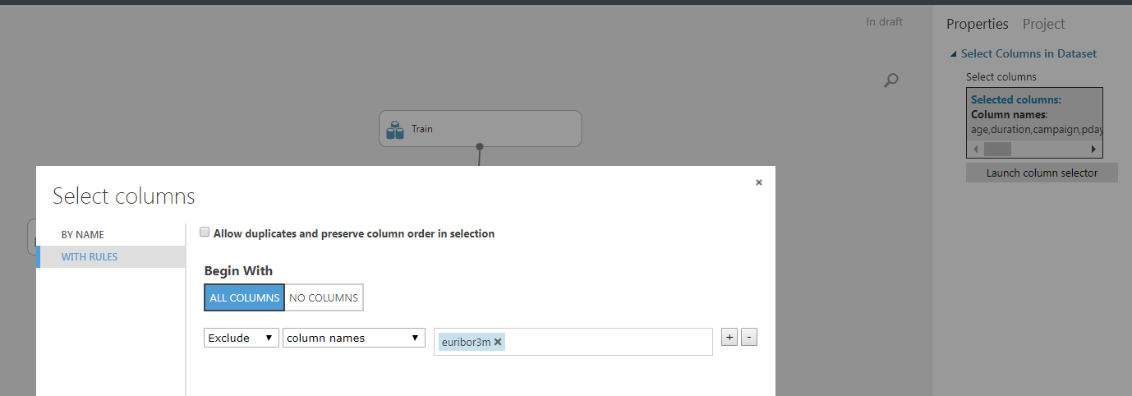

Now the properties pane for **Select Columns in Dataset** indicates that it will pass through all columns from the dataset except **euribor3m**

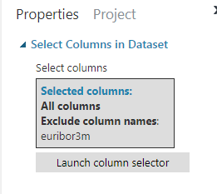

**The properties pane shows that the " euribor3m" column is excluded**

* Now remove the missing values:

Drag the [Clean Missing Data](https://msdn.microsoft.com/library/azure/d2c5ca2f-7323-41a3-9b7e-da917c99f0c4/) module to the experiment canvas and connect it to the [Select Columns in Dataset](https://msdn.microsoft.com/library/azure/1ec722fa-b623-4e26-a44e-a50c6d726223/) module. In the **Properties** pane, select **Remove entire row** under **Cleaning mode**. This directs [Clean Missing Data](https://msdn.microsoft.com/library/azure/d2c5ca2f-7323-41a3-9b7e-da917c99f0c4/) to clean the data by removing rows that have any missing values.

Double-click the module and type the comment "Remove missing value rows."

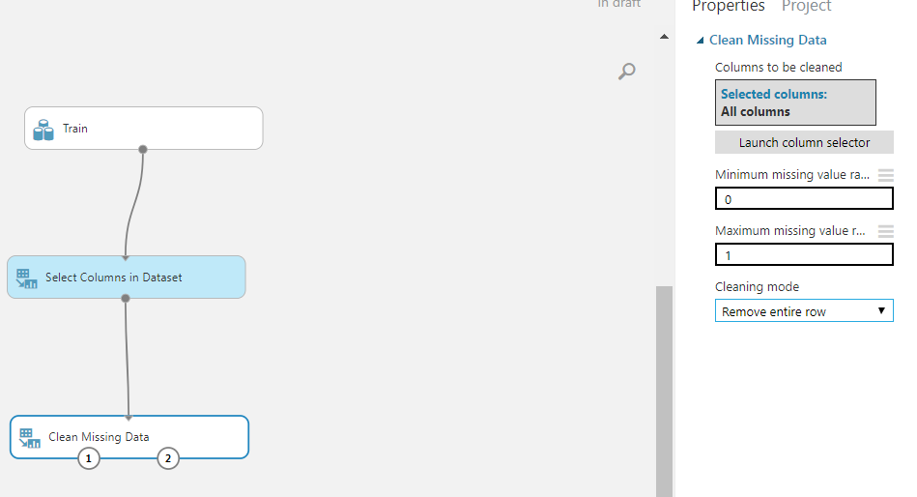

* Run the experiment by clicking **RUN** at the bottom of the page.

When the experiment has finished running, all the modules have a green check mark to indicate that they finished successfully. Notice also the **Finished running** status in the upper-right corner.

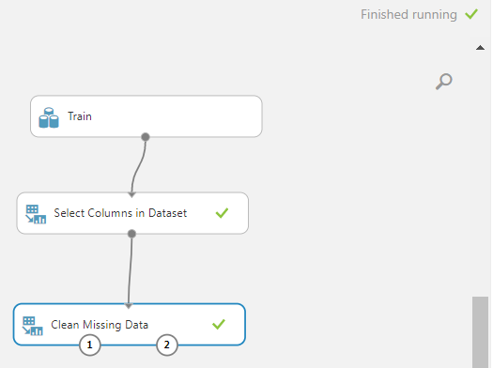

* + [Step 3: Define features](https://docs.microsoft.com/en-us/azure/machine-learning/machine-learning-create-experiment#step-3-define-features)
* In machine learning, features are individual measurable properties of something you’re interested in. In our dataset, each row represents one automobile, and each column is a feature of that automobile.
* Finding a good set of features for creating a predictive model requires experimentation and knowledge about the problem you want to solve. Some features are better for predicting the target than others. Also, some features have a strong correlation with other features and can be removed. For example, city-mpg and highway-mpg are closely related so we can keep one and remove the other without significantly affecting the prediction.2
* Let's build a model that uses a subset of the features in our dataset. You can come back later and select different features, run the experiment again, and see if you get better results. But to start, let's try the following features:
* Drag another [Select Columns in Dataset](https://msdn.microsoft.com/library/azure/1ec722fa-b623-4e26-a44e-a50c6d726223/) module to the experiment canvas. Connect the left output port of the [Clean Missing Data](https://msdn.microsoft.com/library/azure/d2c5ca2f-7323-41a3-9b7e-da917c99f0c4/) module to the input of the [Select Columns in Dataset](https://msdn.microsoft.com/library/azure/1ec722fa-b623-4e26-a44e-a50c6d726223/) module.

1. ***Connect the "Select Columns in Dataset" module to the "Clean Missing Data" module***
2. Double-click the module and type "Select features for prediction."
3. Click **Launch column selector** in the **Properties** pane.
4. Click **With rules**.
5. Under **Begin With**, click **No columns**. In the filter row, select **Include** and **column names** and select our list of column names in the text box. This directs the module to not pass through any columns (features) except the ones that we specify.

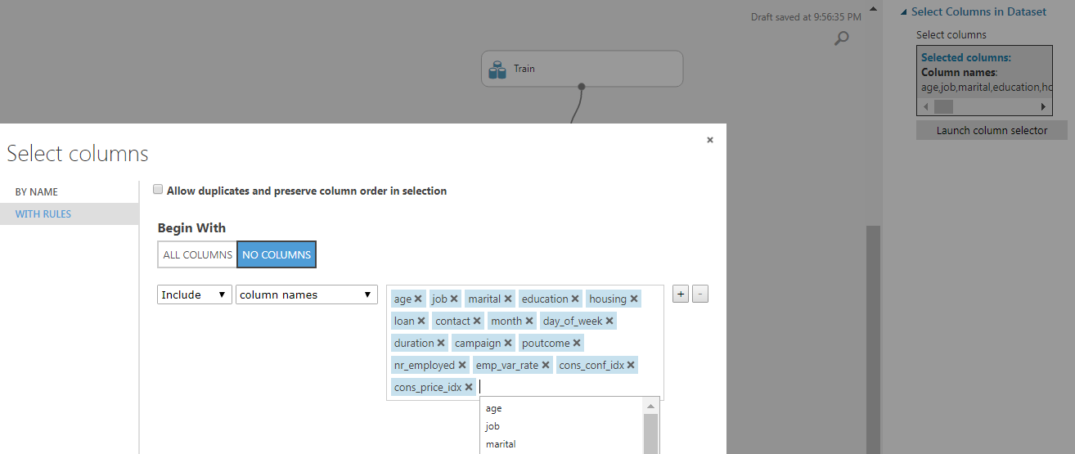

* This produces a filtered dataset containing only the features we want to pass to the learning algorithm we'll use in the next step. Later, you can return and try again with a different selection of features.

**Train the model**

* + [Step 4: Choose and apply a learning algorithm](https://docs.microsoft.com/en-us/azure/machine-learning/machine-learning-create-experiment#step-4-choose-and-apply-a-learning-algorithm)

Now that the data is ready, constructing a predictive model consists of training and testing. We'll use our data to train the model, and then we'll test the model to see how closely it's able to predict prices.

Classification and regression are two types of supervised machine learning algorithms. Classification predicts an answer from a defined set of categories, such as a color (red, blue, or green). Regression is used to predict a number.1

Because we want to predict price, which is a number, we'll use a regression algorithm. For this example, we'll use a simple linear regression model.

We'll use our data for both training the model and testing it by using 2 separate dataset as training and testing datasets.

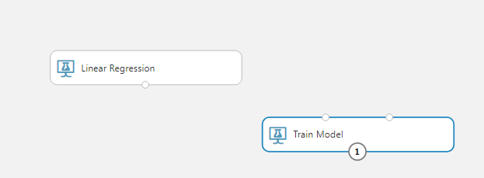

**Score and test the model**

* 1. Perdiction and model Analysis

STEP 1 Predictive experiment created

The trained model “Income Predication” is created for you. Also the web service input/output modules indicate the data flow of Web Service API you are about to generate.

Step1. First we get the dataset in the experiment

Step 2. First we train the dataset and then split fort the test data We select the the “income” as the score the train model.

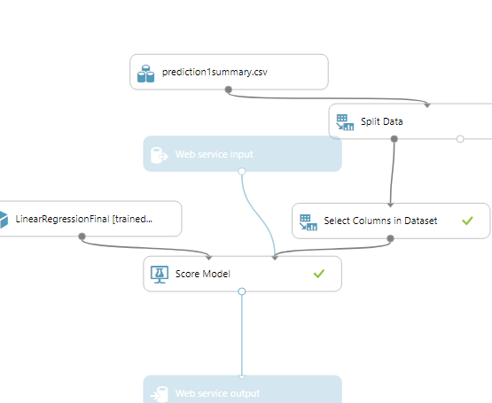

Step 3: Once the model is created we run and create the predictive model for the same on the test data, Predictive model

.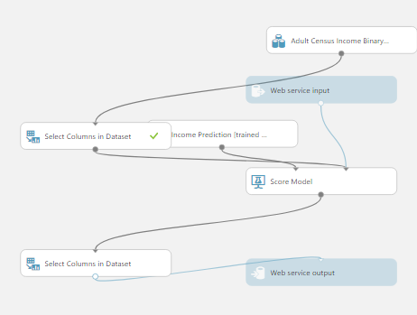

Step 4: Once the model is created we run and then deploy for the web services to test it.

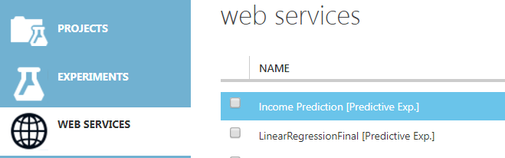

Once the model is in the web service we can predict the income values with probabilities on the dataset.

STEP 2

Infer the web service input schema

Let’s help system to infer web service input schema by excluding the “Income” label column.

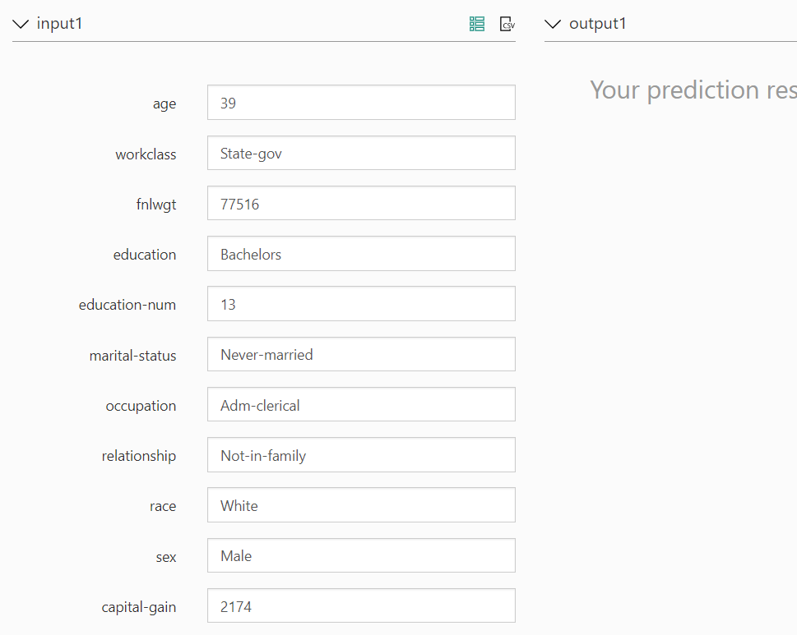

Output prediction for the selected values of the test data will be

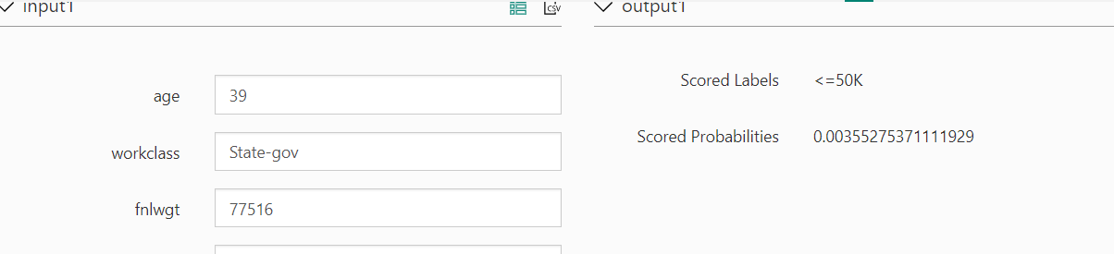

1. Amazon ML as Service
   1. Pre- Requisites:

We need to place our data sets, both Train and Test (in case of Batch Predictions) in Amazon S3 or Redshift of Amazon RDS.

Have and Amazon AWS account with your credit card details registered or a student account.

* 1. Architecture

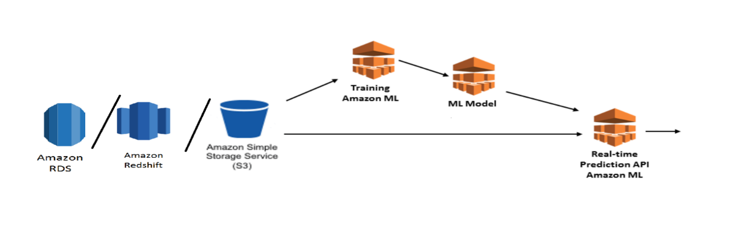

* 1. Data Preparations

**Dataset:** bankig.csv (UCI dataset)

**Prepare the dataset as follows :**

Download the file that contains the historical data for customers who have purchased products similar to your bank term deposit by clicking <https://s3.amazonaws.com/aml-sample-data/banking.csv>. Save it with the name banking.csv

Download the file that you will use to predict whether potential customers will respond to your offer by clicking <https://s3.amazonaws.com/aml-sample-data/banking-batch.csv>. Save it with the name banking-batch.csv.

Open banking.csv. You will see rows and columns of data. The *header row* contains the attribute names for each column. An *attribute* is a unique, named property that describes a particular characteristic of each customer; for example, nr_employed indicates the customer's employment status. Each row represents the collection of observations about a single customer.

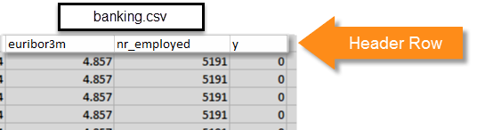

**Note**

Attribute **y** is a binary attribute. It can contain only one of two values, in this case 0 or 1. In the original UCI dataset, the **y** attribute is either Yes or No. We have edited the original dataset for you. All values of attribute **y** that mean yes are now 1, and all values that mean no are now 0. If you use your own data, you can use other values for a binary attribute. For more information about valid values, see [Using the AttributeType Field](http://docs.aws.amazon.com/machine-learning/latest/dg/creating-a-data-schema-for-amazon-ml.html#assigning-data-types).

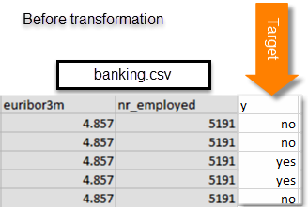 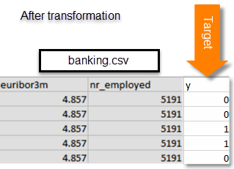

The banking-batch.csv file doesn’t contain the **y** attribute. After you have created an ML model, you will use the model to predict **y** for each record in that file.

Next, upload the banking.csv and banking-batch.csv files to Amazon S3.

* 1. Preparing a Machine Learning Model

**S3 link for the datasets is as follows :**

<https://s3.console.aws.amazon.com/s3/buckets/machinelearningdatasets-team8>

In Amazon ML, click on “Launch”

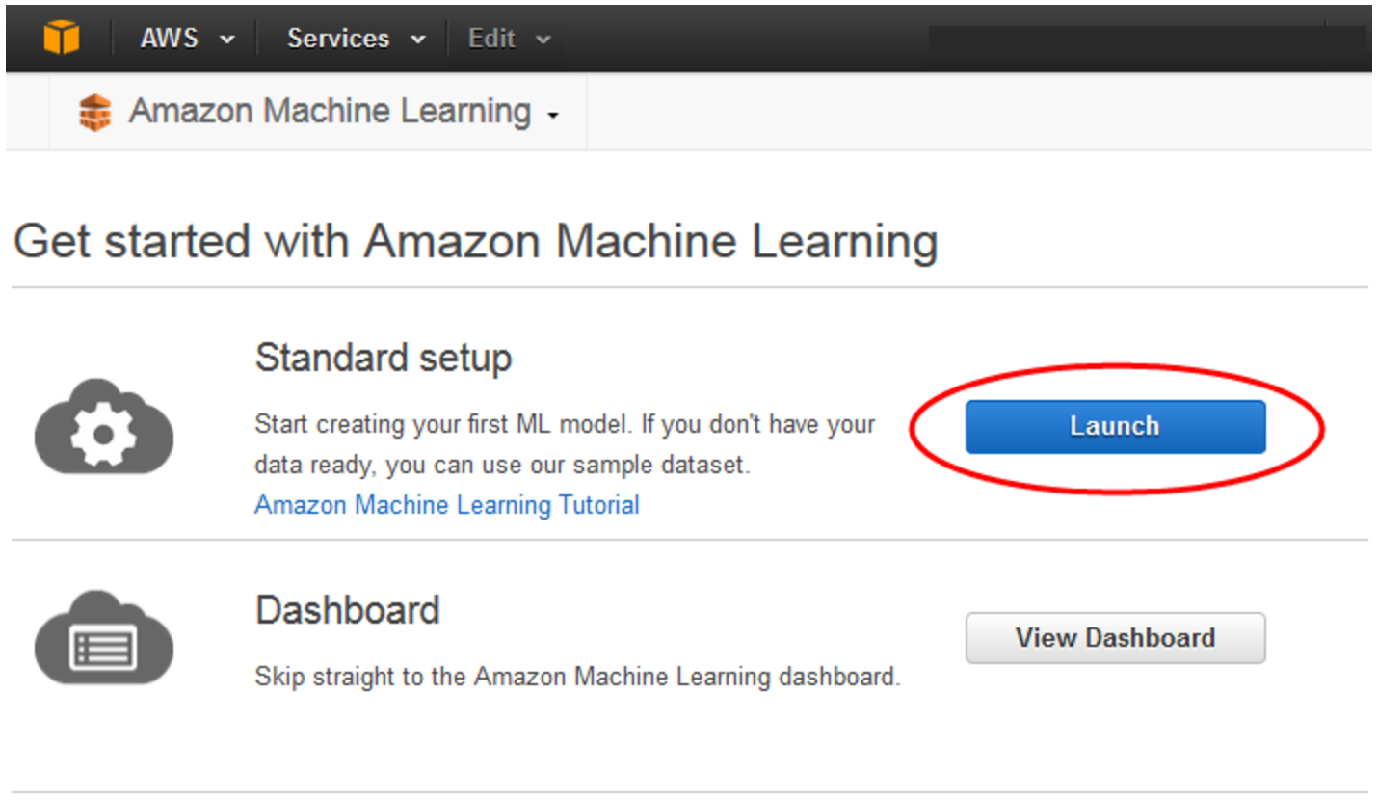

**This data is then accessed using Amazon Machine Learning as follows :**

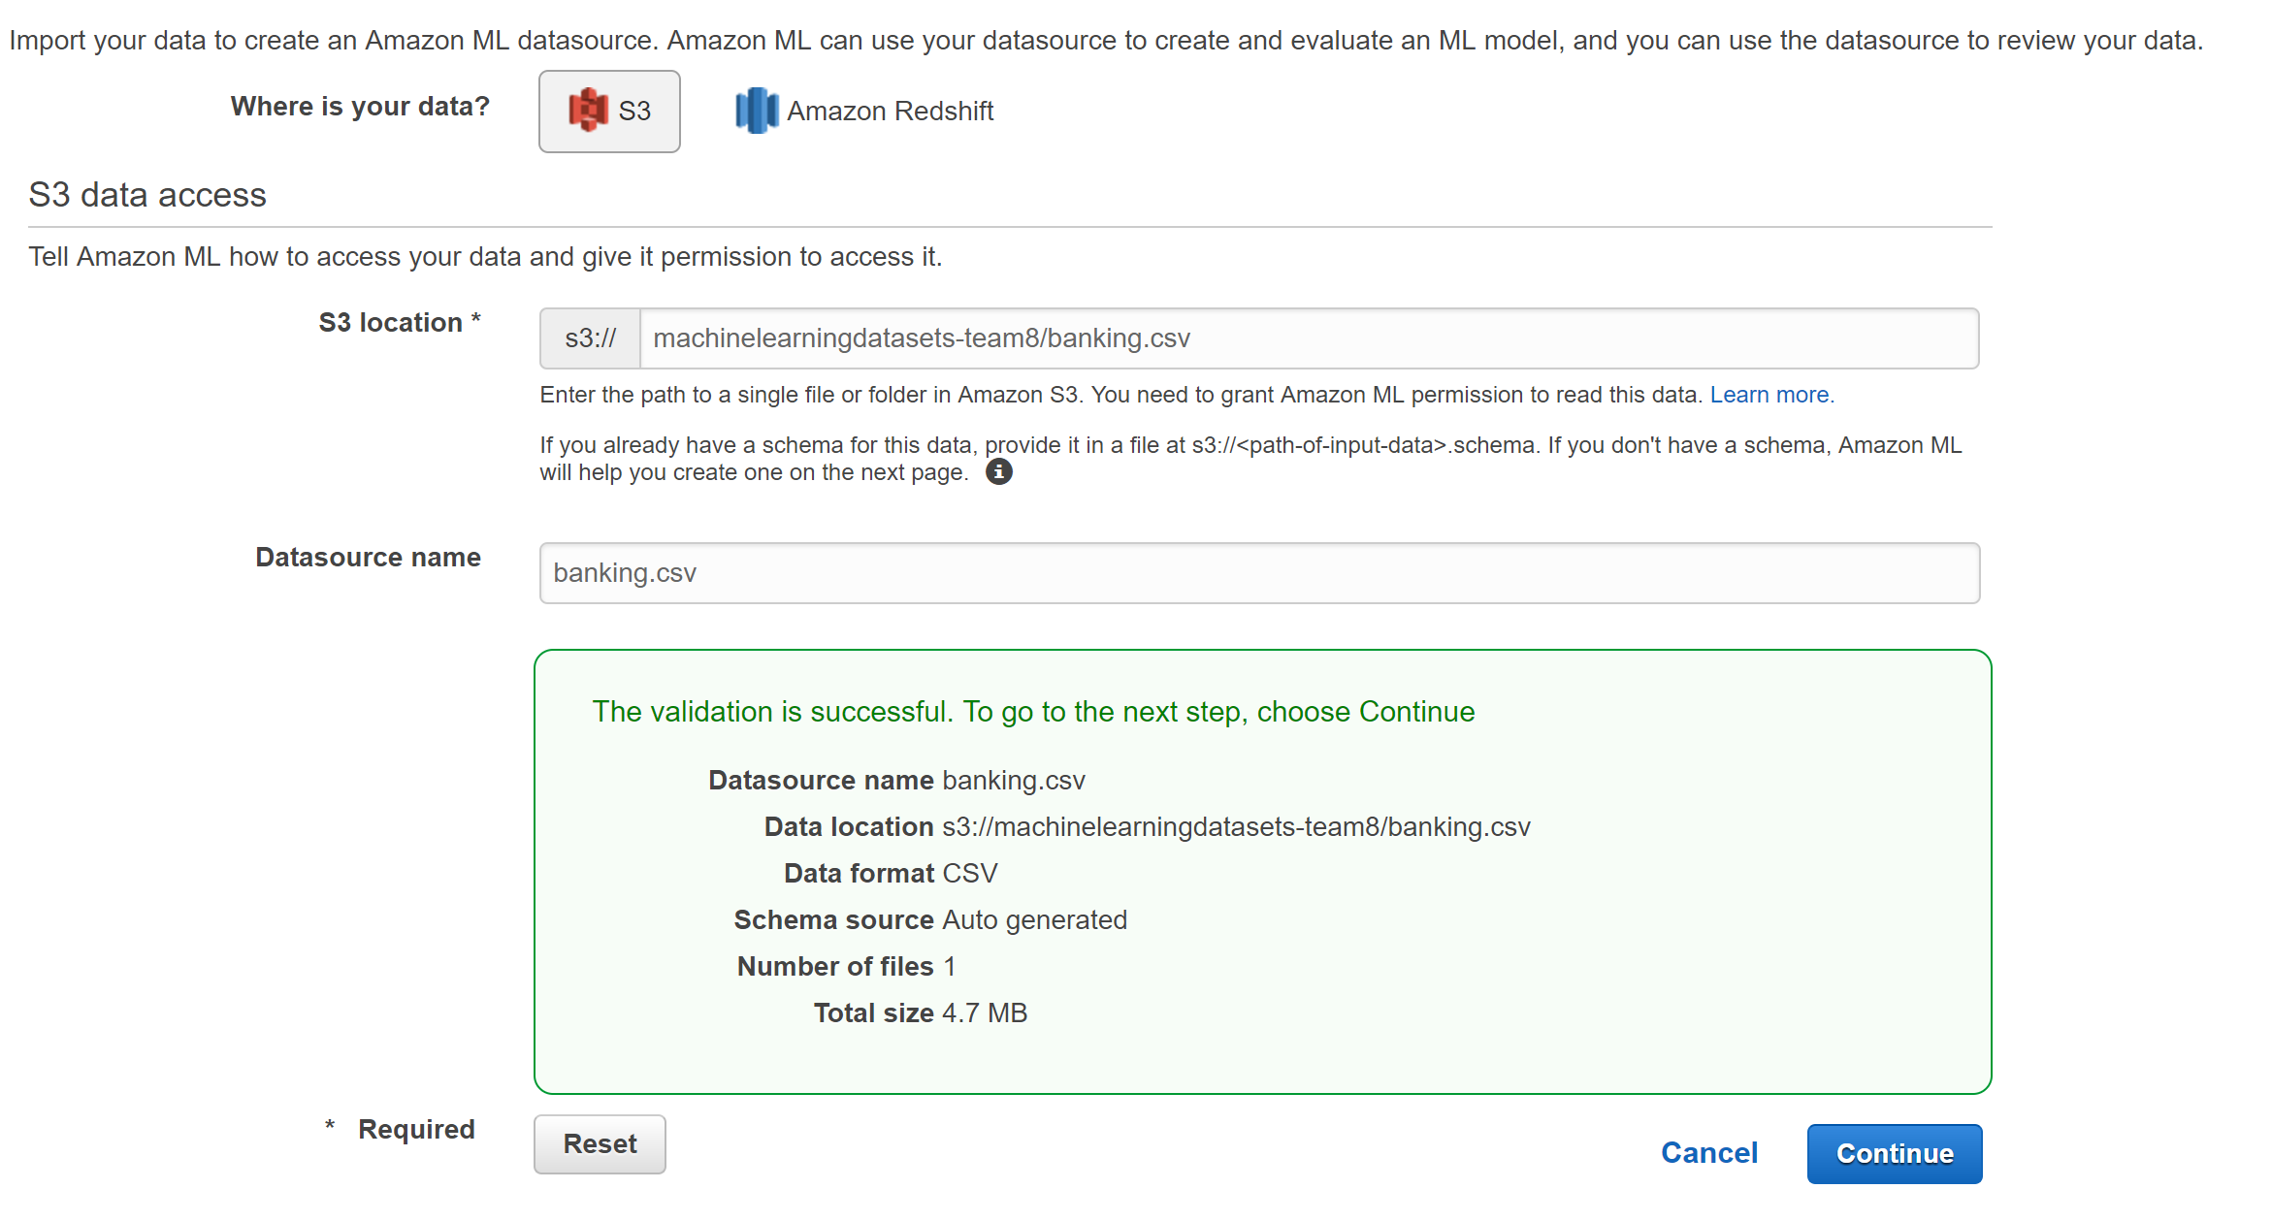

In the Next step, the application asks for a schema. If your first column contains the name of the headers then select the radio button that reads, ”**Yes**” for the question, “**Does the first line in your CSV contain the column names?**”

Check the data types against the table and click on “**Continue**”.

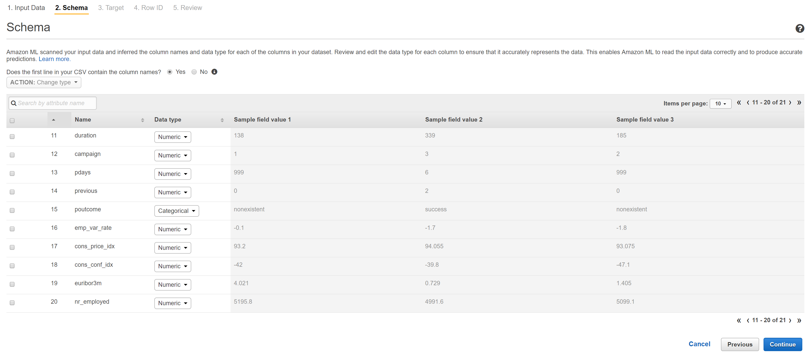

The row with the binary values is called the “**target**“

And if not selected you get a prompt as follows :

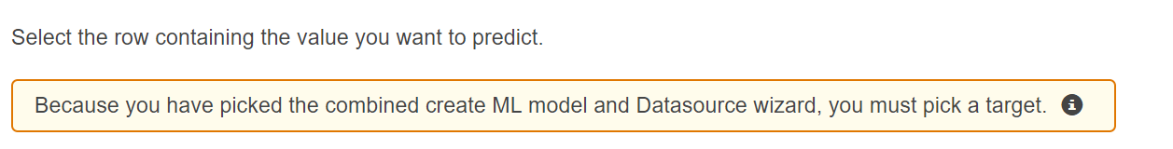

Once a target is selected, you get the following prompt.

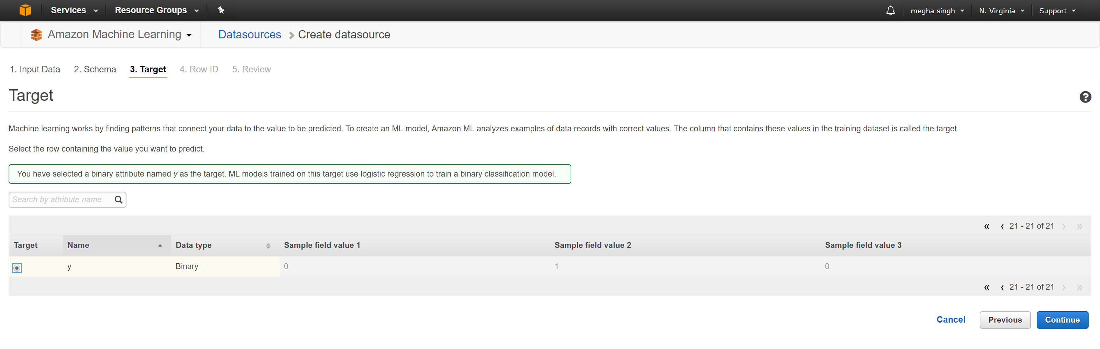

If the file that has been taken as the training dataset doesn’t have an index column then click on the , “**No**” radio button for the question, “**Does your data contain an identifier?” and the application assigns an index column to the data while working on the data but doesn’t display it anywhere else click on the radio button that reads, “Yes” and the train table appears once again, in which we select the column that acts as the index in the dataset.**

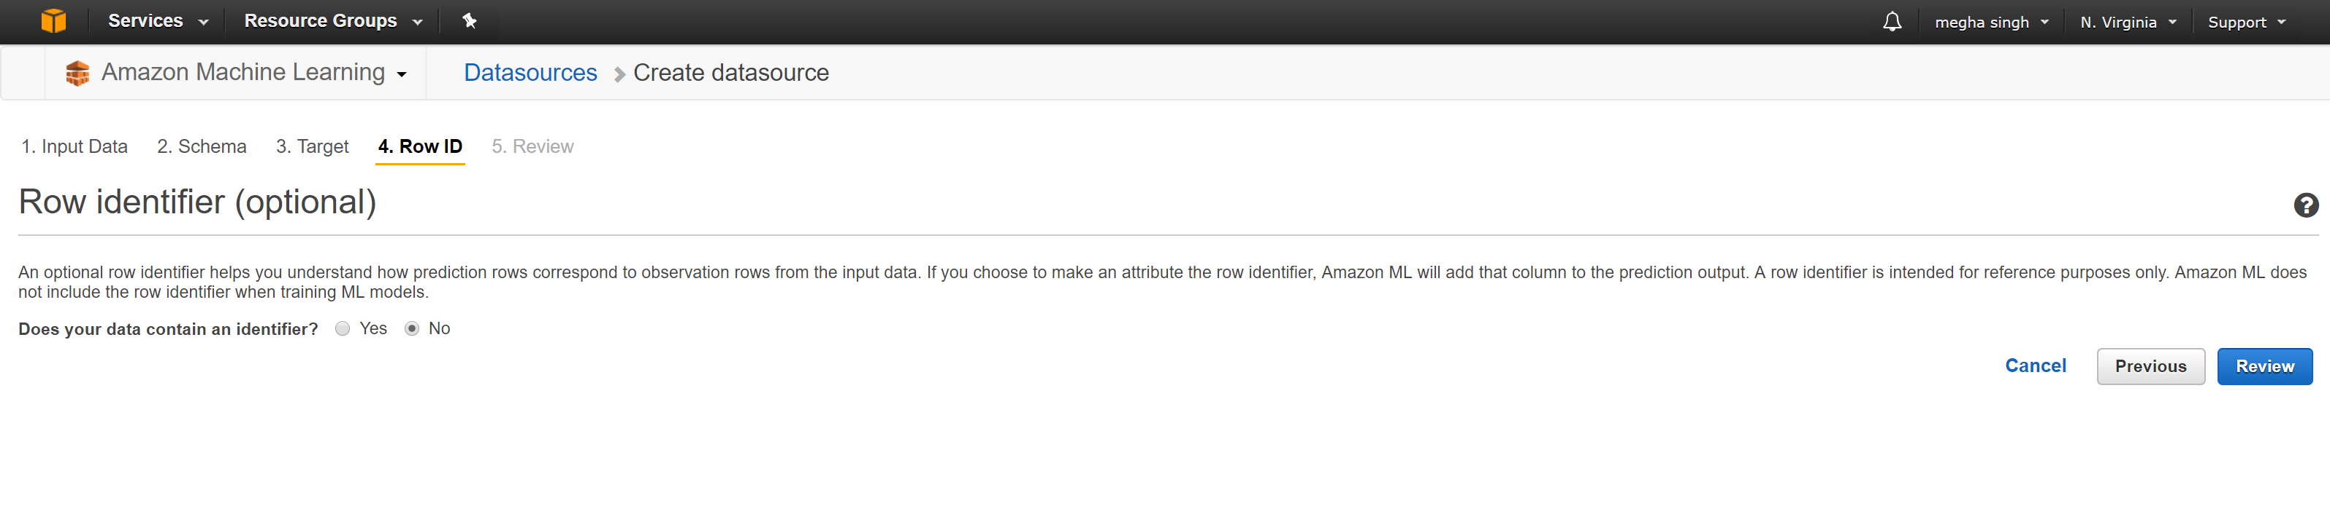

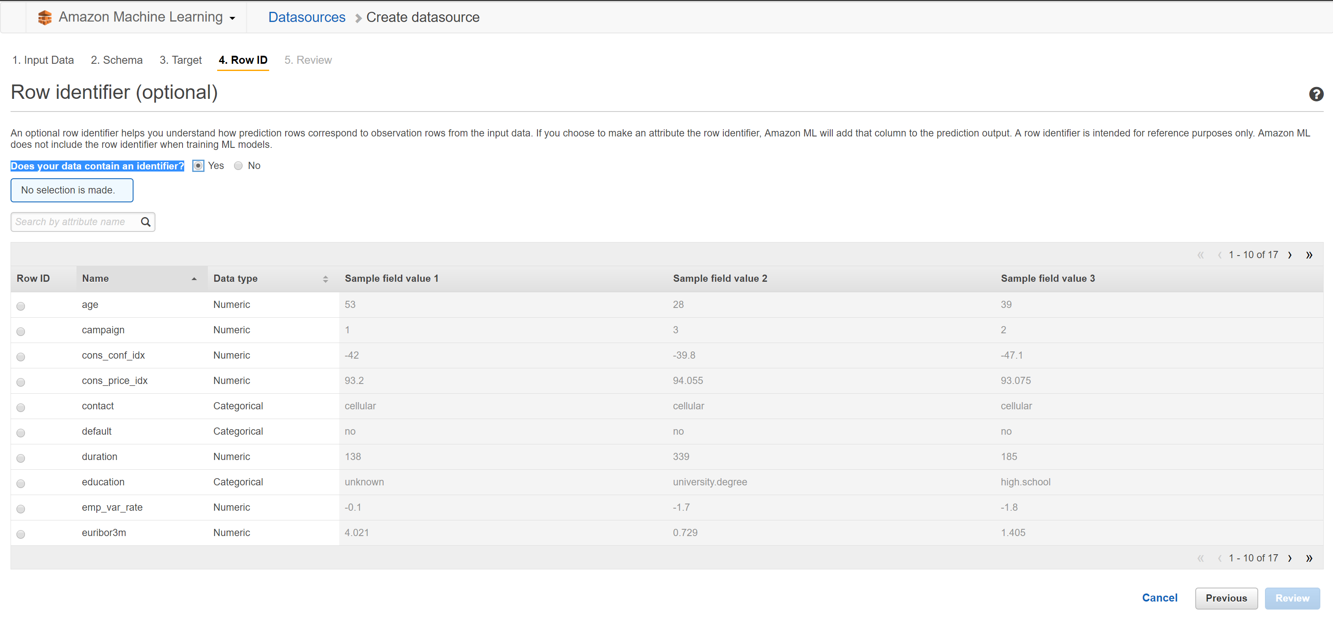

The user is then directed to the review page that looks as follows, where one can review the settings and confirm it by clicking on continue or edit each option by clicking on the “**Edit**” button on the right side of the option.

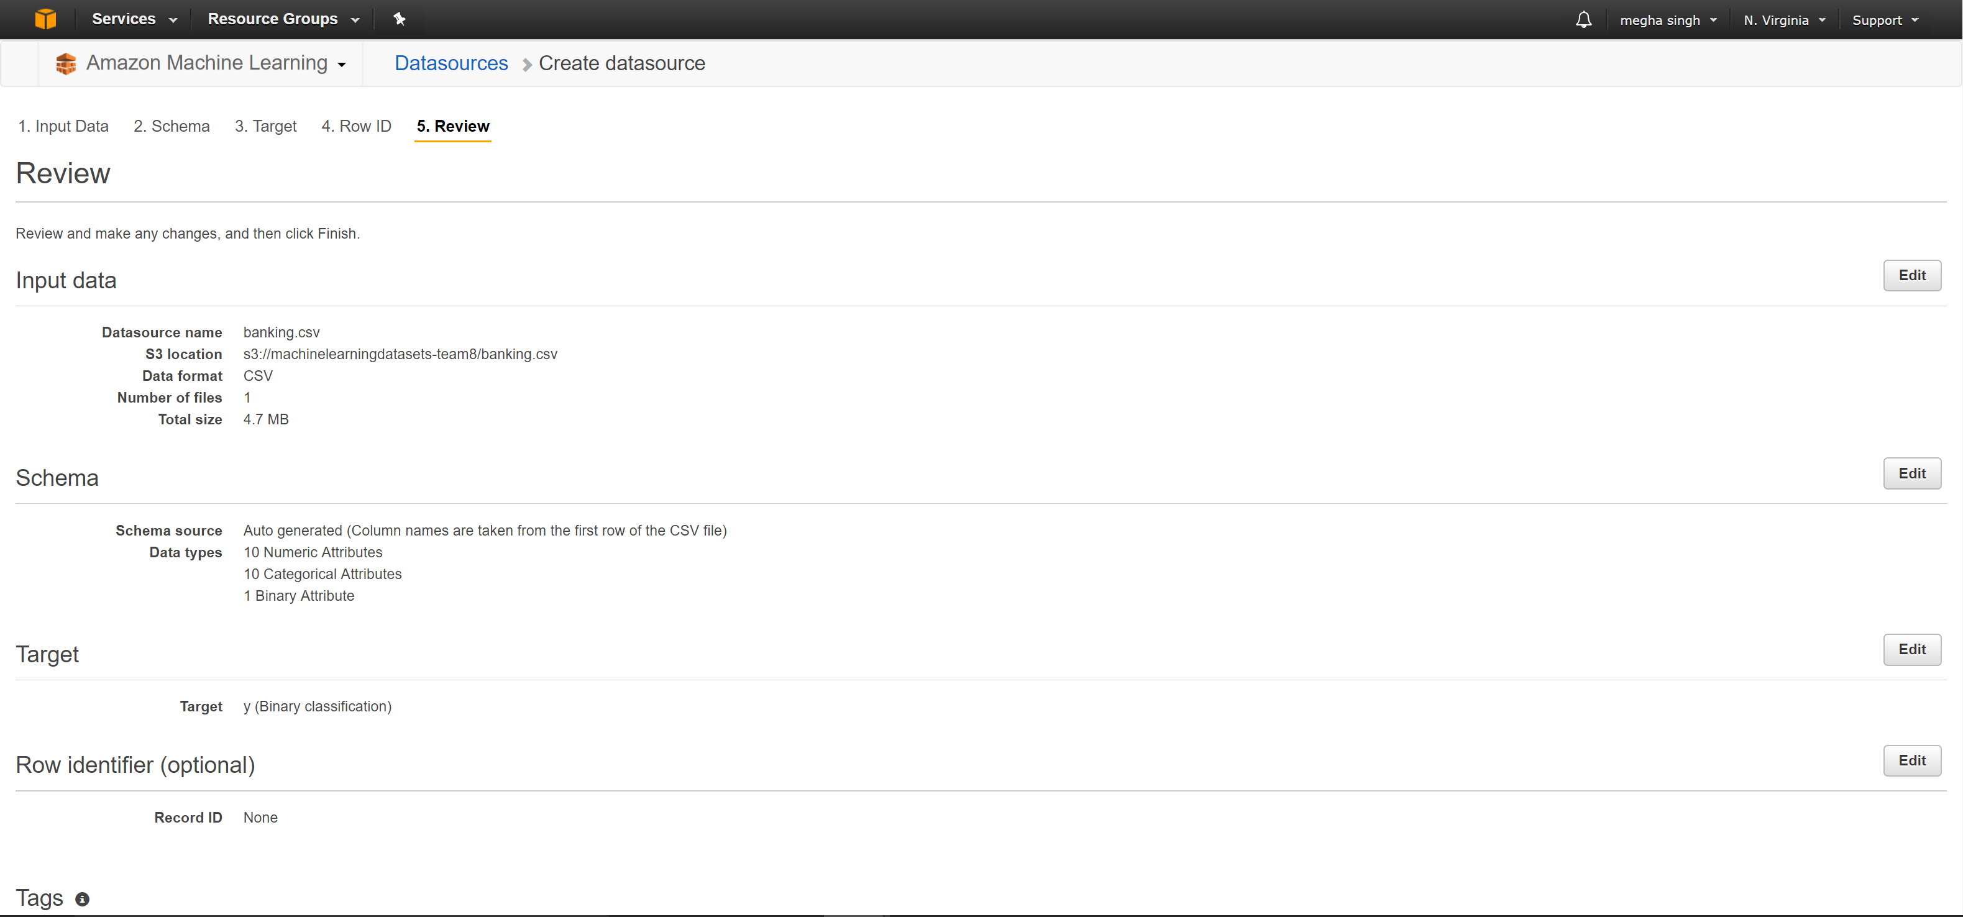

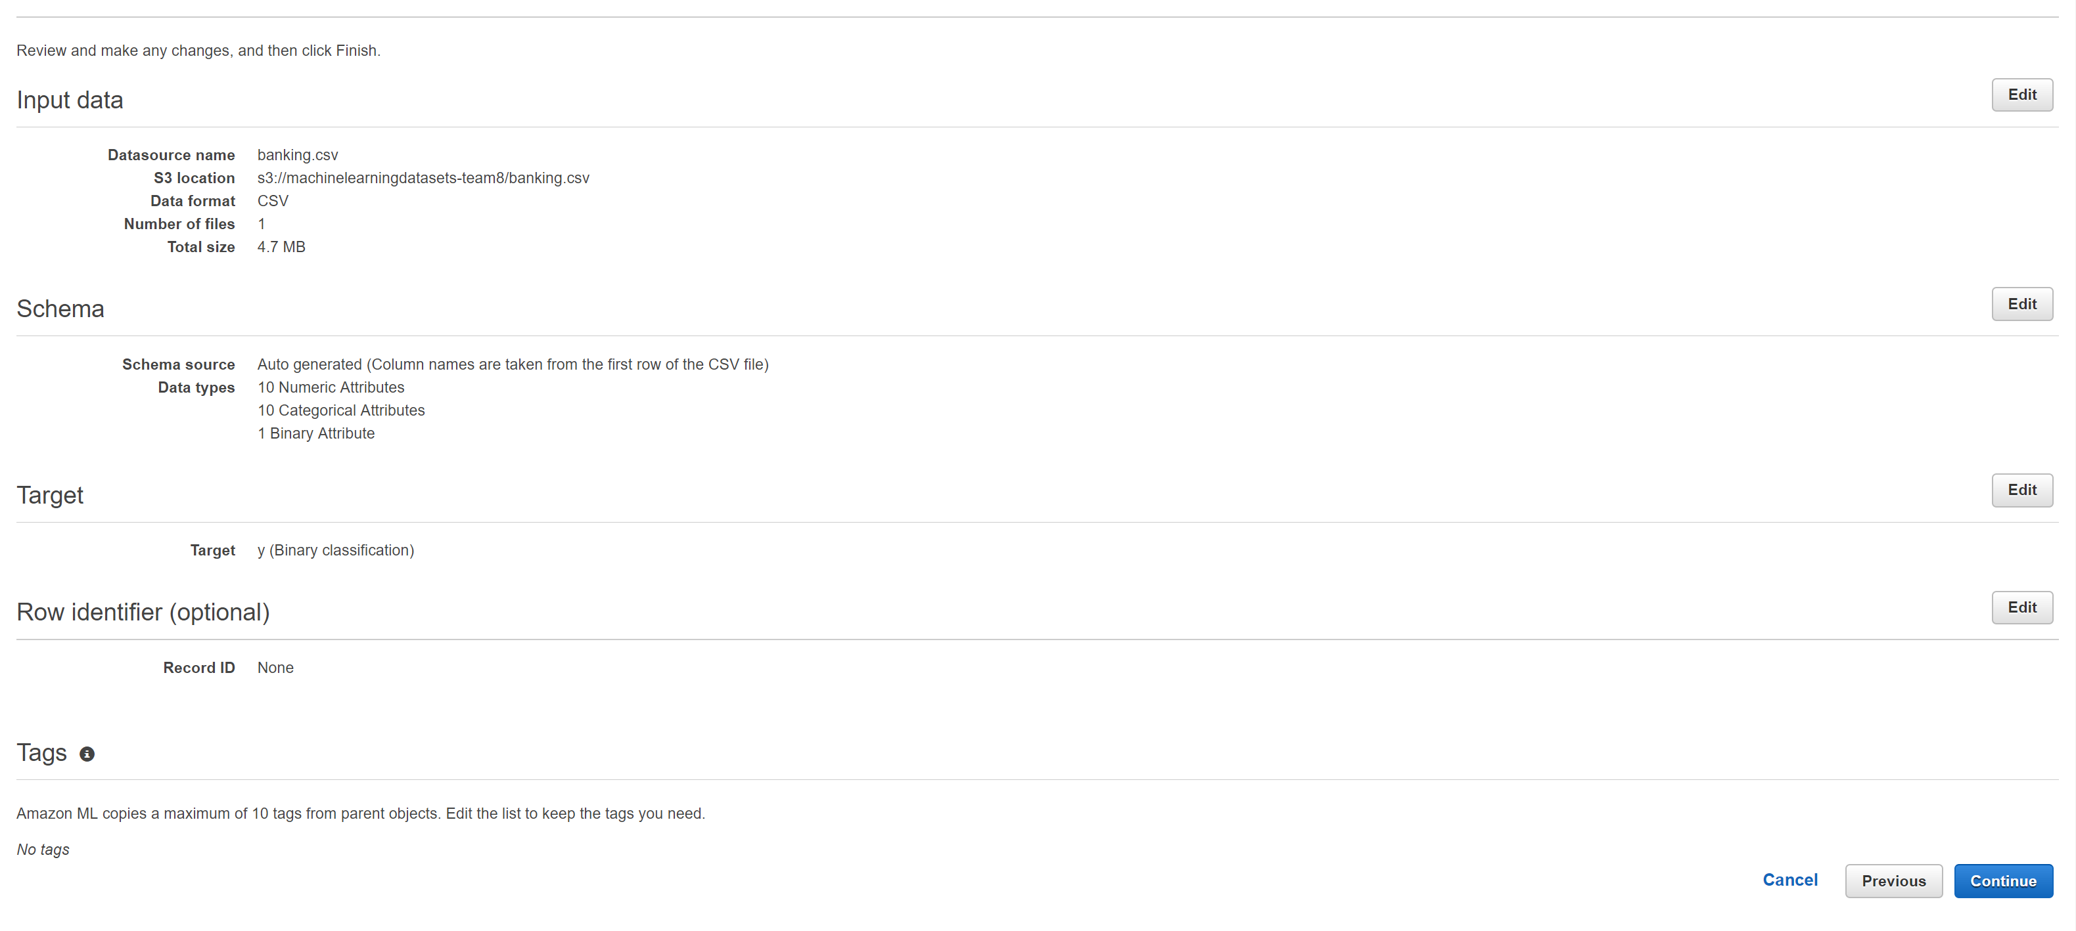

Next, we are directed to the page, “ML Model Setting”

For this example we used Default ML Model.

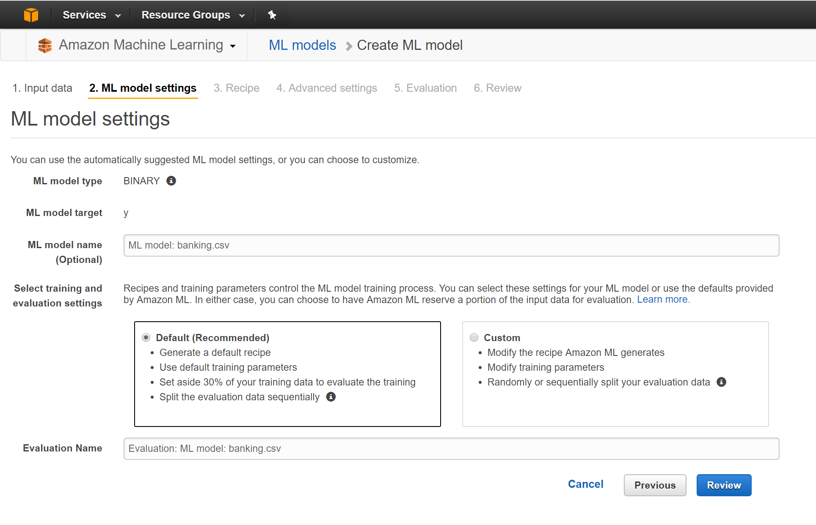

Choose **Review**, review your settings, and then choose **Finish**.

After you choose **Finish**, Amazon ML adds your model to the processing queue. When Amazon ML creates your model, it applies the defaults and performs the following actions:

* + Splits the training datasource into two sections, one containing 70% of the data and one containing the remaining 30%
  + Trains the ML model on the section that contains 70% of the input data
  + Evaluates the model using the remaining 30% of the input data

While your model is in the queue, Amazon ML reports the status as **Pending**. While Amazon ML creates your model, it reports the status as **In Progress**. When it has completed all actions, it reports the status as **Completed**. Wait for the evaluation to complete before proceeding.

Now you are ready to [review your model's performance and set a cut-off score](http://docs.aws.amazon.com/machine-learning/latest/dg/step-4-review-model-and-set-cutoff.html).

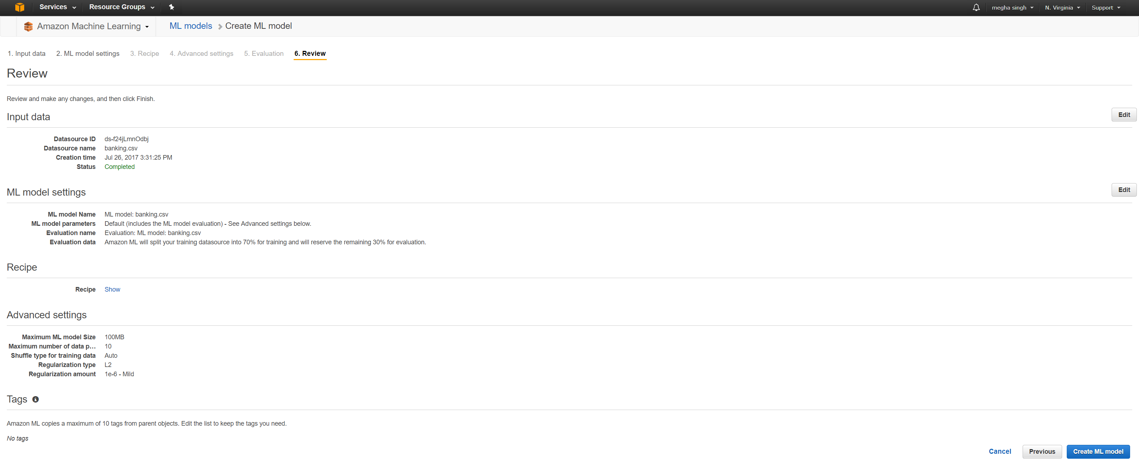

A summary of the ML Model is obtained as below :

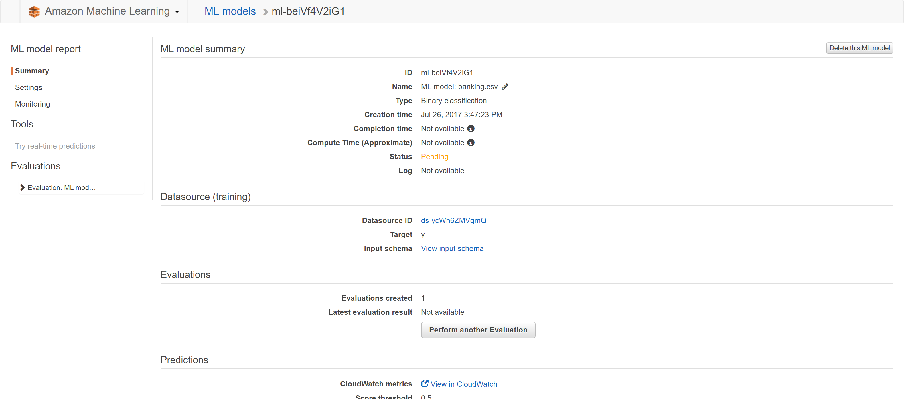

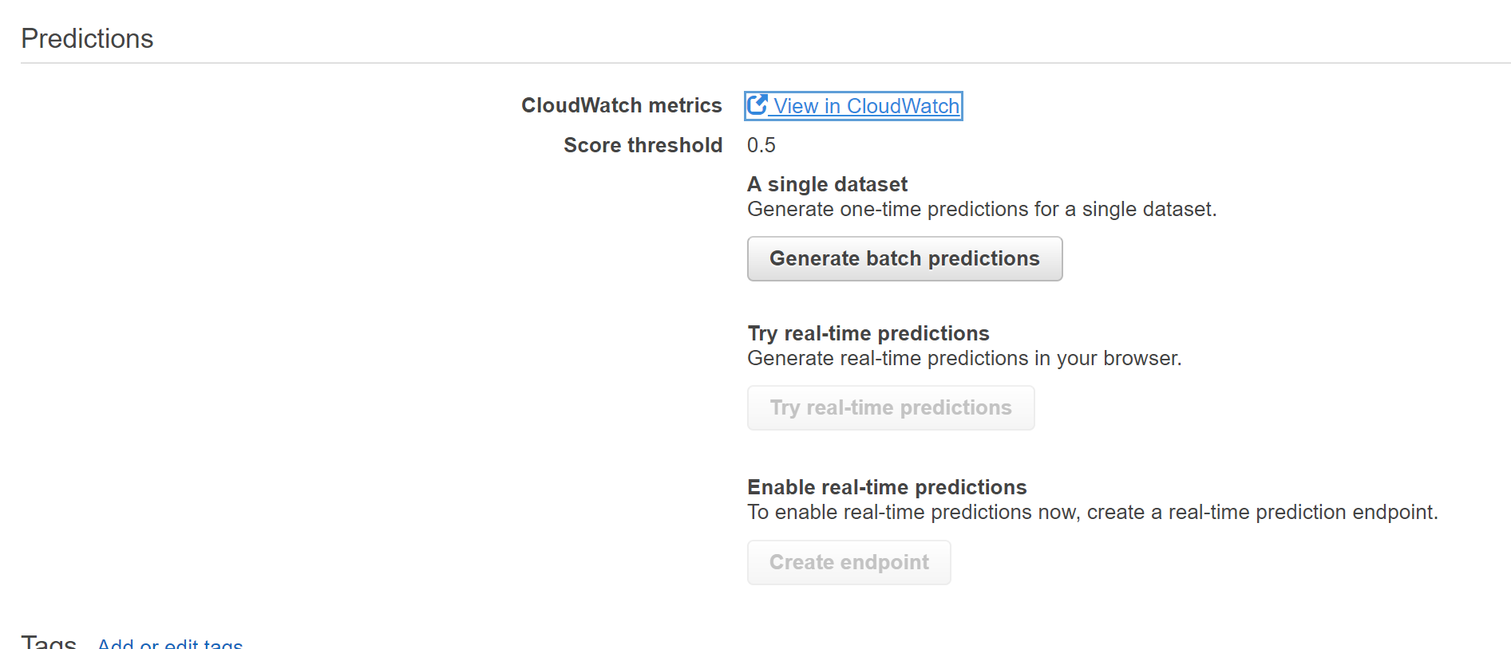

The evaluation summary shows pending status since the model is in the queue.

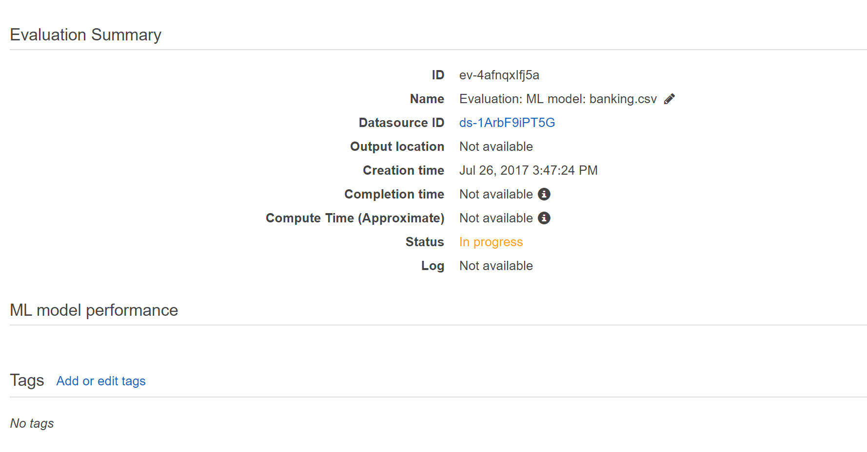

Now the status has been changed to “**In Progress**”, which means the model is being created.

Once the evaluation has been completed the metrics are as follows:

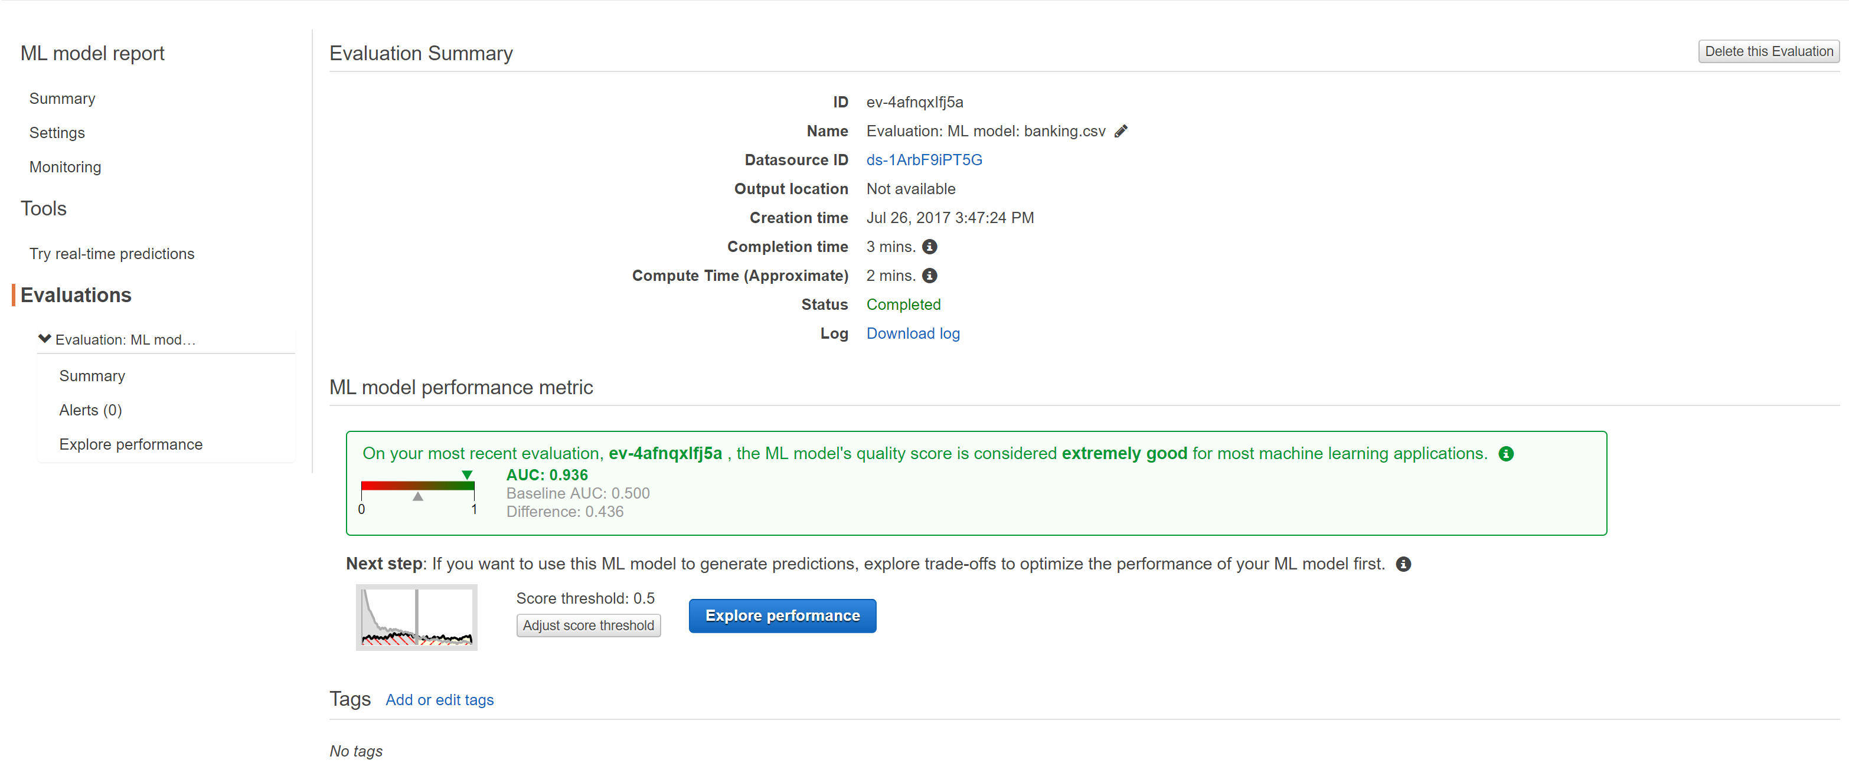The following is the model’s performance details;

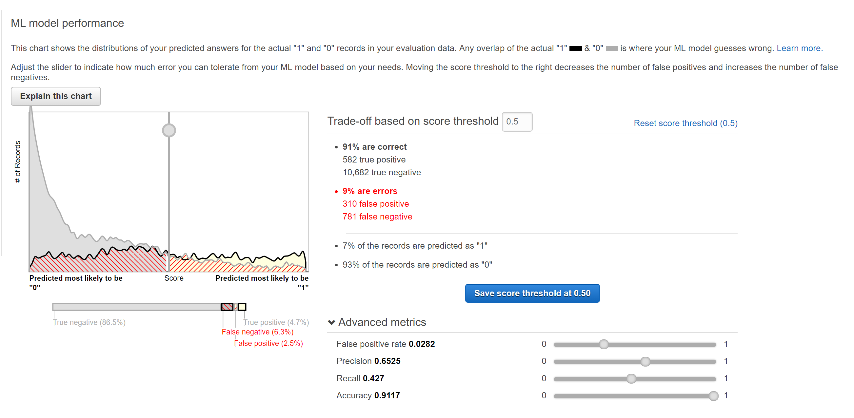

Shifting the slider to the right to a score threshold of 0.77, we get the following statistics :

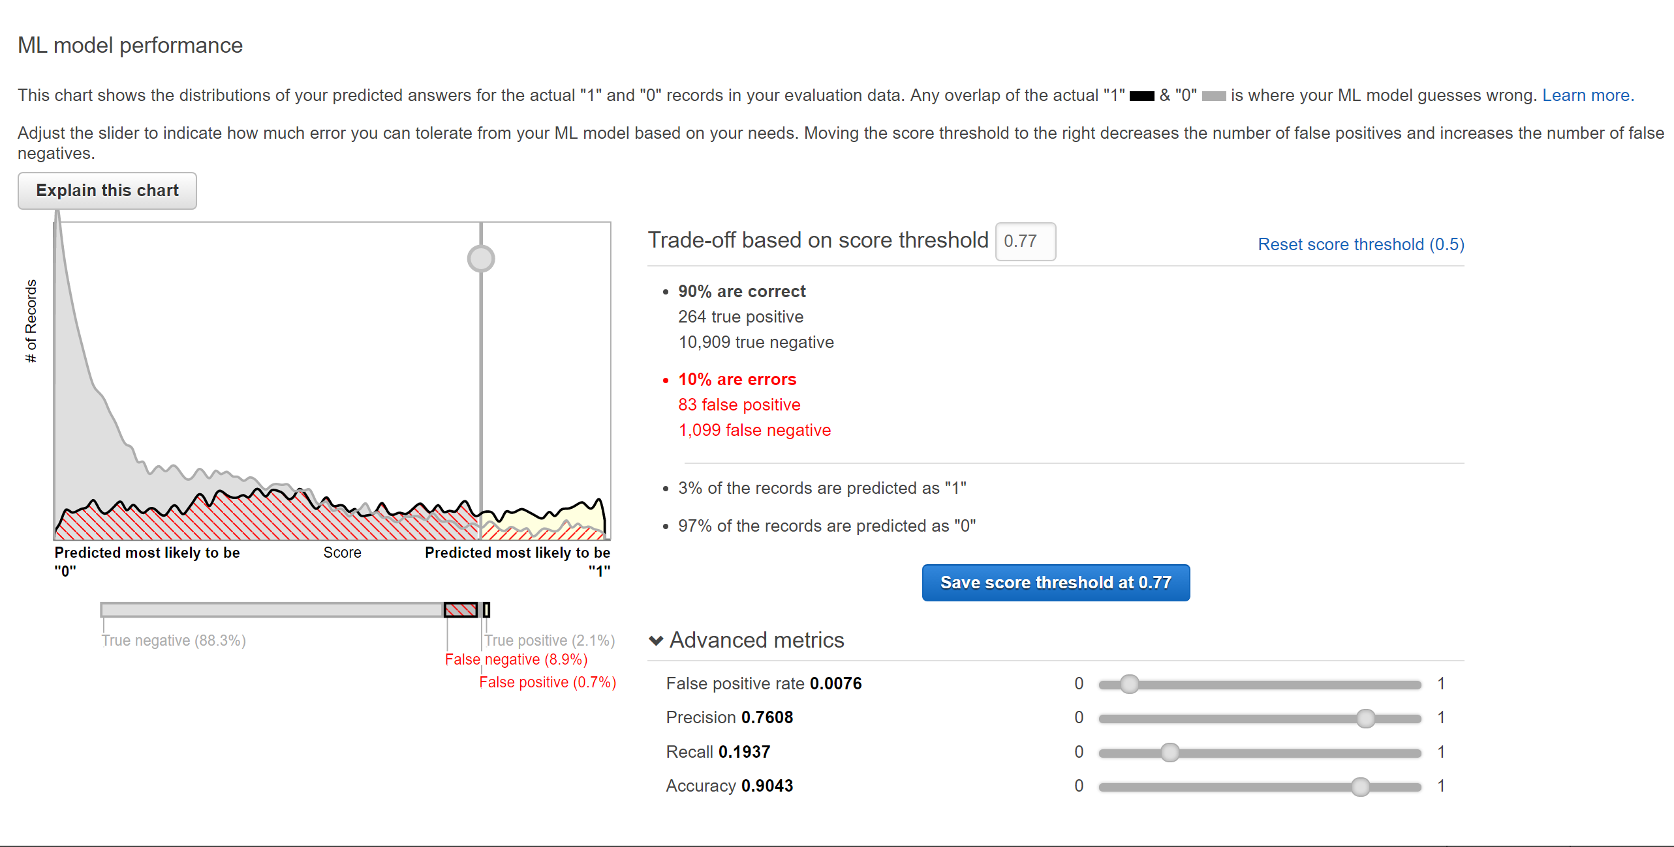

Shifting the slider to the left to a score threshold of 0.09 and 0.18, we get the following respective statistics :

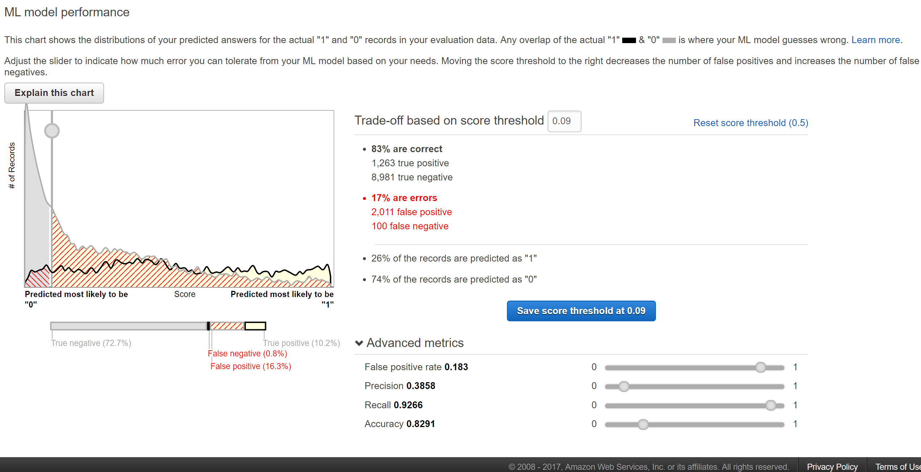

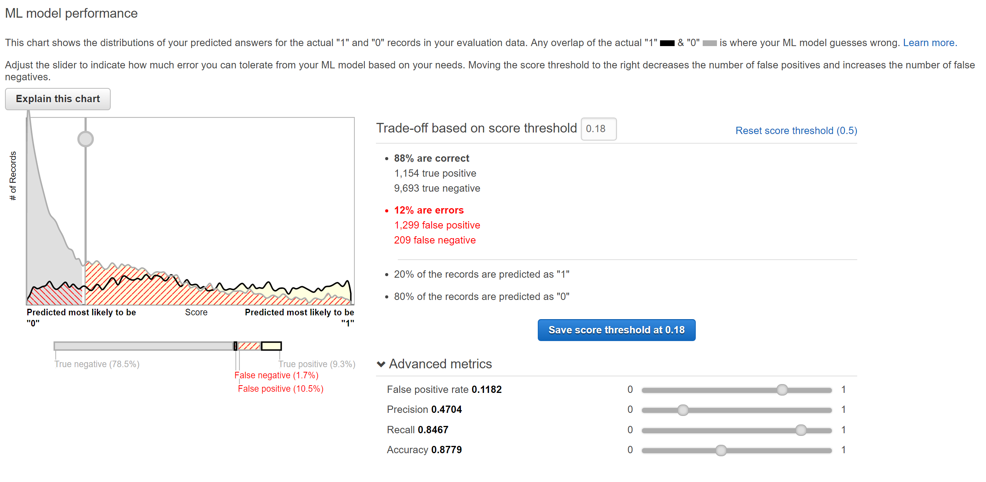

The explaination of the chart s as follows :

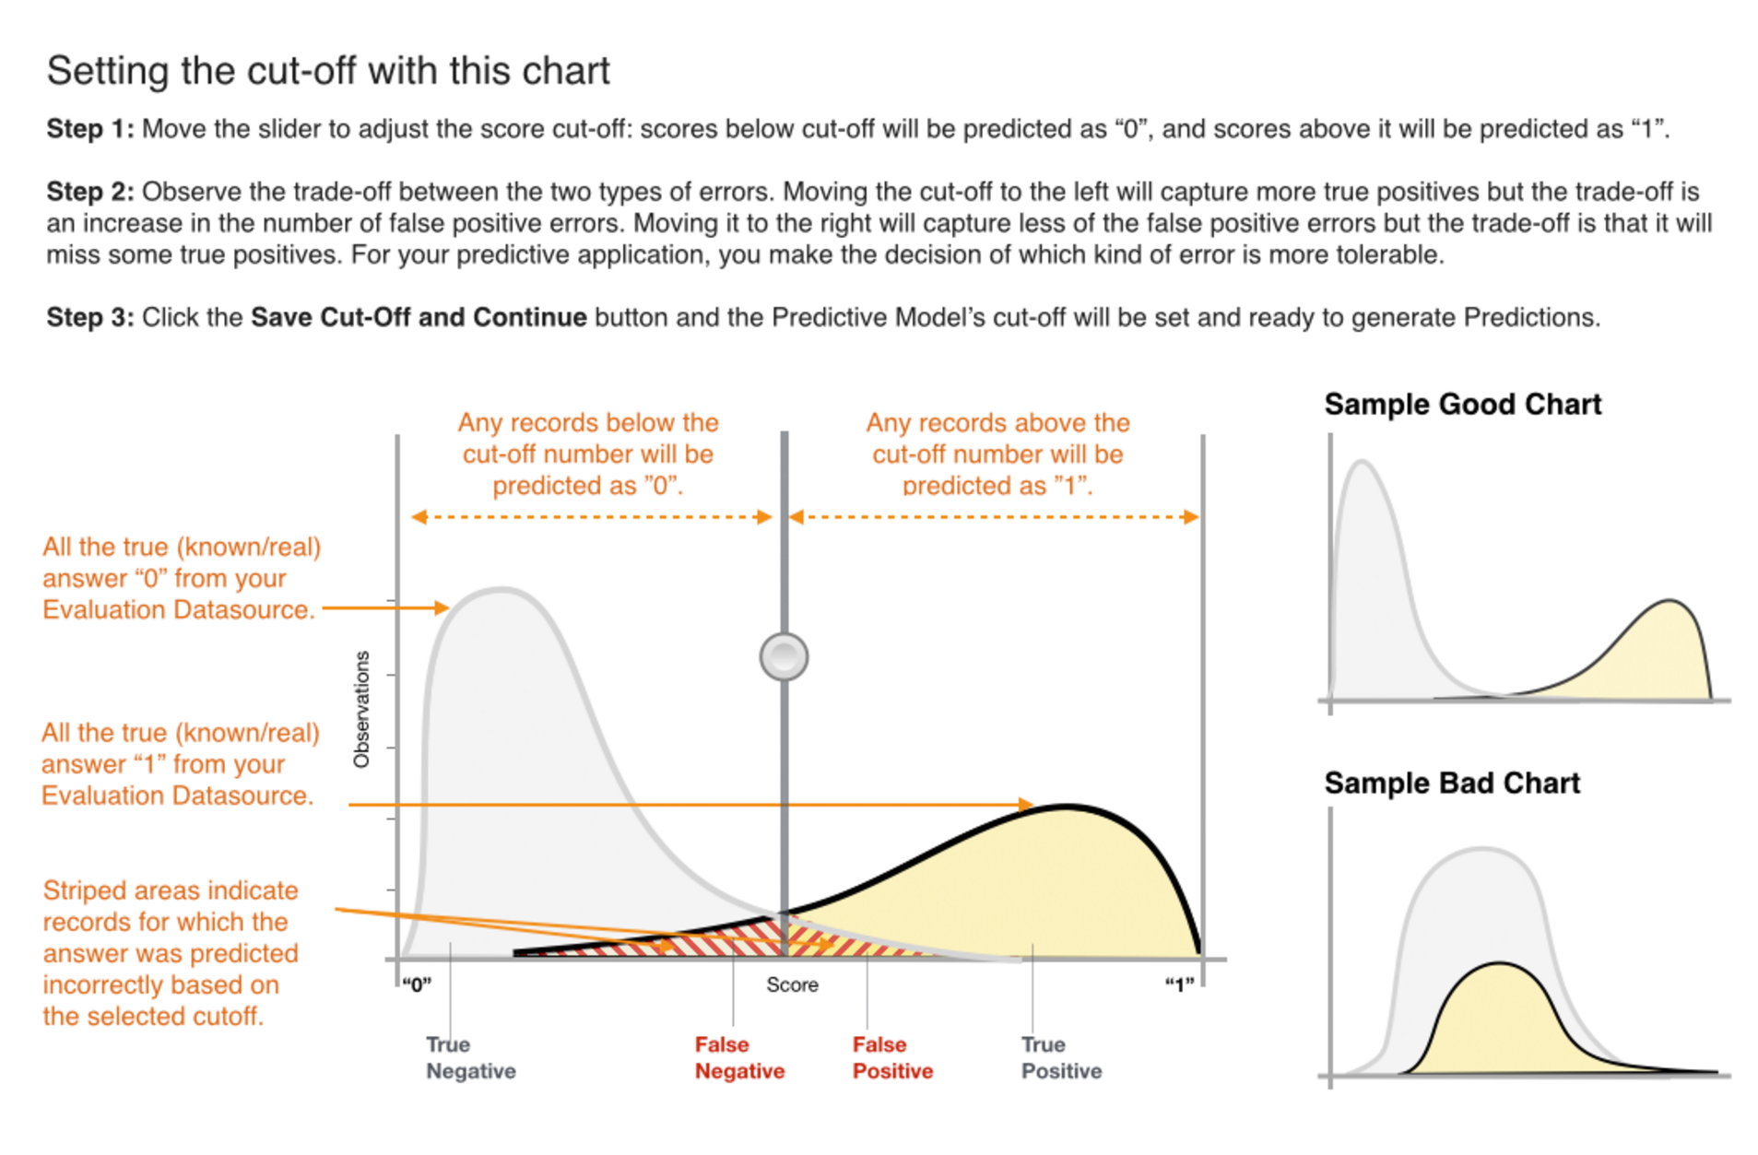

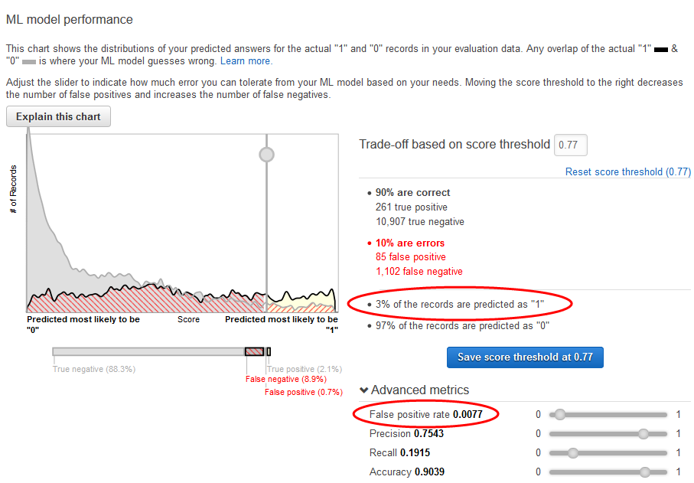

Note the impact of this score threshold on the ML model's performance: the false positive rate is 0.007. Let's assume that that false positive rate is acceptable.

Choose **Save score threshold at 0.77**.

Every time you use this ML model to make predictions, it will predict records with scores over 0.77 as "**1**", and the rest of the records as "**0**".

* 1. Perdition and model Analysis

**Using the ML Model to Generate Predictions:**

Amazon Machine Learning (Amazon ML) can generate two types of predictions—batch and real-time.

A *real-time prediction* is a prediction for a single observation that Amazon ML generates on demand. Real-time predictions are ideal for mobile apps, websites, and other applications that need to use results interactively.

A *batch prediction* is a set of predictions for a group of observations. Amazon ML processes the records in a batch prediction together, so processing can take some time. Use batch predictions for applications that require predictions for sets of observations or predictions that don't use results interactively.

A real time prediction can be done as follows:

Click on “Paste a Record” and paste the following as a record in the field given :

**32,services,divorced,basic.9y,no,unknown,yes,cellular,dec,mon,110,1,11,0,nonexistent,-1.8,94.465,-36.1,0.883,5228.1**

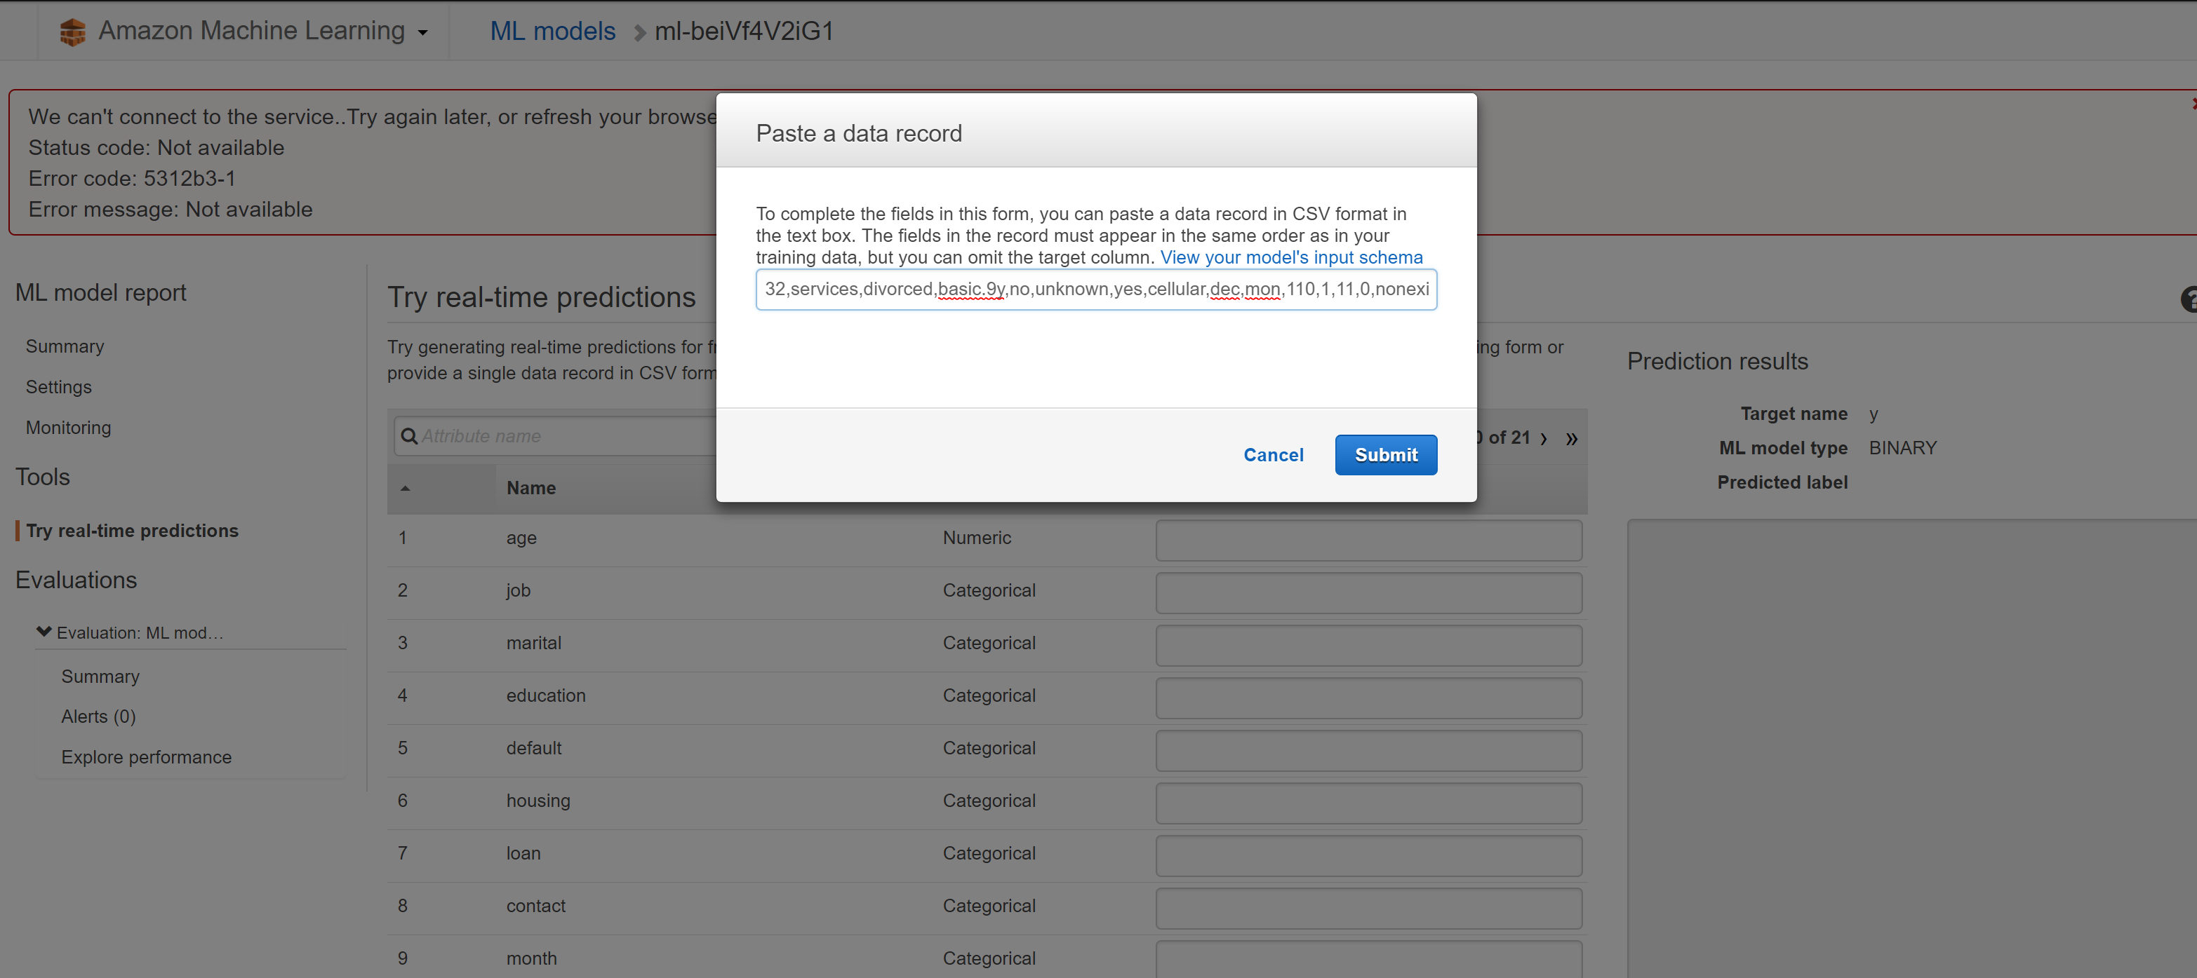

The following fields get populated and click on “**Create Prediction**“.

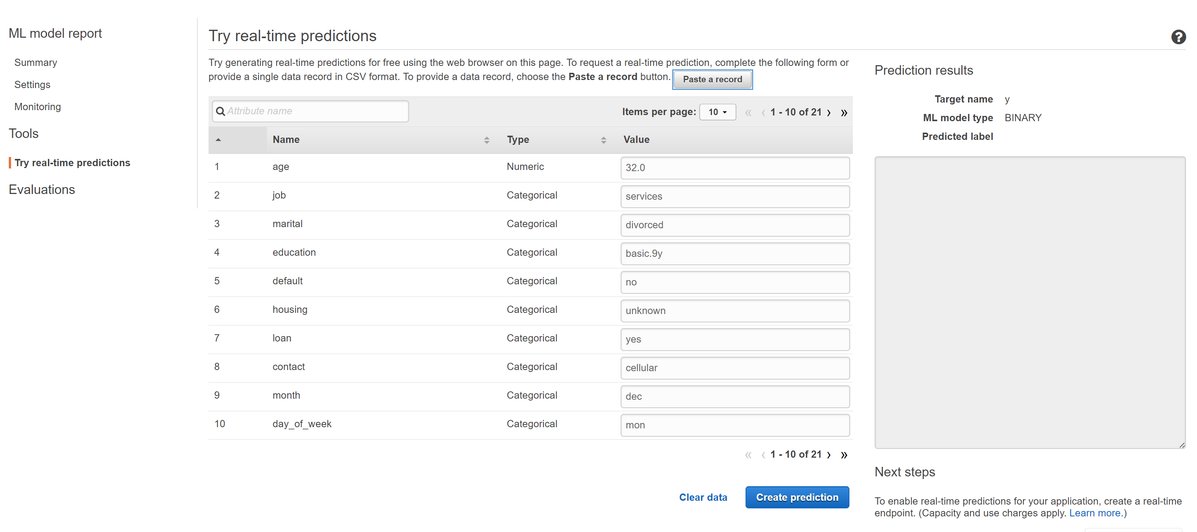

Now the prediction result on the right side, in the results pane, give the value that is predicted for the test record. Even the value of the prediction scores are given in the results pane.

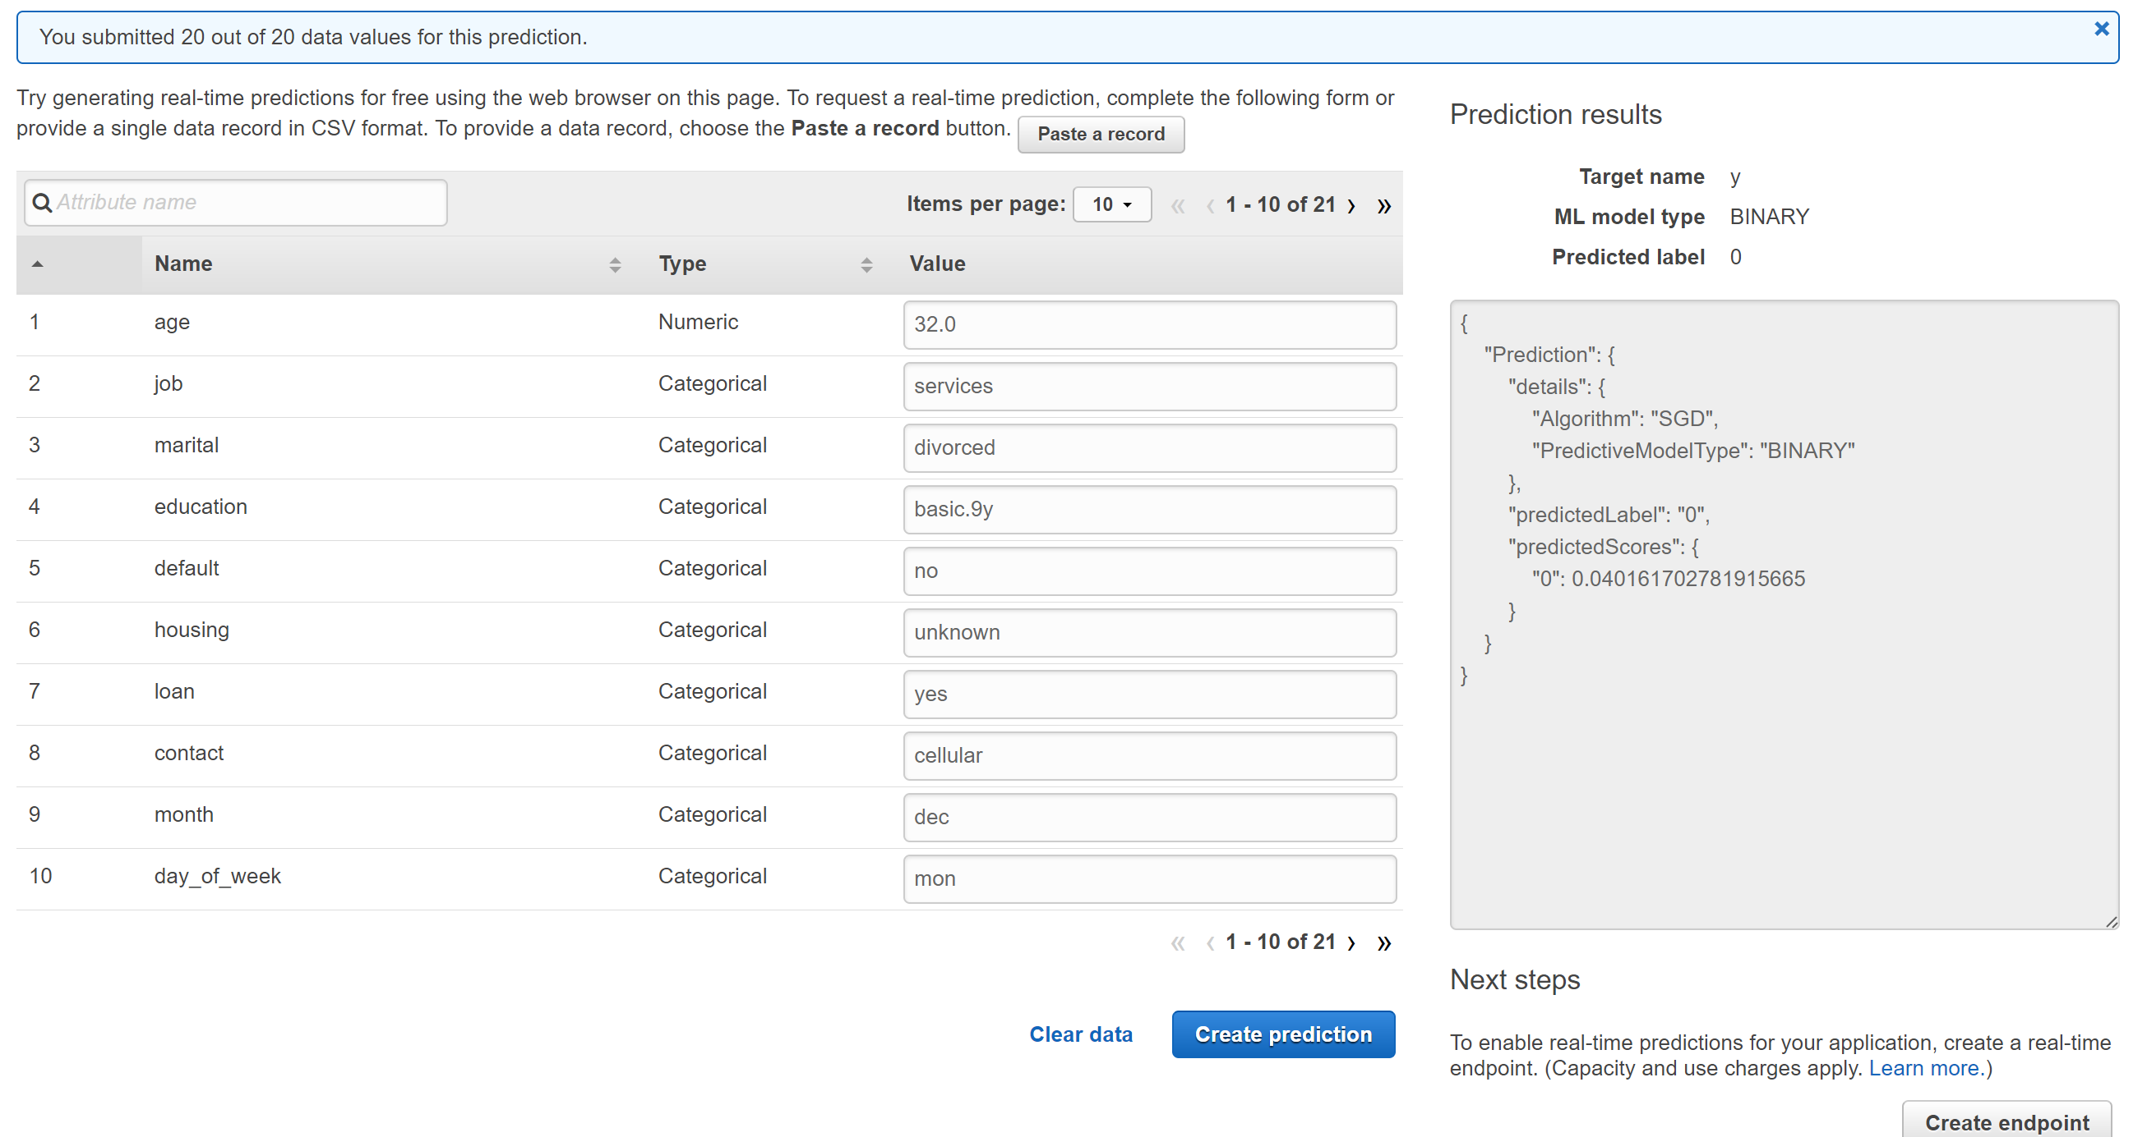

A prompt as below appears, if you click on the “**Create endpoint**” button

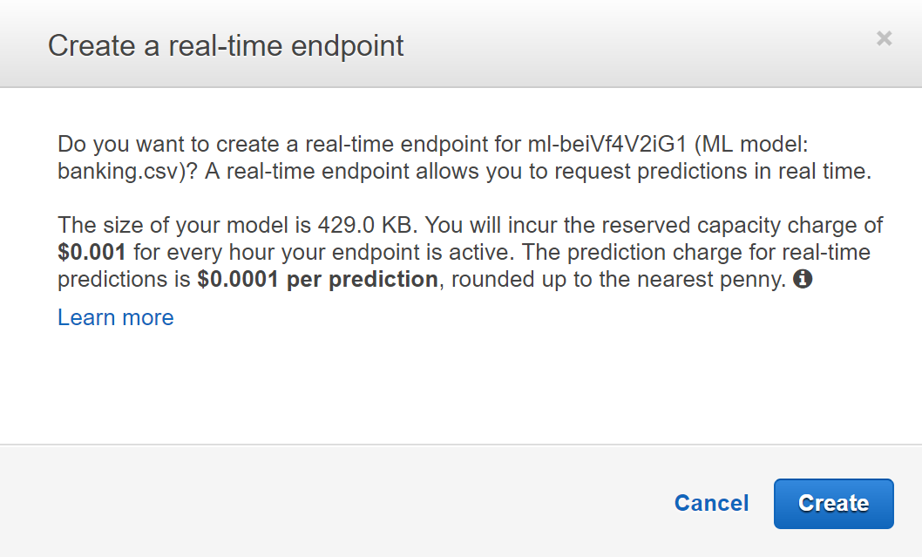

For Batch Predictions:

Go to Amazon ML and click on **Create new** -> **Batch Prediction** as shown below :

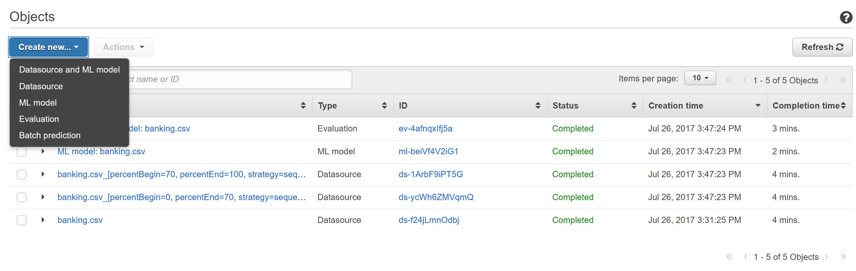

You are directed to a new page and the different models created are shown. On the **ML model for batch predictions** page, choose **ML model: Banking Data 1**.

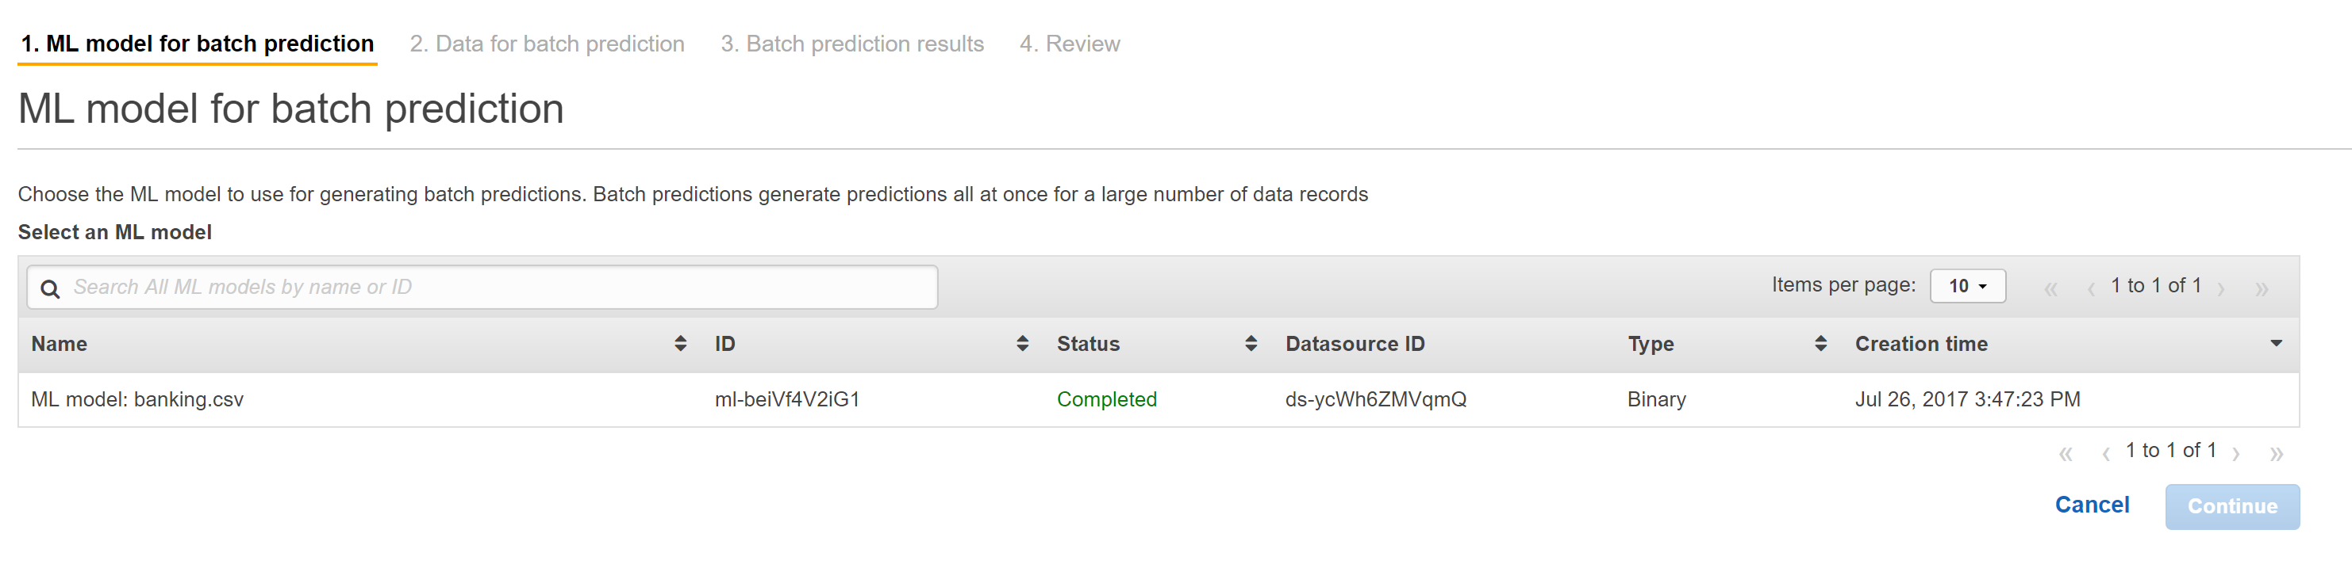

Amazon ML displays the ML model name, ID, creation time, and the associated datasource ID as shown below. Choose **Continue**.

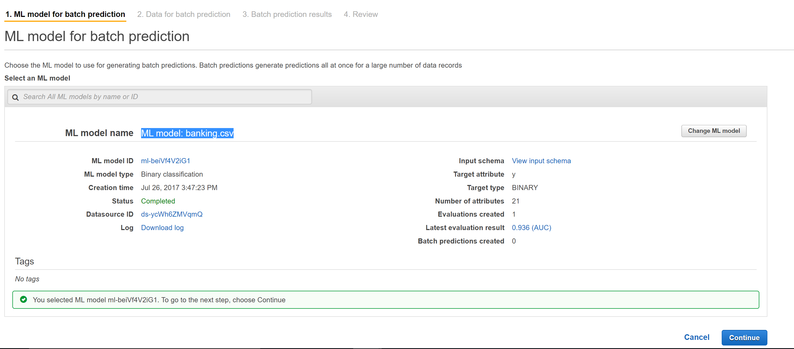

To generate predictions, you need to provide Amazon ML the data that you need predictions for. This is called the *input data*. First, put the input data into a datasource so that Amazon ML can access it.

For **Locate the input data**, choose **My data is in S3, and I need to create a datasource**.

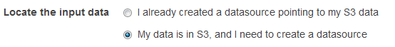

For **Datasource name**, type **Banking Data 2**.

For **S3 Location**, type the full location of the banking-batch.csv file: *your-bucket***/banking-batch.csv**.

For **Does the first line in your CSV contain the column names?**, choose **Yes**.

Choose **Verify**.

Amazon ML validates the location of your data, just like it did the first time while entering the train data.

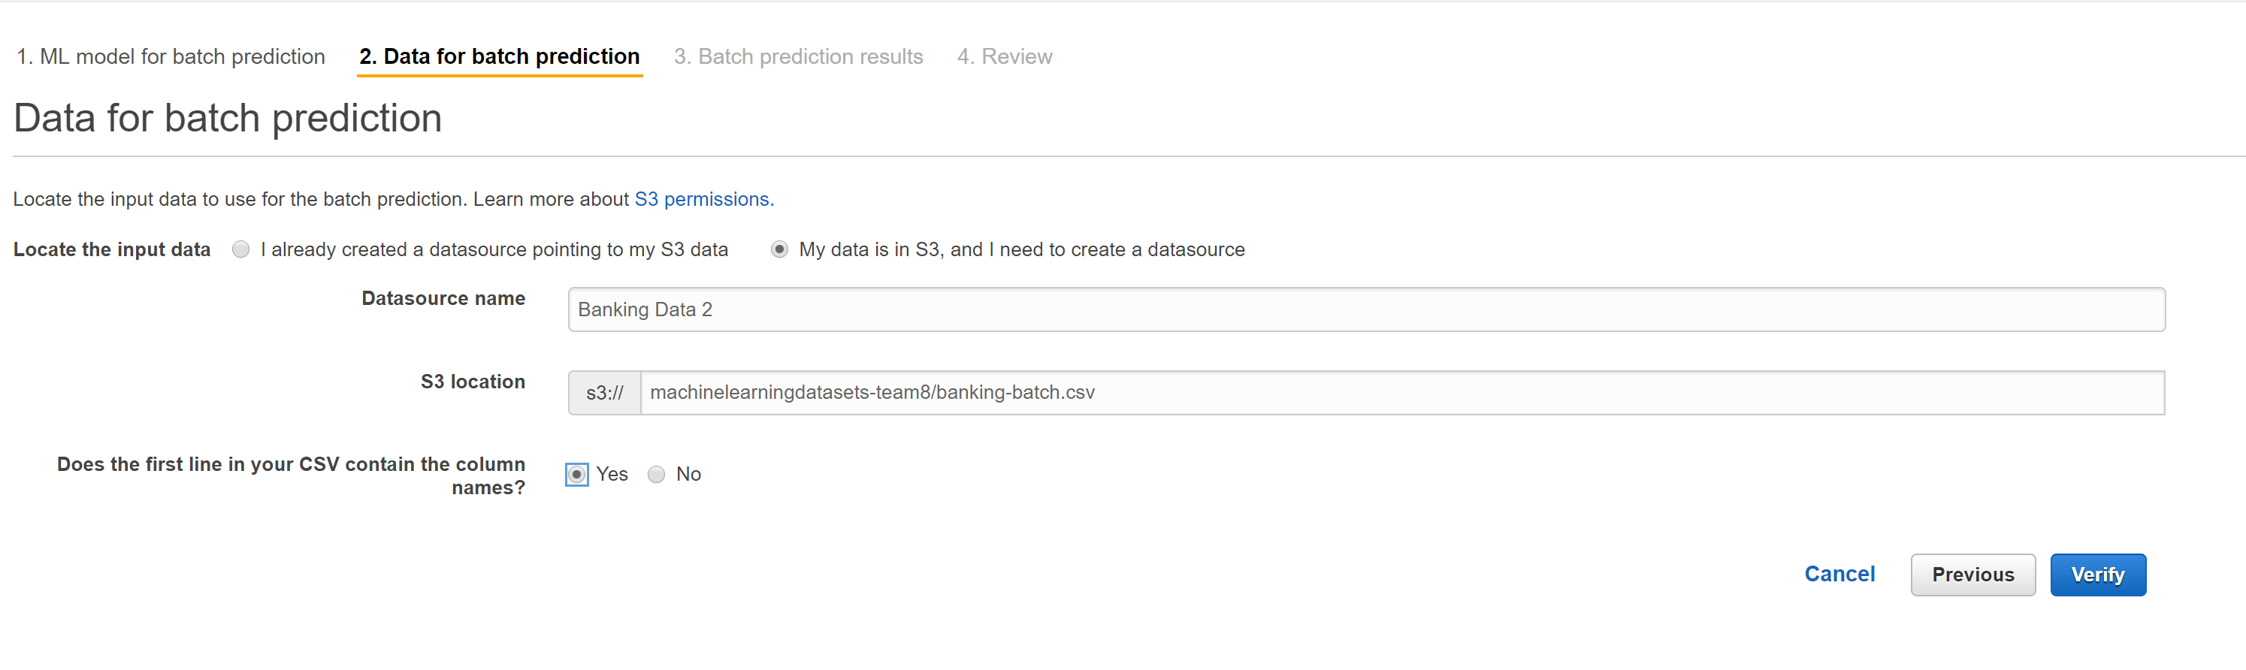The following prompt must appear just below the radio button and click on **Continue.**

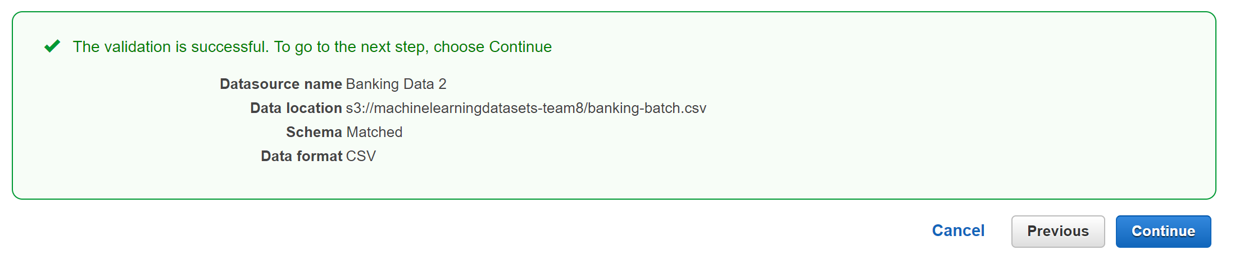

For **S3 destination**, type the name of the Amazon S3 location where you uploaded the files in Step 1: Prepare Your Data. Amazon ML uploads the prediction results there.

For **Batch prediction name**, accept the default, **Batch prediction: ML model: banking.csv** . Amazon ML chooses the default name based on the model it will use to create predictions. In this tutorial, the model and the predictions are named after the training datasource.

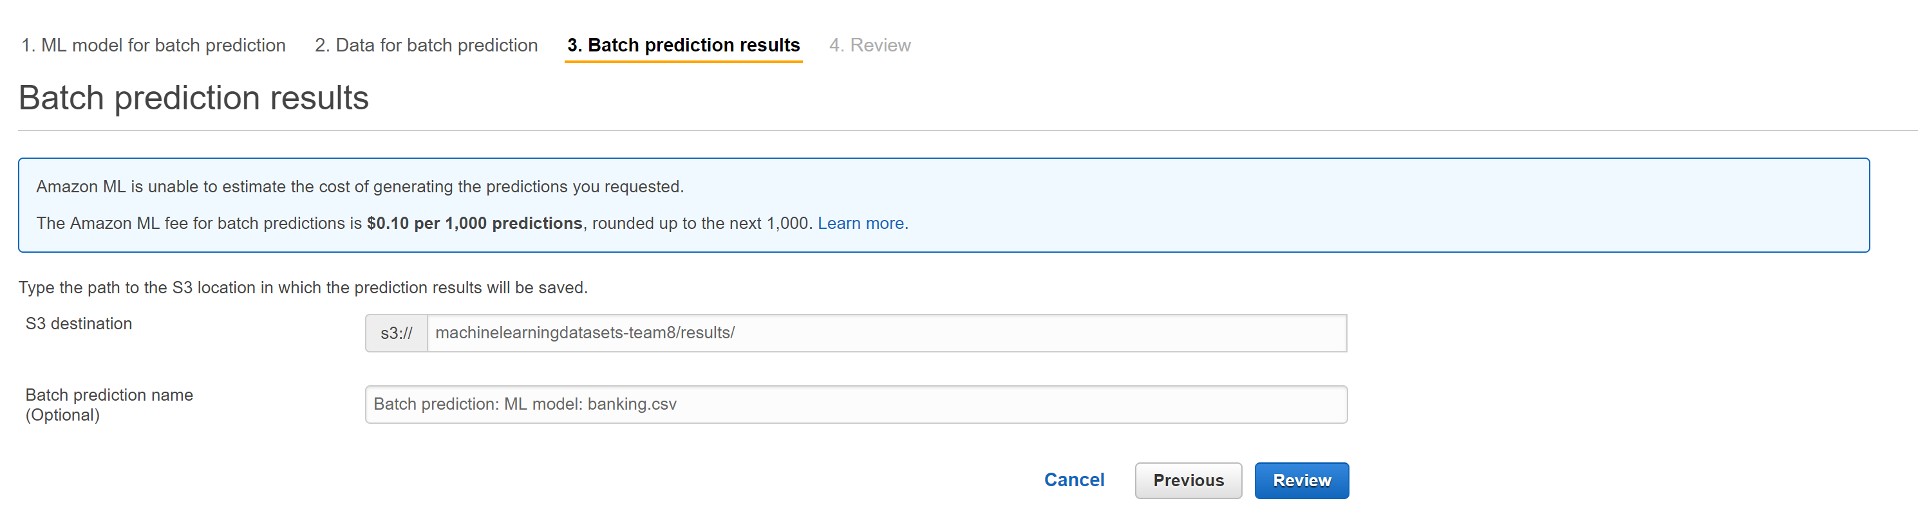

The following prompt appears for which you click on “**Yes**”.

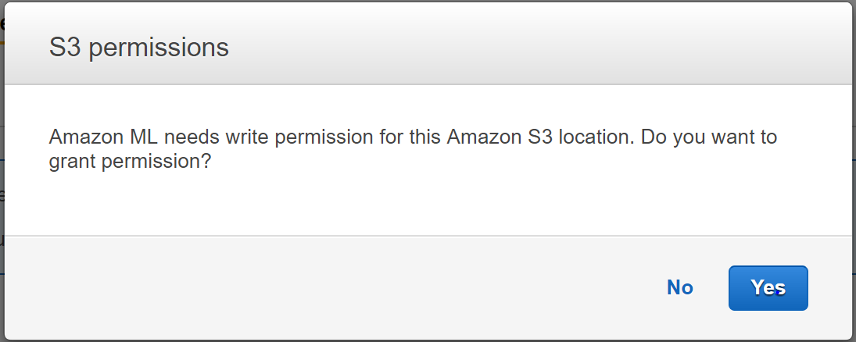

On the **Review** page, choose **Finish**.

The batch prediction request is sent to Amazon ML and entered into a queue. The time it takes Amazon ML to process a batch prediction depends on the size of your datasource and the complexity of your ML model. While Amazon ML processes the request, it reports a status of **In Progress**. After the batch prediction has completed, the request's status changes to **Completed**. Now, you can view the results.

The batch-prediction summary shows “**In progress**” in the figure below.

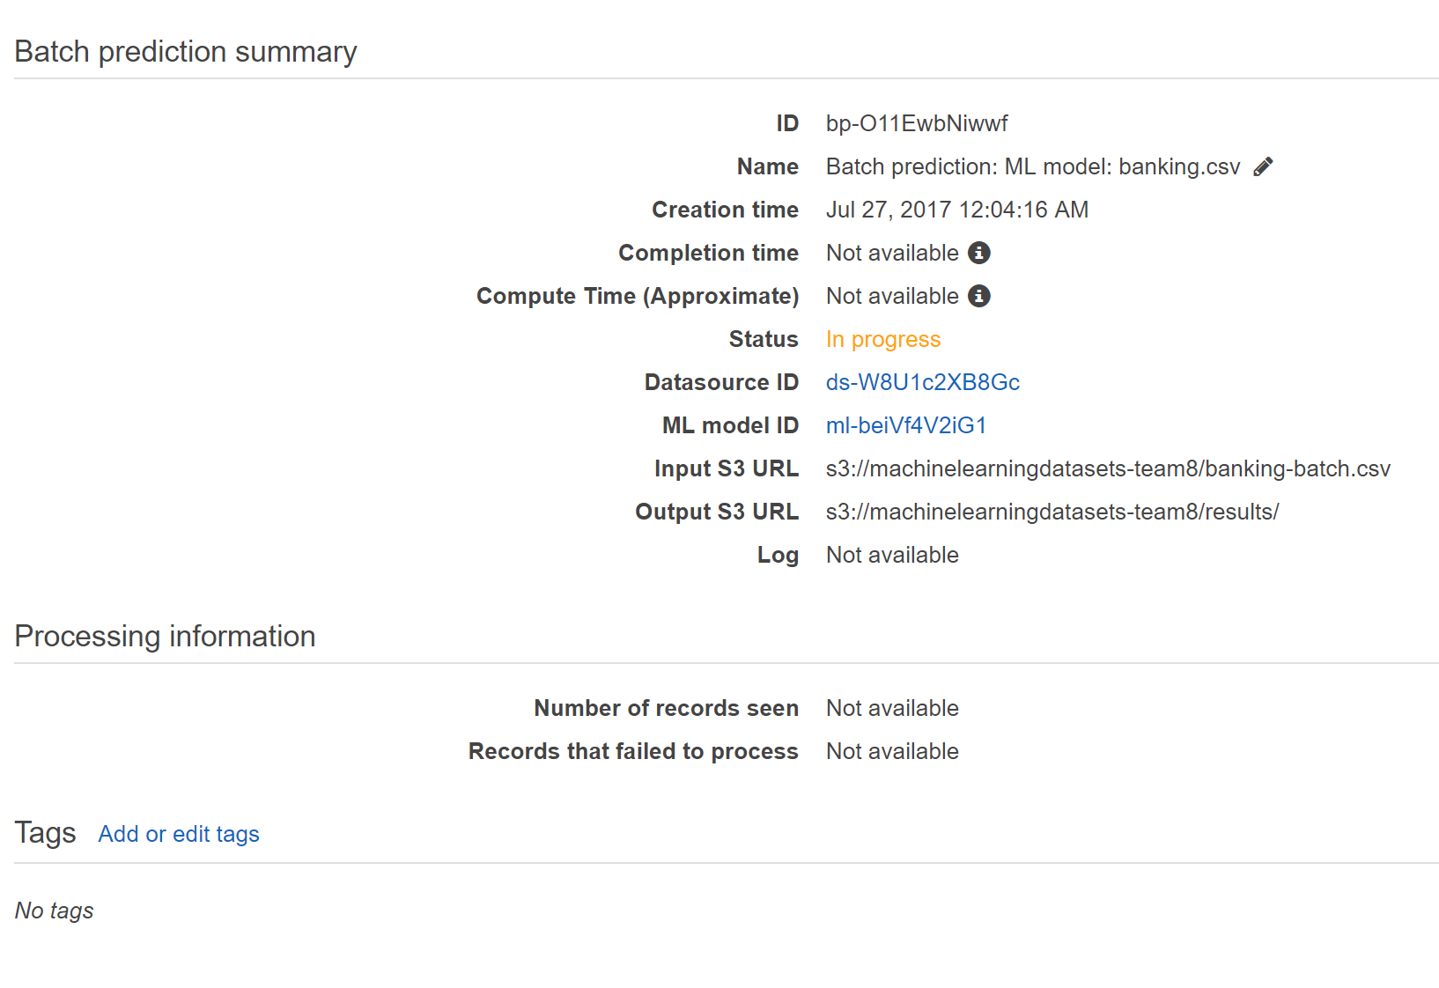

On completion of prediction, the status changes to “Completed”.

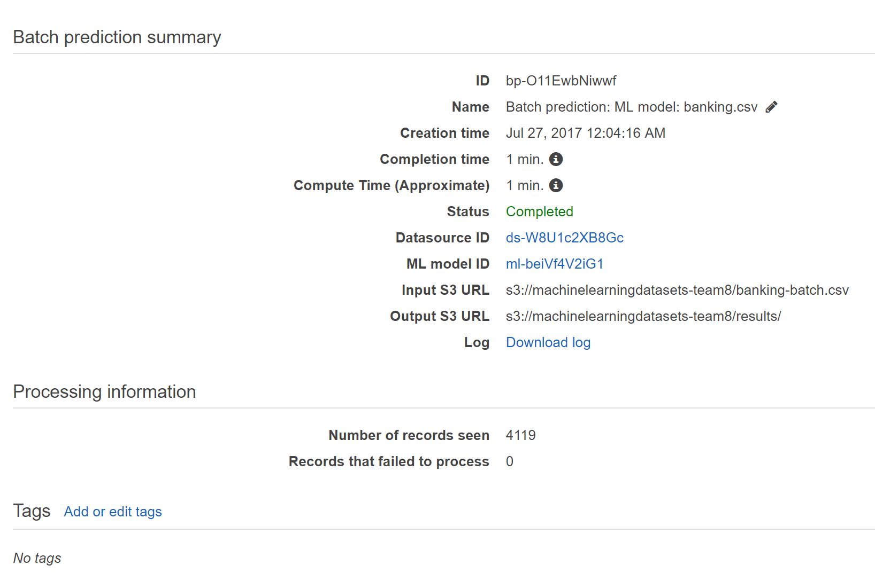

The following is the log record for the same :

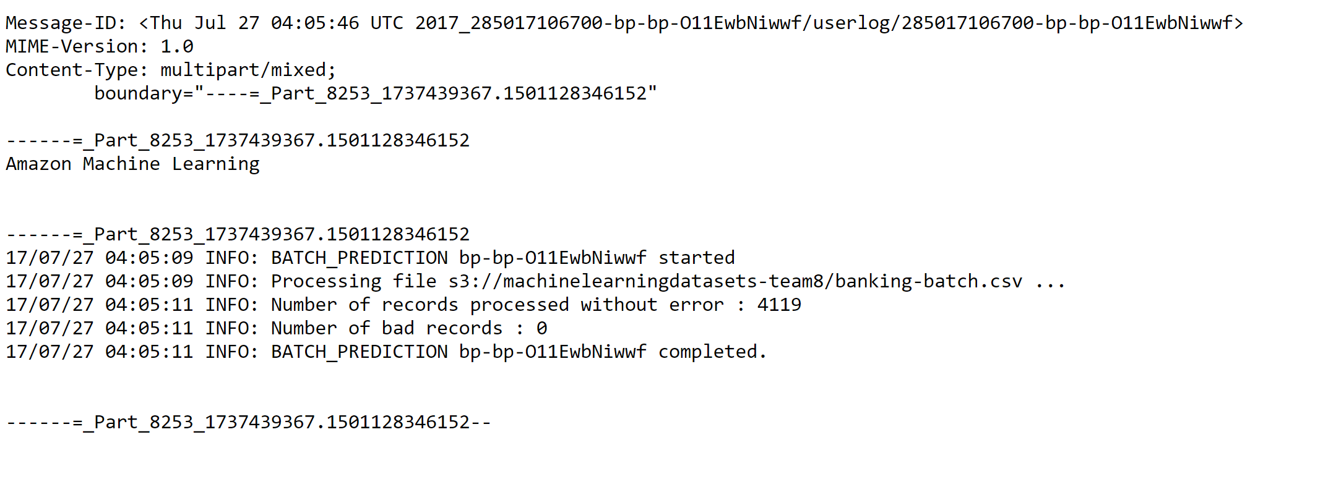

To view the results of the batch prediction, go to the Amazon S3 console at <https://console.aws.amazon.com/s3/> and navigate to the Amazon S3 location referenced in the **Output S3 URL** field. From there, navigate to the results folder, which will have a name similar to s3:// machinelearningdatasets-team8/results.

The prediction is stored in a compressed .gzip file with the .gz extension.

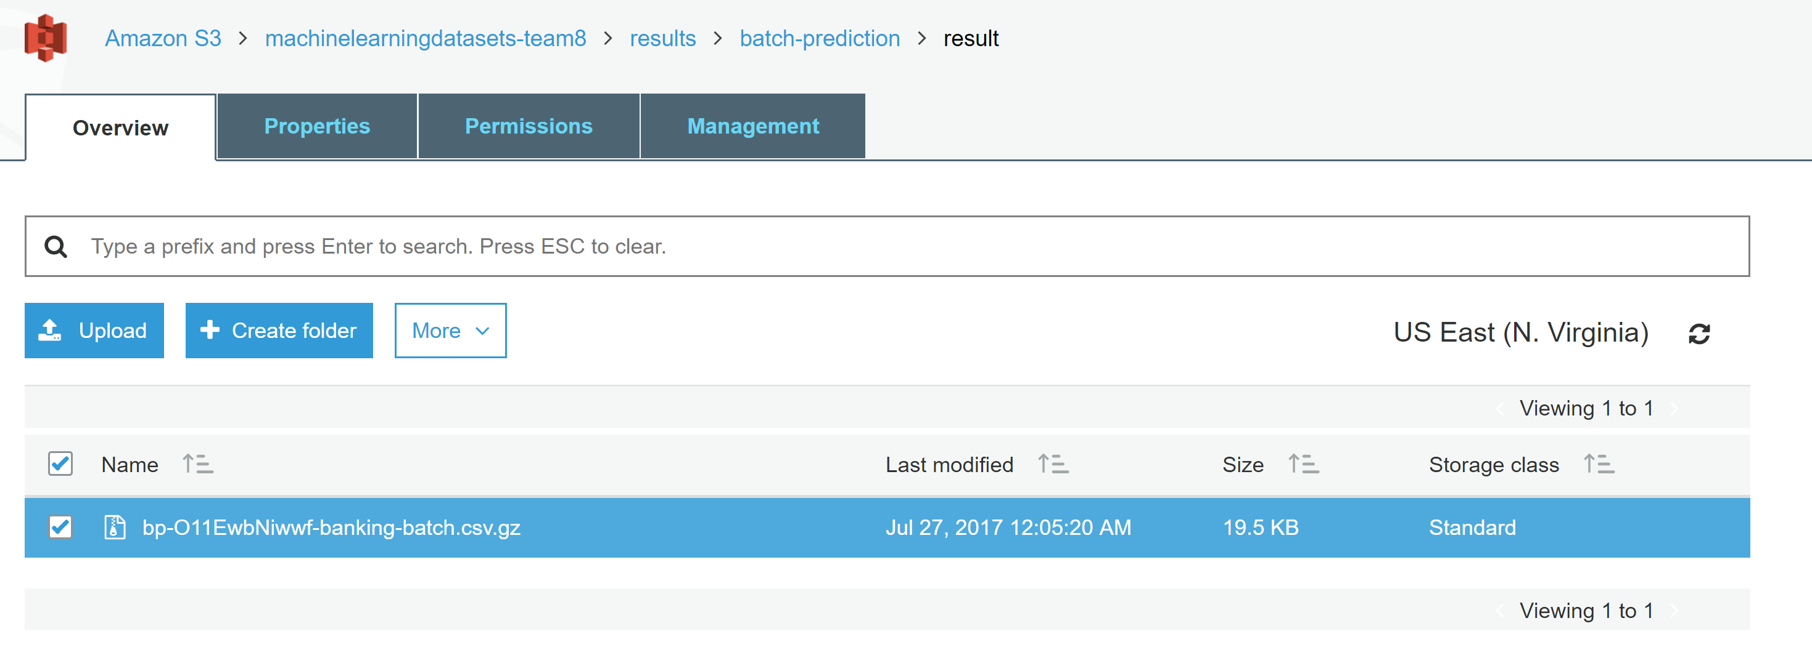

Download the prediction file to your desktop, uncompress it, and open it.

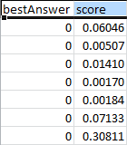

The file has two columns, **bestAnswer** and **score**, and a row for each observation in your datasource. The results in the **bestAnswer** column are based on the score threshold of 0.77 that you set in Step 4: Review the ML Model's Predictive Performance and Set a Score Threshold. A **score** greater than 0.77 results in a **bestAnswer** of 1, which is a positive response or prediction, and a **score** less than 0.77 results in a **bestAnswer** of 0, which is a negative response or prediction.

The following examples show positive and negative predictions based on the score threshold of 0.77.

Positive prediction:

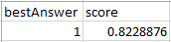

In this example, the value for **bestAnswer** is 1, and the value of **score** is 0.8228876. The value for **bestAnswer** is 1 because the **score** is greater than the score threshold of 0.77. A **bestAnswer** of 1 indicates that the customer is likely to purchase your product, and is, therefore, considered a positive prediction.

Negative prediction:

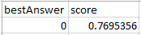

In this example, the value of **bestAnswer** is 0 because the **score** value is 0.7695356, which is less than the score threshold of 0.77. The **bestAnswer** of 0 indicates that the customer is unlikely to purchase your product, and is, therefore, considered a negative prediction.

1. BIG ML as service

It’s a visual Tool and can easily deploy any ML model

You can either import train and test dataset by simply dragging the dataset csv file in bigML or get the inbuilt dataset under sources tab

* 1. Perdition and model Analysis

**Preparing Dataset:**

1. For this we can either import the dataset from local or we can use the inbuilt dataset.
2. For importing the dataset we can simply drag and drop the dataset in sources, but for demo we have used the inbuilt titanic dataset. Given as below with values:

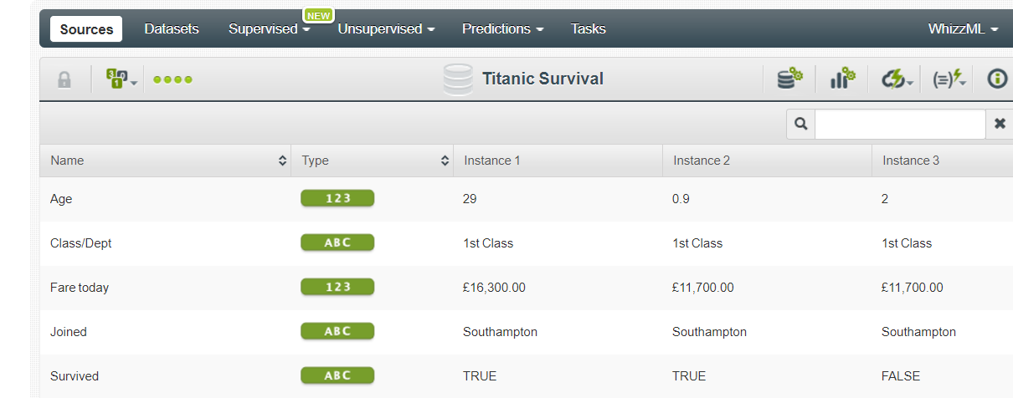

Here in this dataset we can see the pattern who survived or not with their probability for survival.

Can easily see the survival

Add dataset toy your project by clicking on configure button 

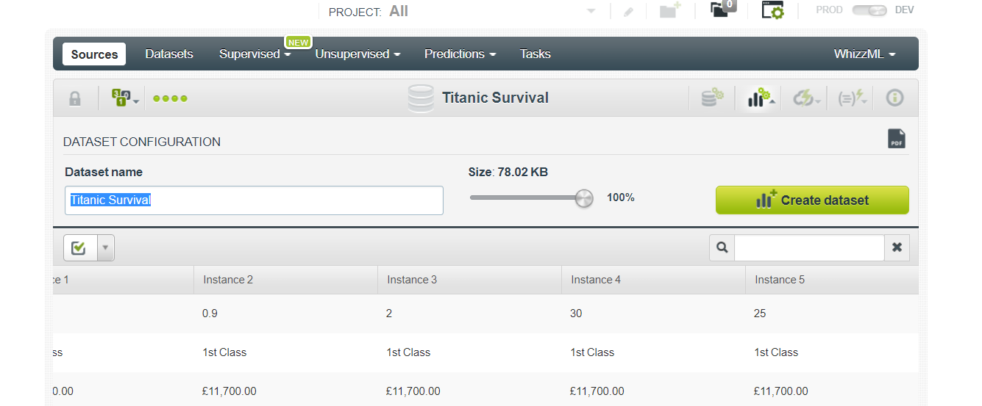

Dataset is added to the Project:

In bigML here is an inbuilt pipeline of the processes from Sources->Datasets->Supervised Models-> Prediction on the model you created. Here we will use the inbuilt Titanic Survival Model:

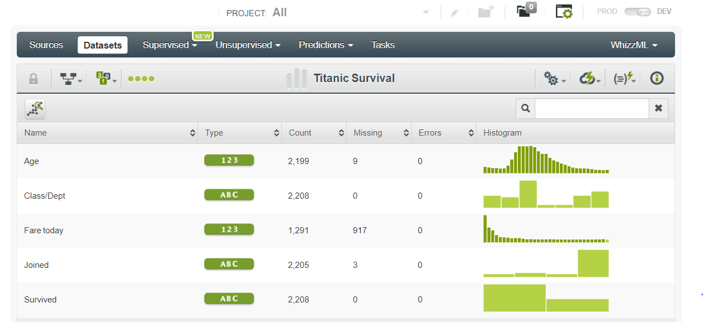

It easily allows to visualize the dataset easily like the age distribution is easily explained using the histogram with the count

For every column it easily helps to analysis of data with parameters as Mean, median or Minimum value.

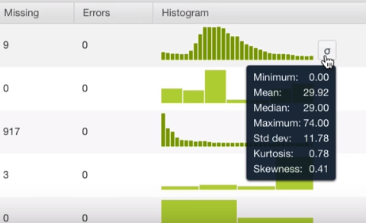

Allows Easy analysis of data:

Now we create the Machine learning model using the Big ML on Titanic data set for this demo we chose

Titanic dataset which is available in its inbuilt dataset library, here maximum age us 74 or minimum us 0.

In class/dept you can see the count for class 1, 2, 3etc from the dataset



So With big ML we can easily do the EDA and visualization on the dataset and can handle the missing value and outliers faster.

* 1. Perdition and model Analysis
     1. For Prediction:
* For the machine learning algorithm we can use decision tree for prediction for the survival on the dataset
* By using one click predition option it evaluates the whole model using prediction Model
* It figures the model for us here it used the decision tree and draws the patterns using if-then and tells the possibilities of survival

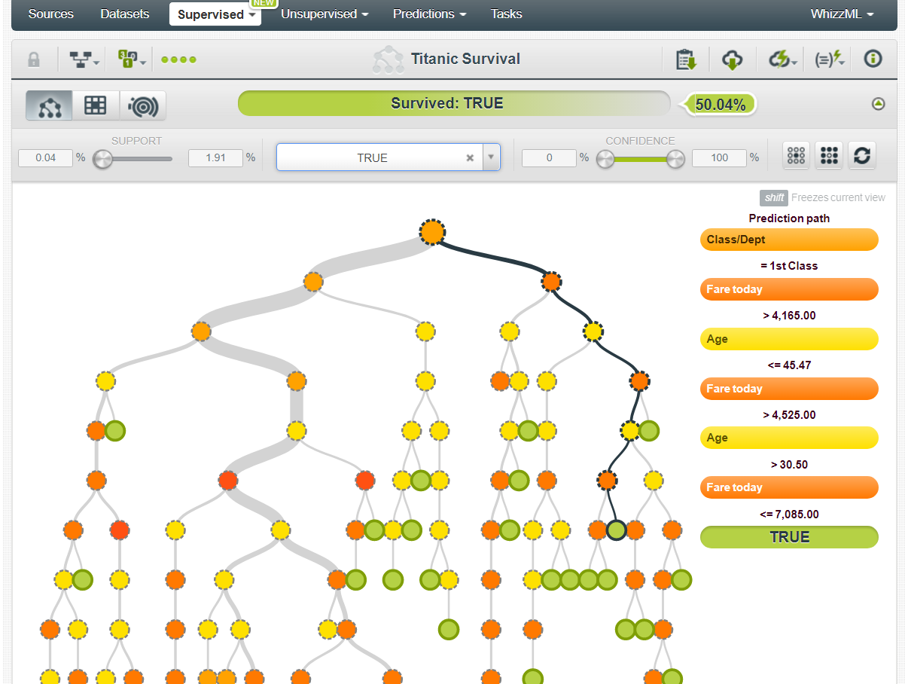

* Those that were in the first but in second class or and tells the survived with the confidence level and categories and you an use reset button.
* It provides the various patterns whether it can predict the value of the survival probabilities.

Here in this you can break any pattern for analysis:

1. 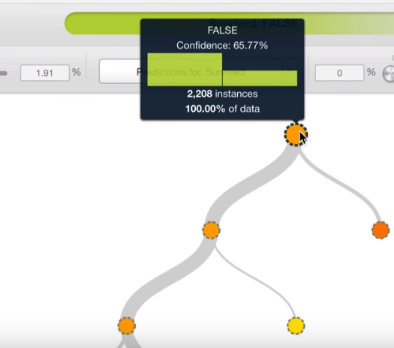 Here it is the class department.
2. 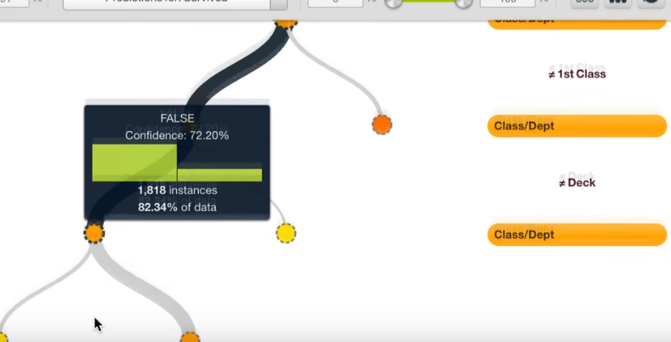 Those were not in first(that) class but in second class
3. 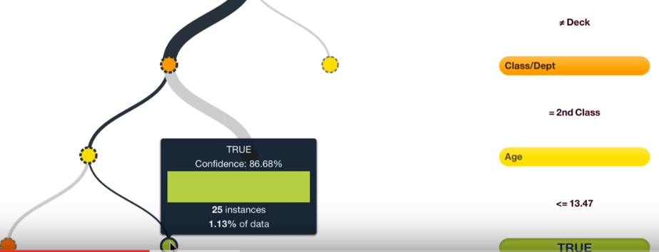

* **Here in this 86.6% of the confidence level shows they are going to survive male with 25 instances people in this category who survived**

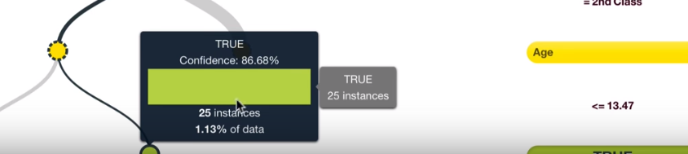

We can also get the model sumary report

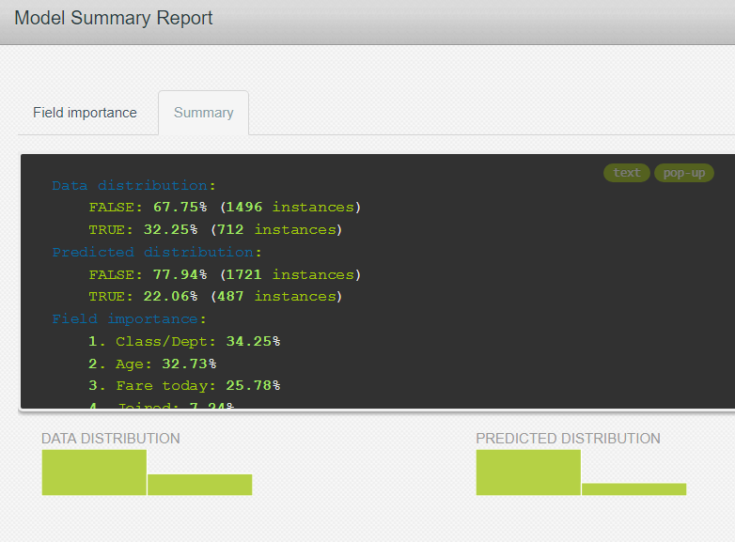 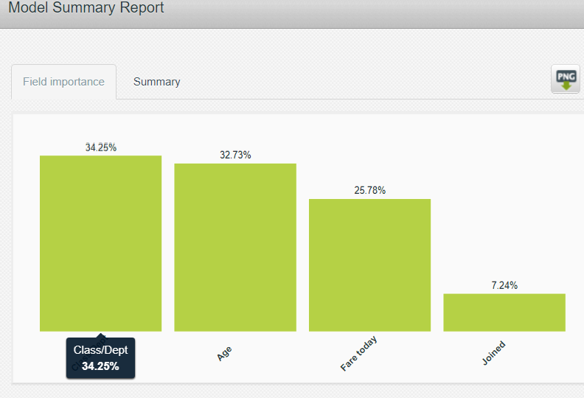

here we can see the class is the most importance and clearly class and age is most important in this model as first class people have more access to survival resources and people with younger age will have more probabilities of survival as well.

* + 1. For Evaluation

**Step 1.** We can also check the evaluation of the model

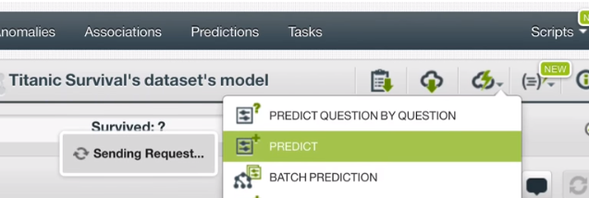

**Step 2:** Predictive analysis : People in First class with age 36 who joined at Belfast with fare 24719 will survive with 52.30% confidence level according to this model.

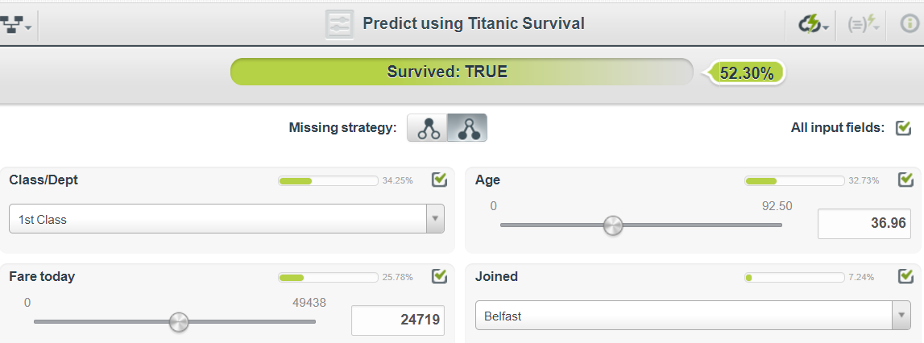

**Step 3:** Similarly by changing the values we can check if the person will be able to survive or not based on the trained model.

**Step 4:** We can also use the Test data set for prediction

By simply adding test dataset to sources and then using the batch prediction on test we can run the trained model on test dataset

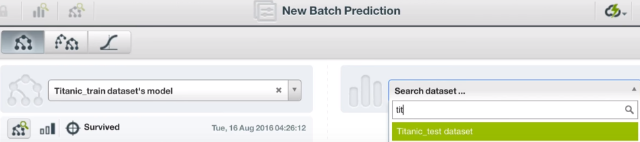

**Step 5:** We can see the predicted values on test dataset

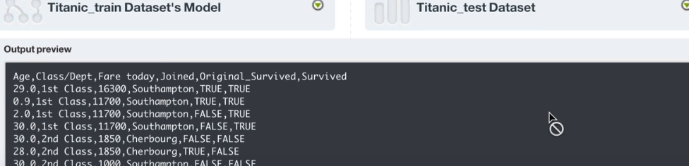

Here we can see how well the model worked on the testing dataset by simply checking the True and False values.

1. H2O ML as Service

Dataset Used:

Prostate Dataset: <https://s3.amazonaws.com/machinelearningdatasets-team8/prostate.csv> is the link to download the dataset.

To install H2O, go to the link <https://www.h2o.ai/download/> and download the version suitable for your PC.

To use it directly in python , click on the python installation tab as shown below :

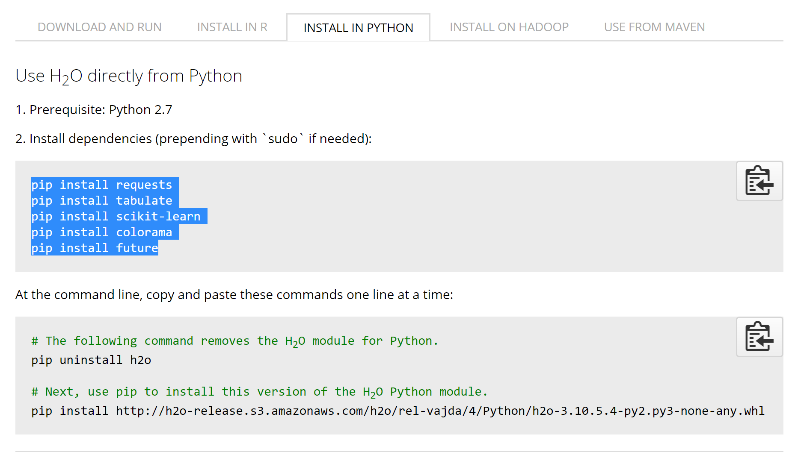

For a windows system, this is how the installation would look on the command prompt.

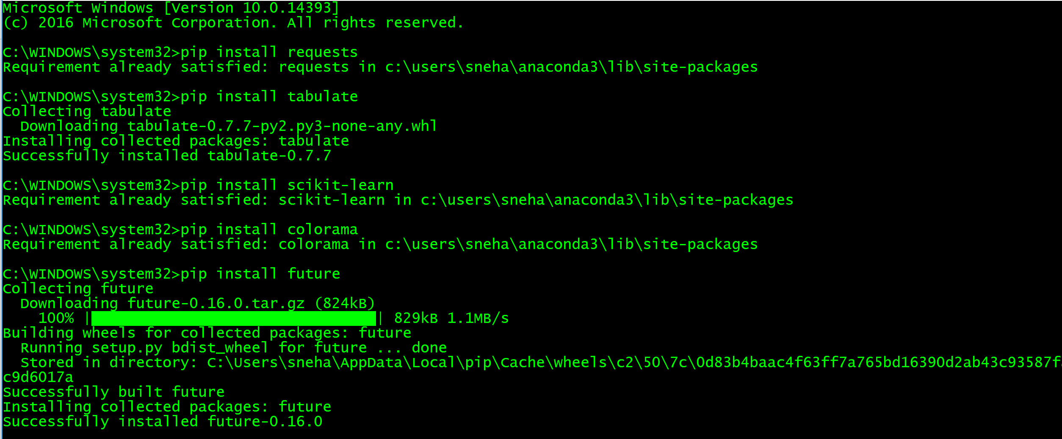

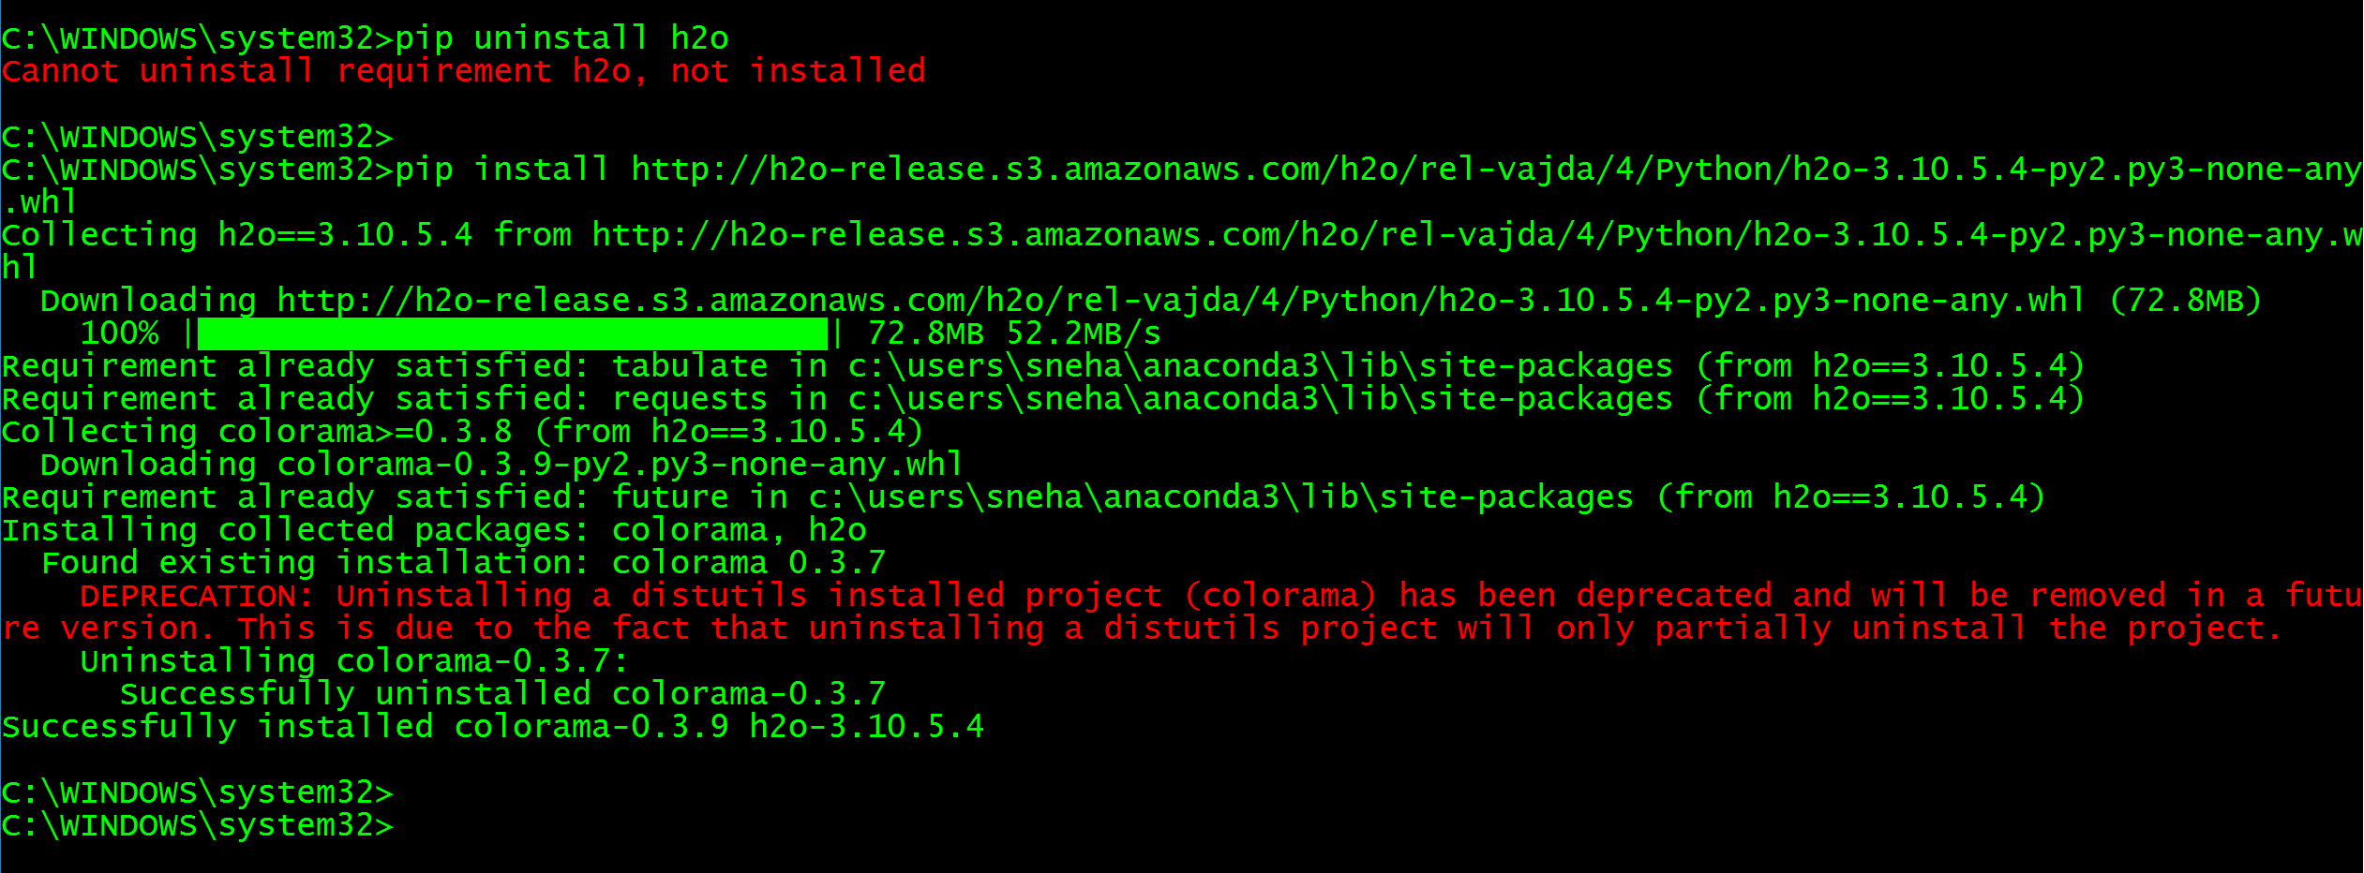

On successful download of H2O, we need to type **java -jar h2o.jar** in the directory named h20-3.10.5.4, in the downloads folder, on the command prompt

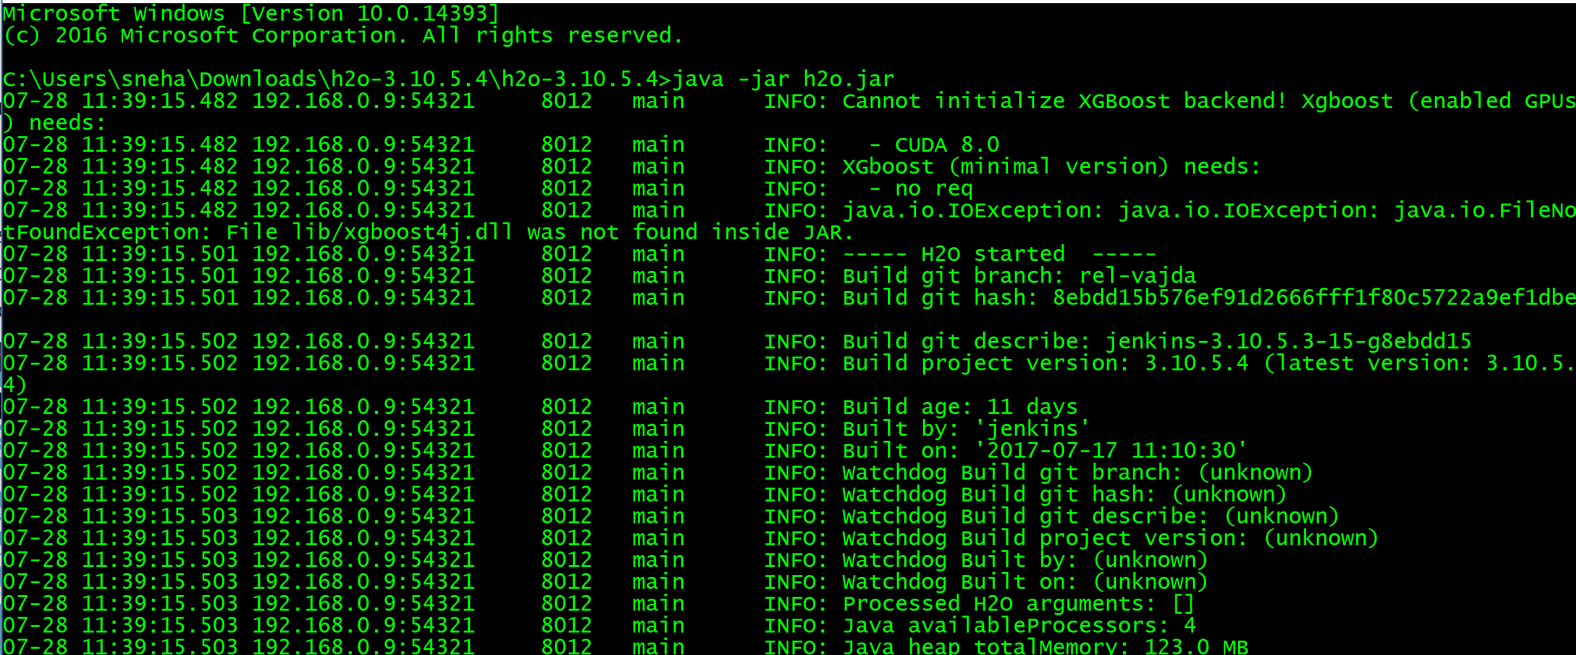

After the above steps open Jupyter Notebook and import h2o and check the connection a follows :

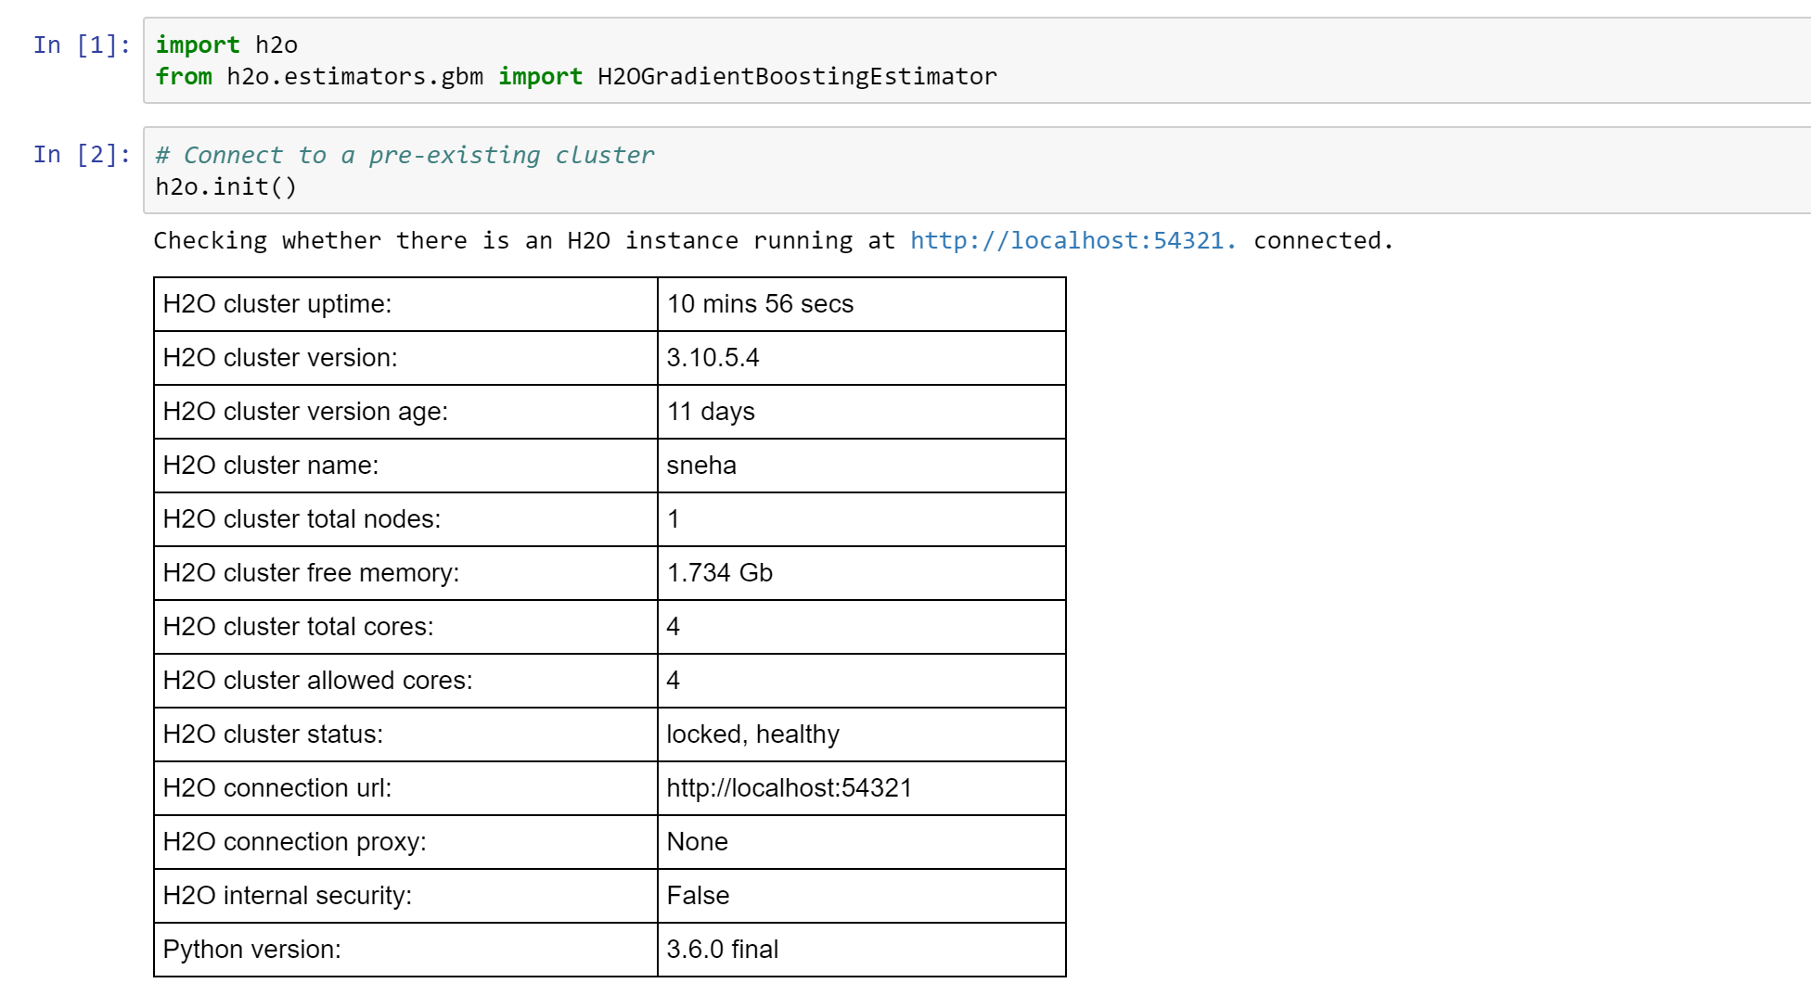

Import the file and check it.

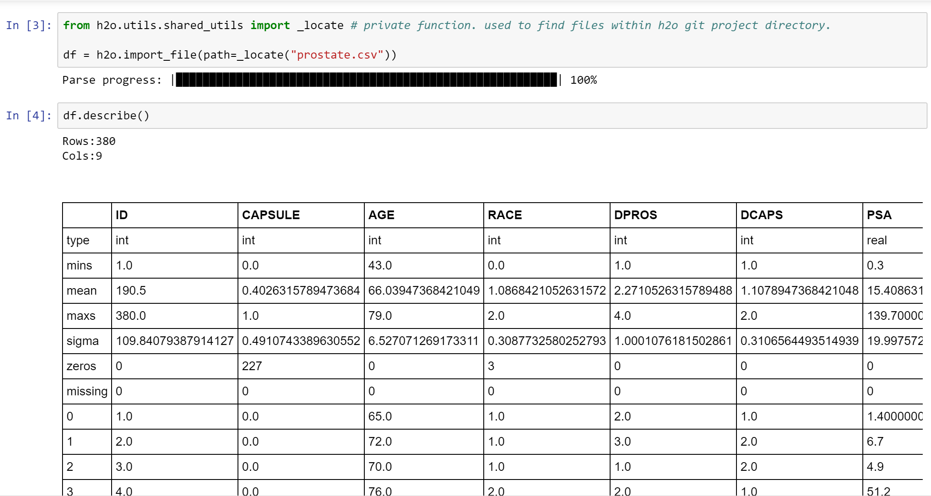

On distributing data and using it for training and testing purposes, this is the final errors and matrices report using H2O as below:

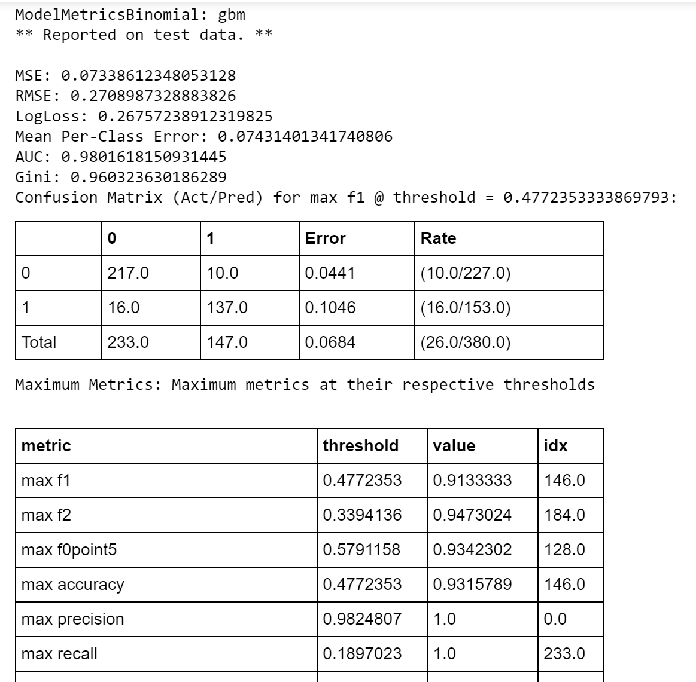

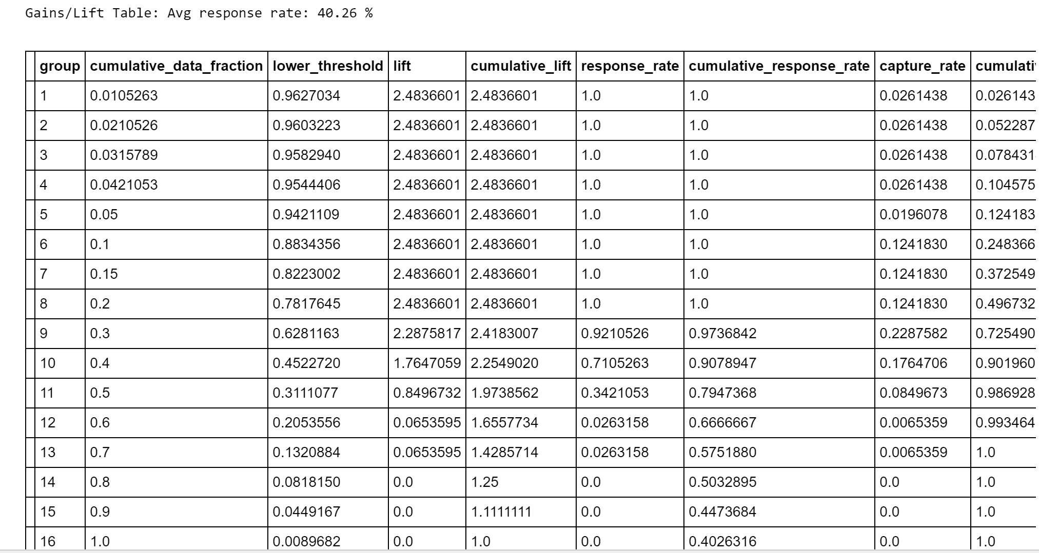

The above code gives us an example of running machine learning in python using H2O.

In the code above we use Gradient Boosting:

### **Gradient Boosting Machine :** (GBM)

Gradient Boosting Machine (for Regression and Classification) is a forward learning ensemble method. The guiding heuristic is that good predictive results can be obtained through increasingly refined approximations. H2O’s GBM sequentially builds regression trees on all the features of the dataset in a fully distributed way - each tree is built in parallel.

We can also perform gradient boosting with H2O and Anaconda. [Gradient boosting](https://en.wikipedia.org/wiki/Gradient_boosting) is an ensemble machine learning technique (commonly used in conjunction with decision trees) that can perform regression and classification tasks on a data set.

In this example, we’ll use the supervised gradient boosting algorithm in H2O on a cleaned version of the Prostate Cancer data from the previous deep learning example.

First, we’ll import and run the gradient boosting estimator from H2O on the Prostate Cancer data:

|  |
| --- |
| >>> from h2o.estimators.gbm import H2OGradientBoostingEstimator  >>> my_gbm = H2OGradientBoostingEstimator(distribution = "bernoulli", ntrees=50, learn_rate=0.1)  >>> my_gbm.train(x=list(range(1,train.ncol)), y="CAPSULE", training_frame=train, validation_frame=train)    gbm Model Build progress: |███████████████████████████████████████████████| 100% |

After we’ve trained the gradient boosting model, we can view the resulting model performance metrics:

|  |
| --- |
| >>> my_gbm_metrics = my_gbm.model_performance(train)  >>> my_gbm_metrics.show()    ModelMetricsBinomial: gbm  ** Reported on test data. **    MSE: 0.07338612348053128  RMSE: 0.2708987328883826  LogLoss: 0.26757238912319825  Mean Per-Class Error: 0.07431401341740806  AUC: 0.9801618150931445  Gini: 0.960323630186289  Confusion Matrix (Act/Pred) for max f1 @ threshold = 0.4772353333869793: |

## [**h2o-machine-learning-4a.png**](https://www.continuum.io/files/h2o-machine-learning-4apng)

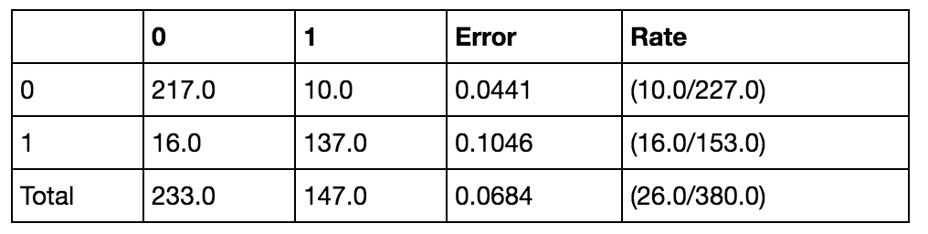

1. IBM Watson ML as Service
   1. Architecture

IBM Data Science Experience (DSX) provides you with the environment and tools to solve your business problems by collaboratively analyzing data. This illustration shows how the architecture of DSX is centered around the project. A project is how you organize your resources for solving a business problem.

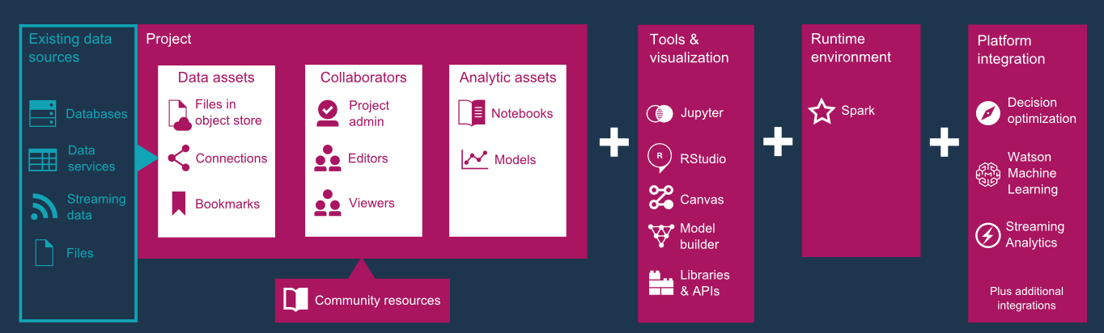

* 1. Data Preperation

The dataset we use here is got from

<https://github.com/pmservice/customer-satisfaction-prediction/blob/master/data/WA_Fn%20UseC_%20Telco%20Customer%20Churn.csv>

**Create new Project :**

To create a new project sign in into IBM Data Science website <https://datascience.ibm.com/>

Click on the **New Project** button

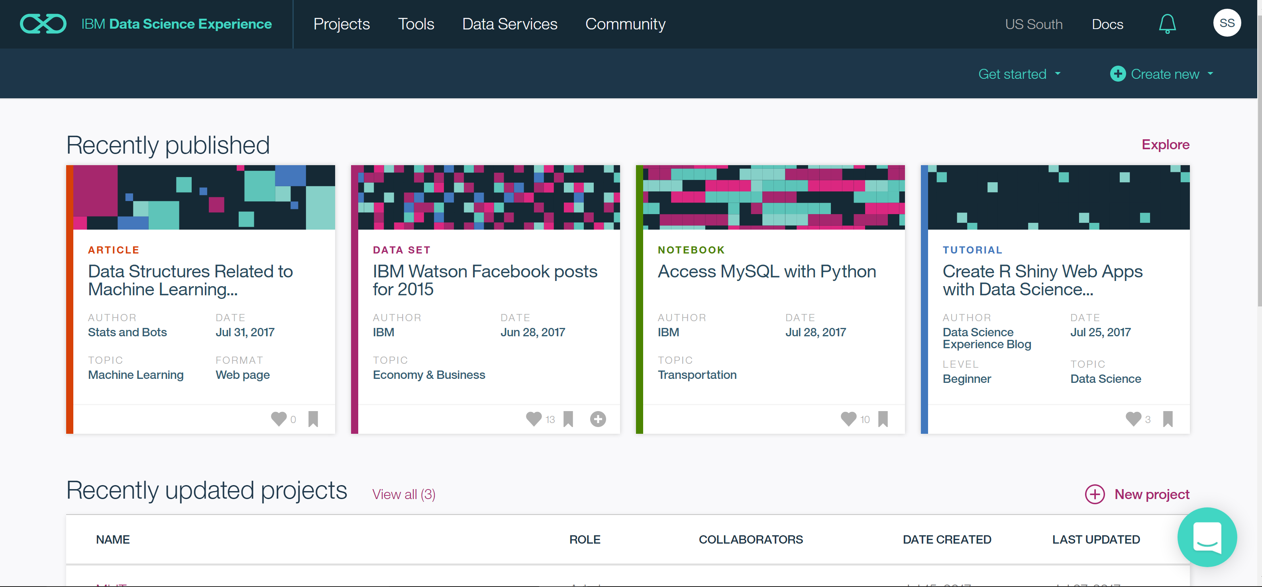

Give a Name and Description to your project and click **Create**

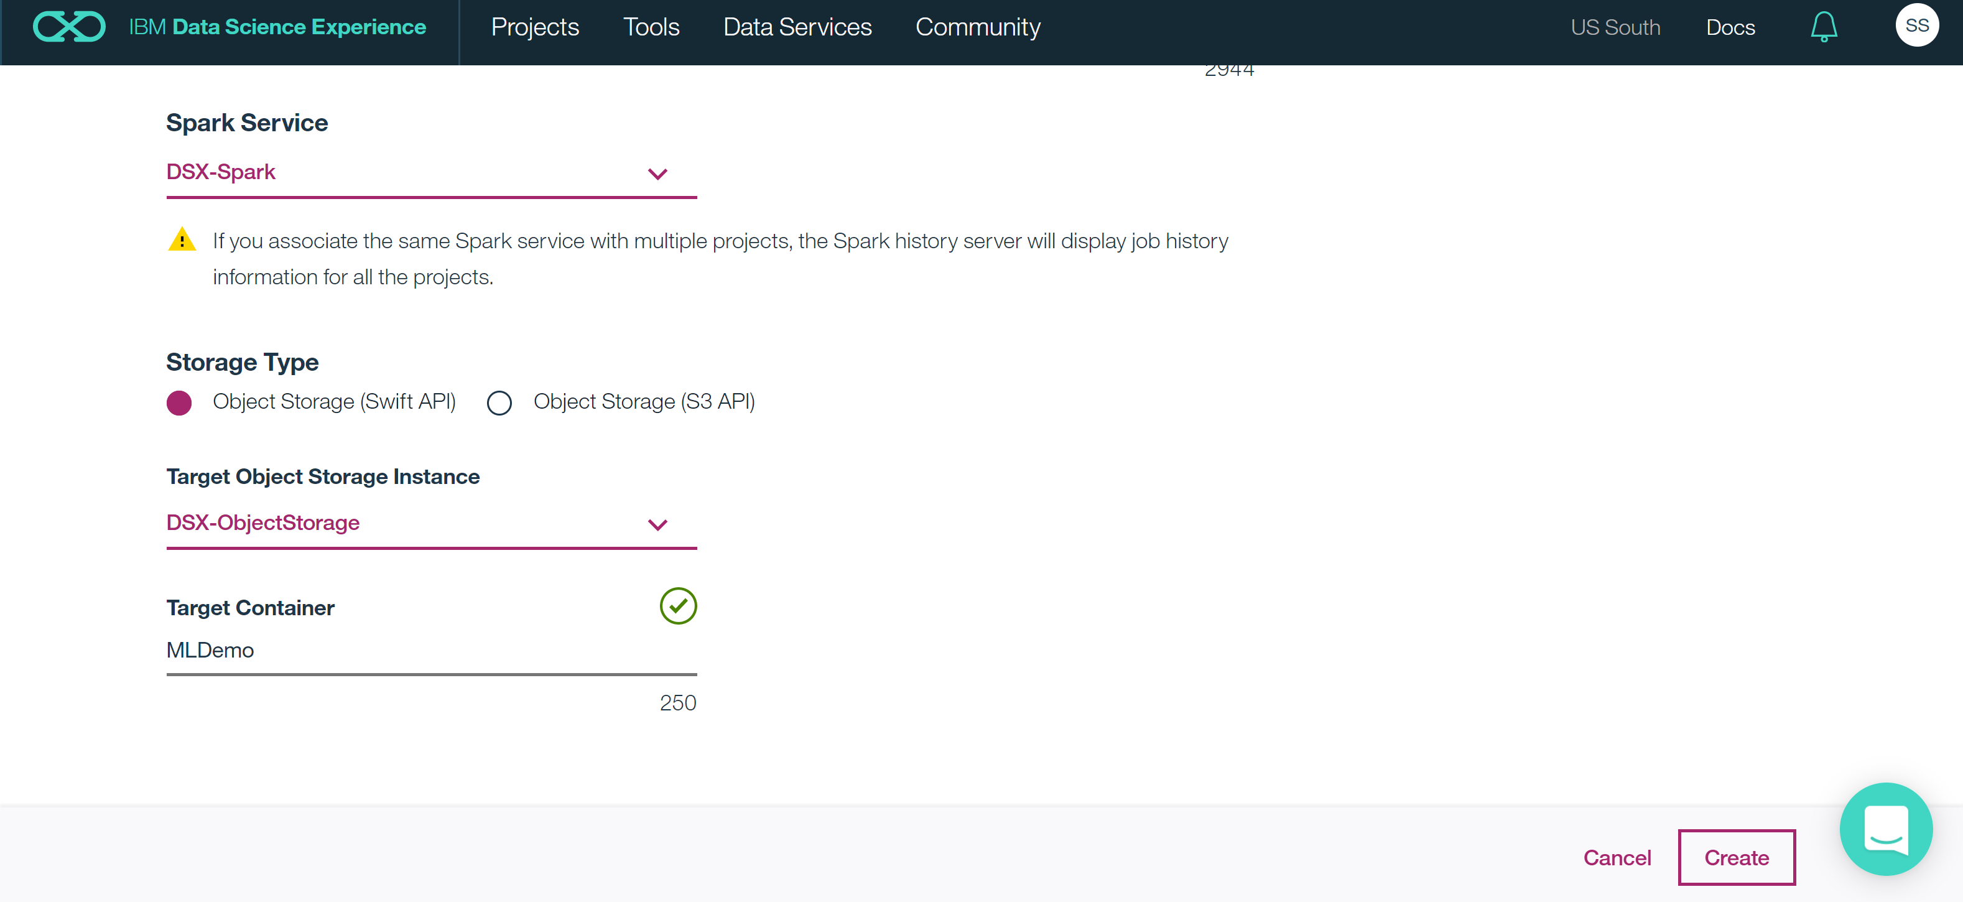

Now in the screen that appears, we can add different objects like data assets, notebooks etc.

**Import Data :**

To add a file to a project: From project’s Data Assets page, click the Find and Add Data icon  on the top right corner of the screen . Browse for the file or drag it onto the Files pane.

**Create Model:**

Once you get the required file into IBM Watson, you need to click on **Add to project**  and the **Model**.

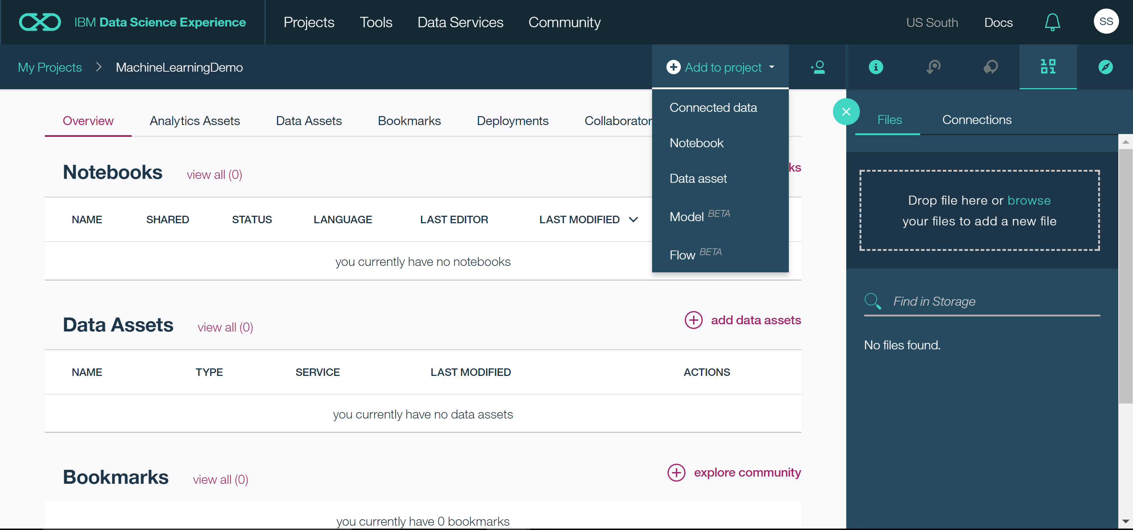

Once you are in the page to create model you will be able to select what model you want to use and whether it should be creating the model to be used on the data, automatically or would you like to manually specify a model.

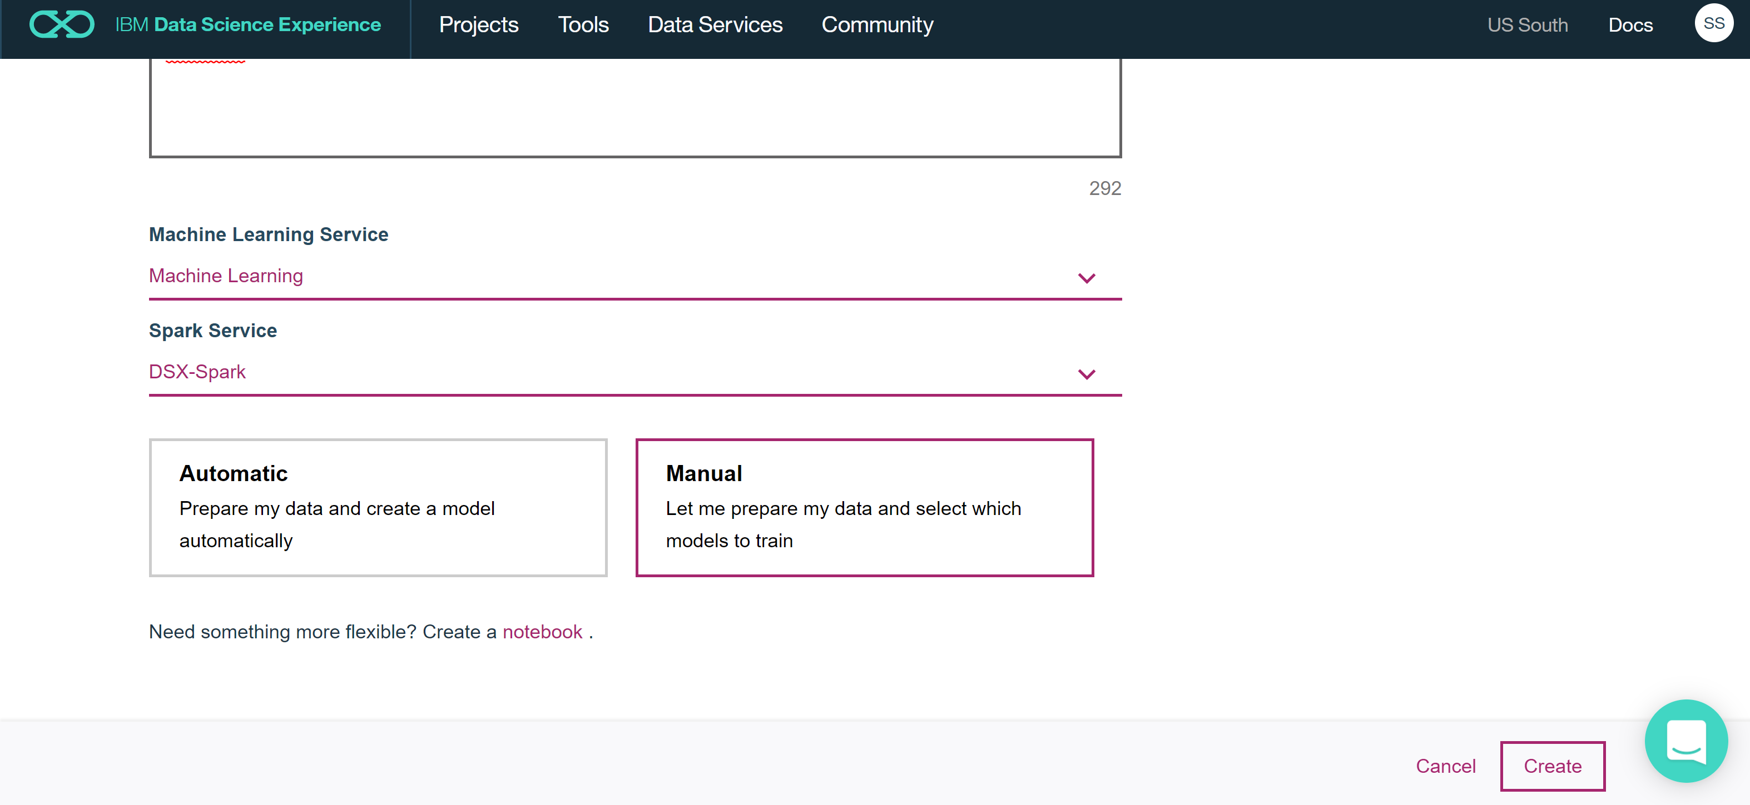

The next step would be to select a dataset from the datasets in Watson, brought in from your local system, on which the model will be trained and tested.

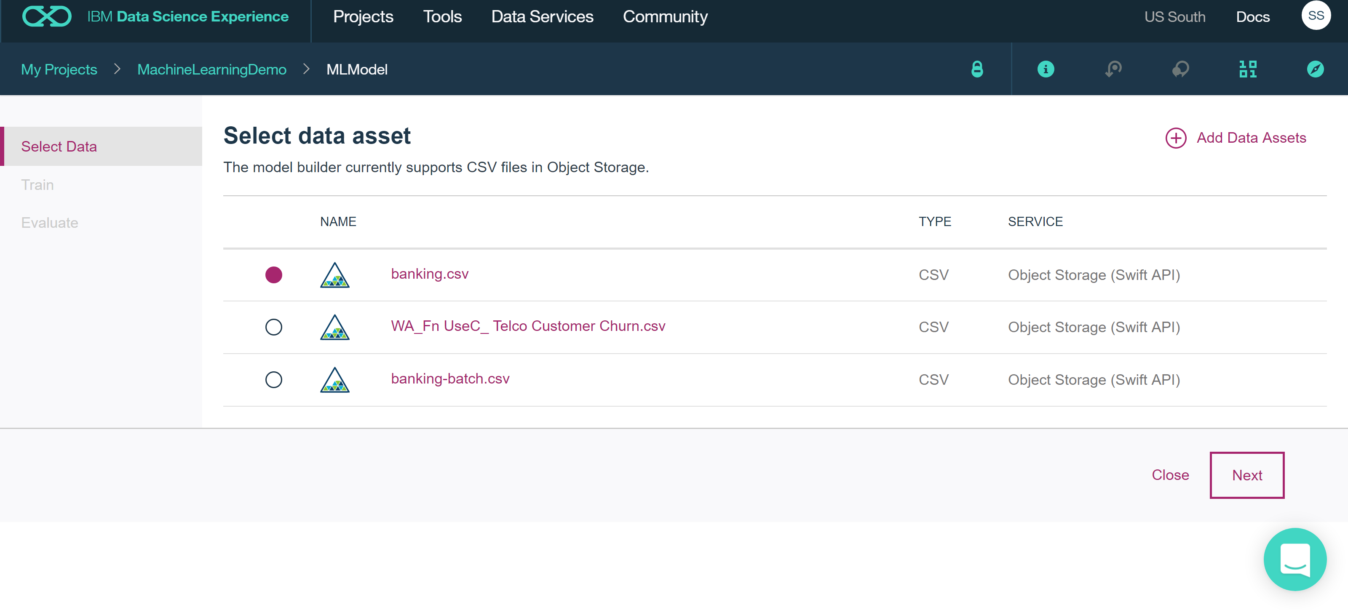

Based on the dataset values you need to choose the Target column on which the prediction is to be made. And the columns on which the prediction depends. The application also makes suggestion based on the kind of data found in the datasets. Here we chose the binary classification since the value in the y column is either 0 or 1 for all records.

* 1. Predition and model Analysis

Here you can also choose by using the slider on the bottom of the page the percentage of data that goes into IBM Watson as train data and test data and a small part of the data will be held for some other use. In the example below, the system has taken a 60% of the total data for training purpose and a 20 percent for testing purpose.

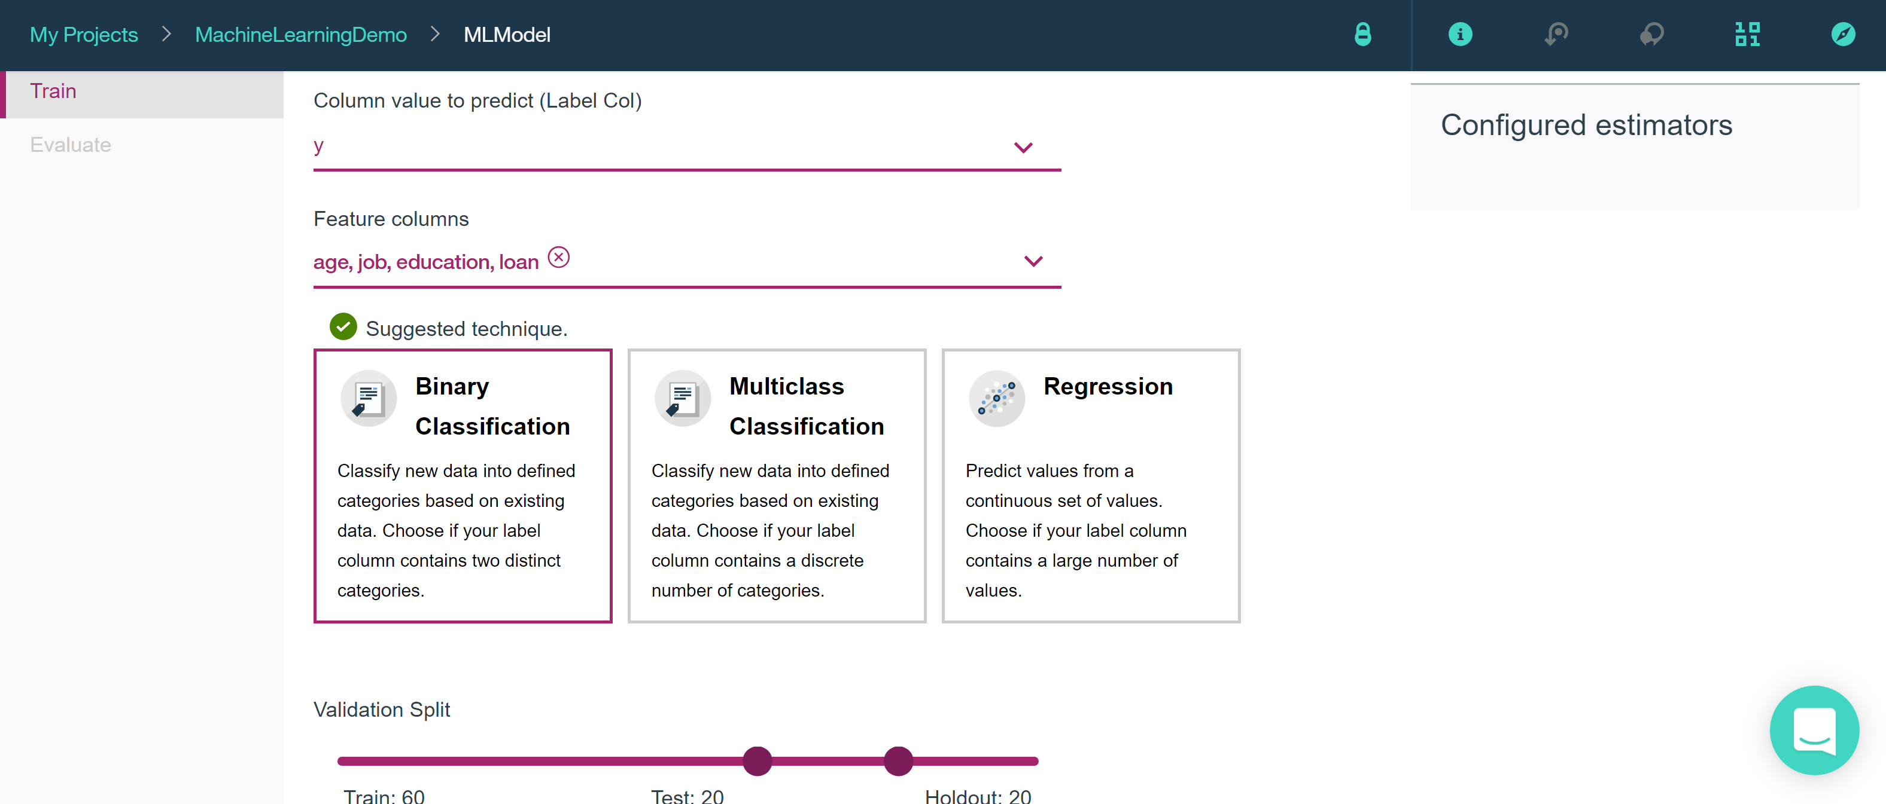

Another feature to select is the estimator. This means the type of regression or classification that will be used in the Machine Learning algorithm. Here we chose **Logistic Regression**

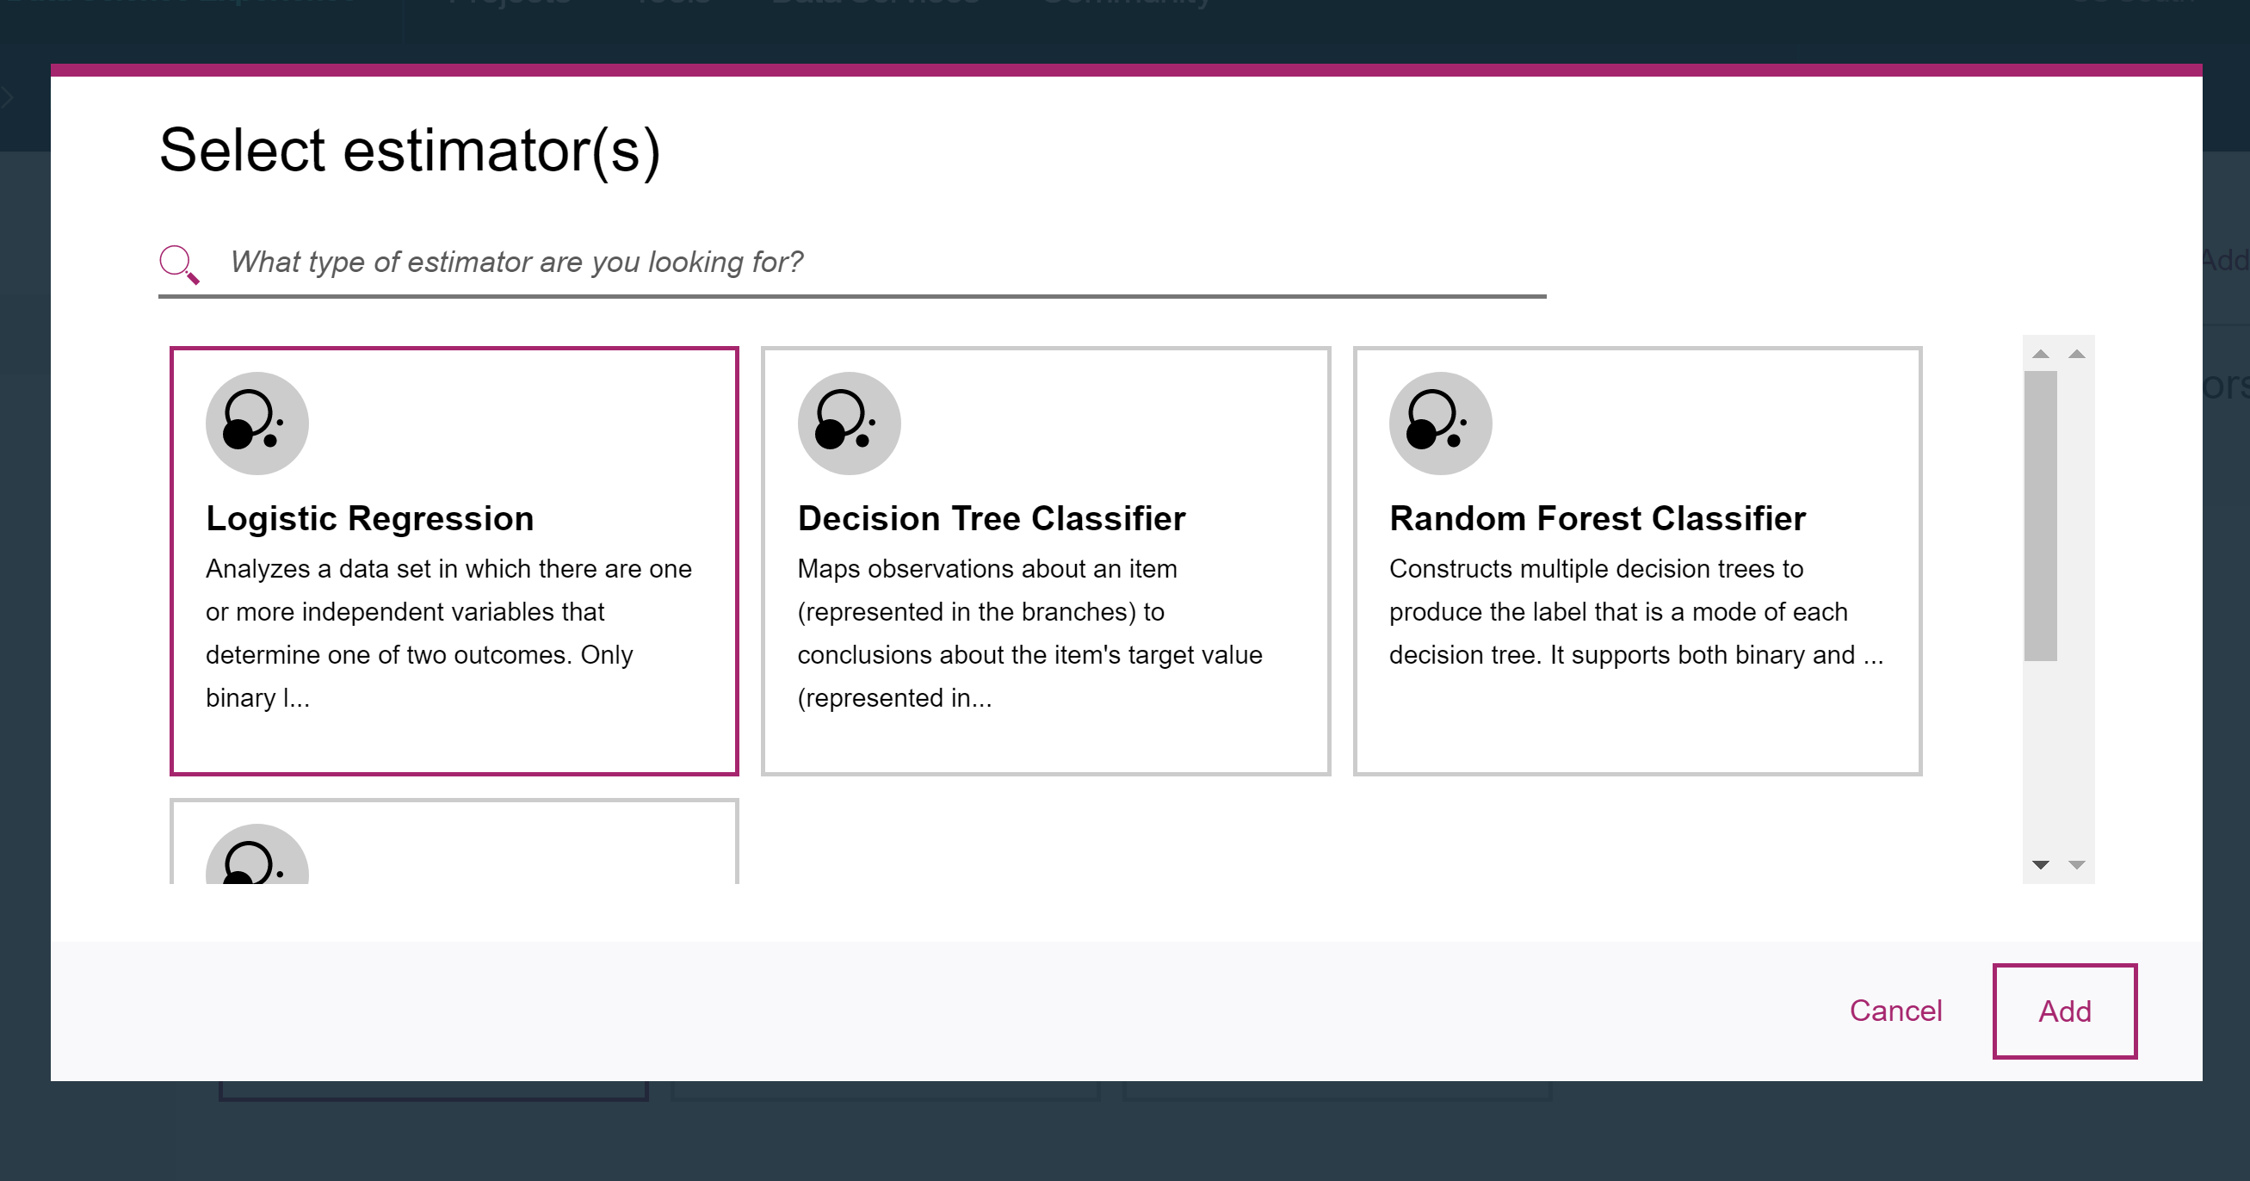

As the status shows, the model takes a few minutes to complete the training and evaluation or testing of the model on the remaining dataset.

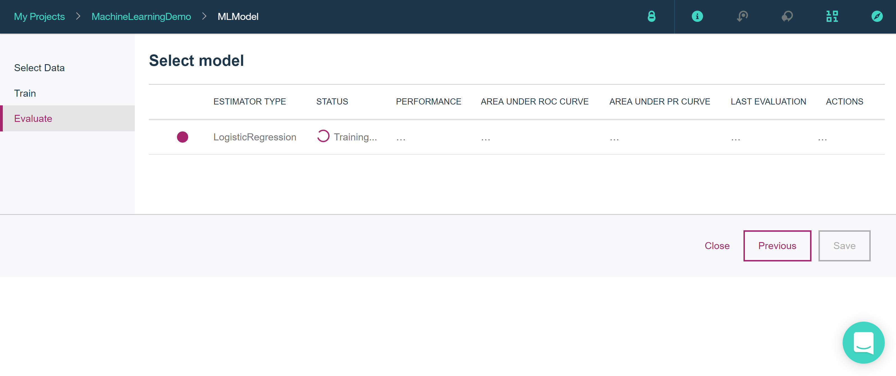

Finally the model is evaluated as poor and the areas under the ROC curve and the PR curve are given.

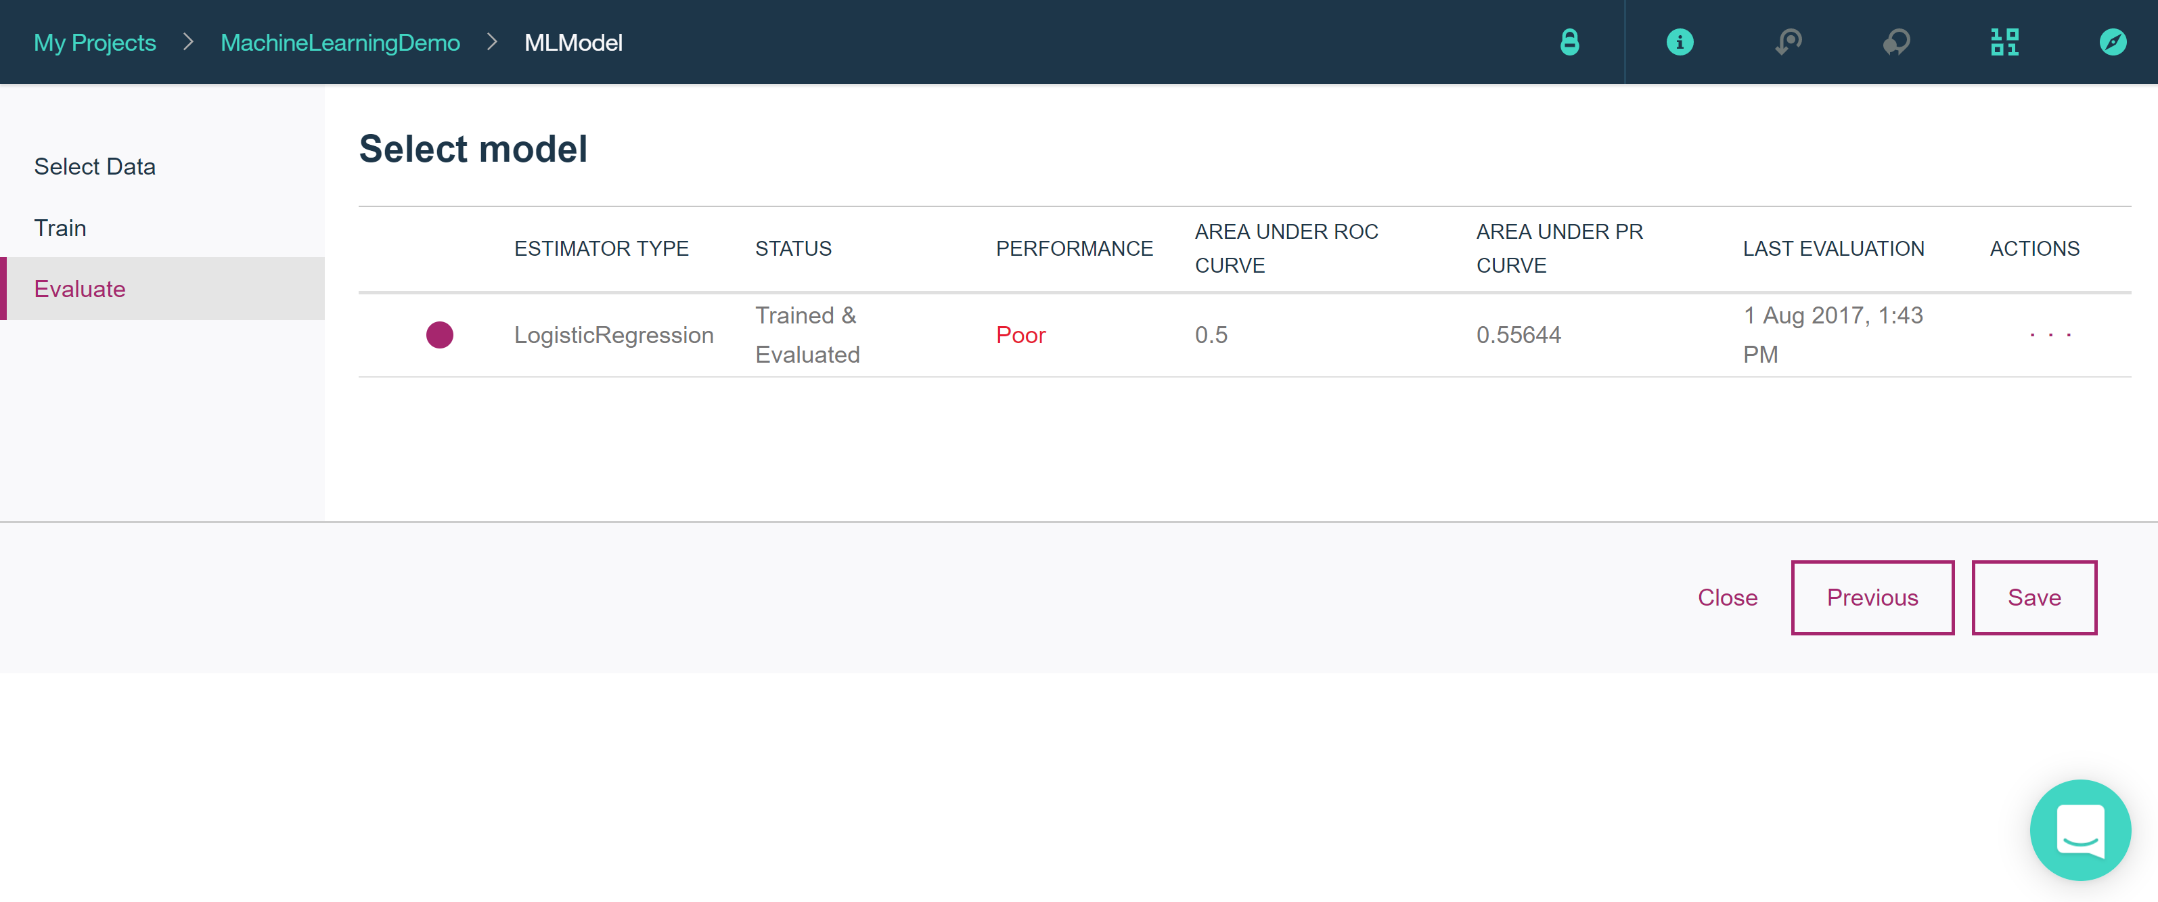

The following figure shows a few system details of the Model used

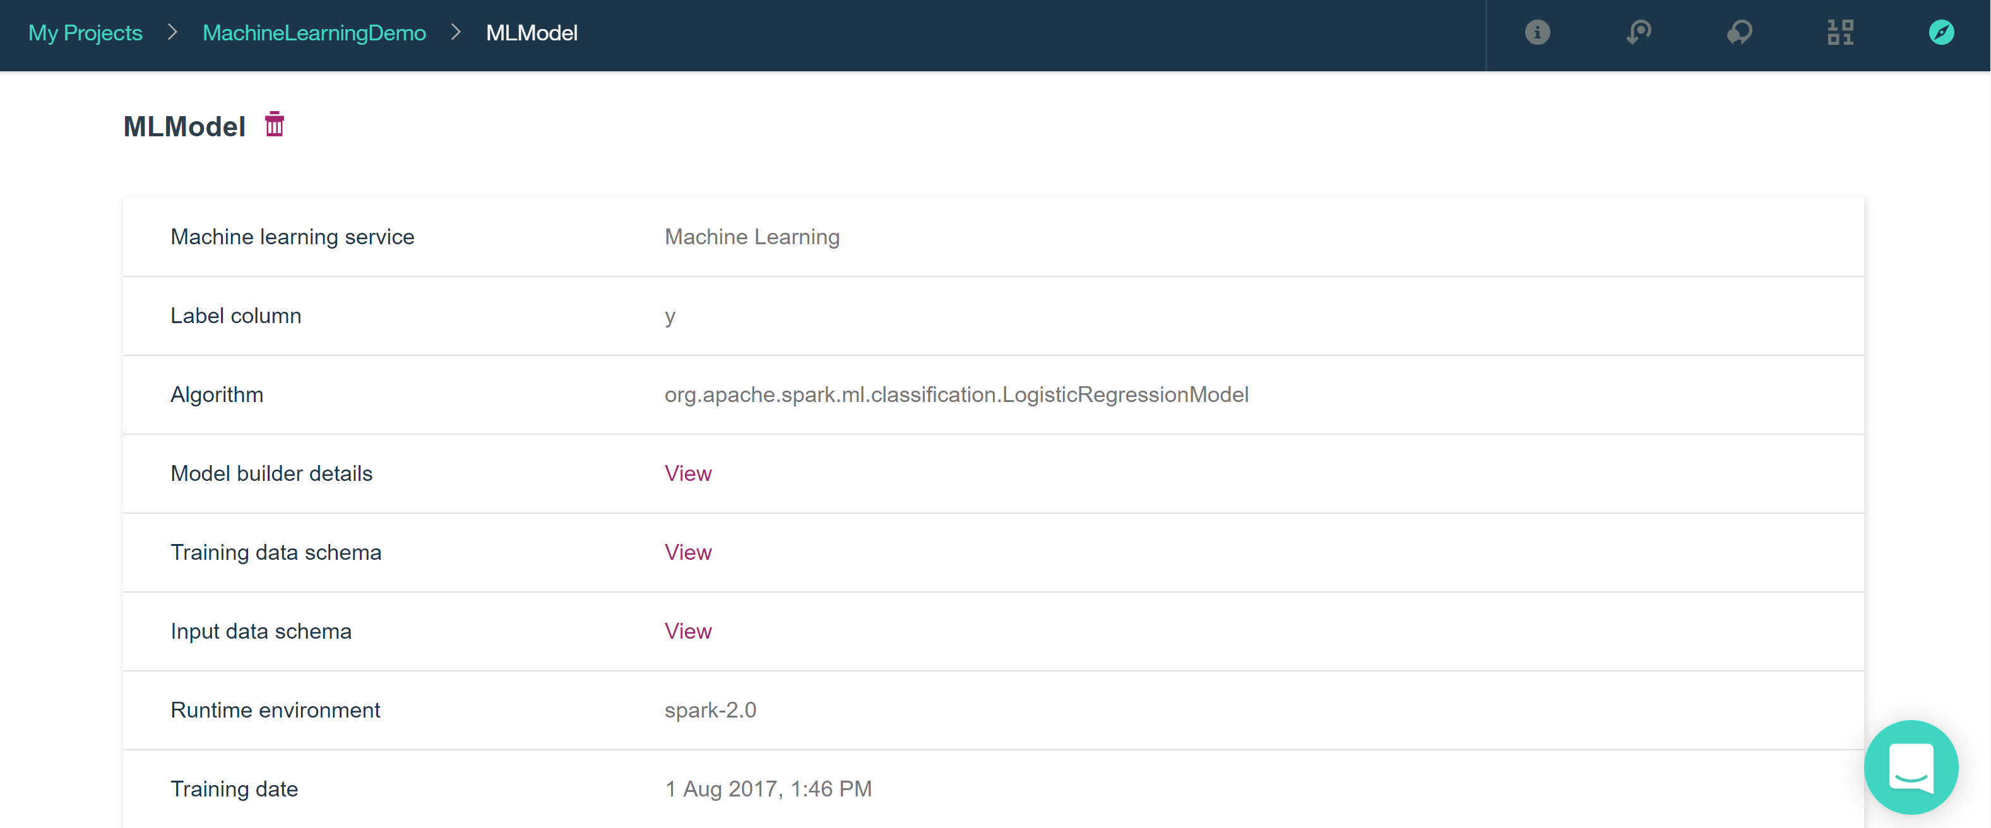

For prediction we need to provide inputs or use the default input to get the following result

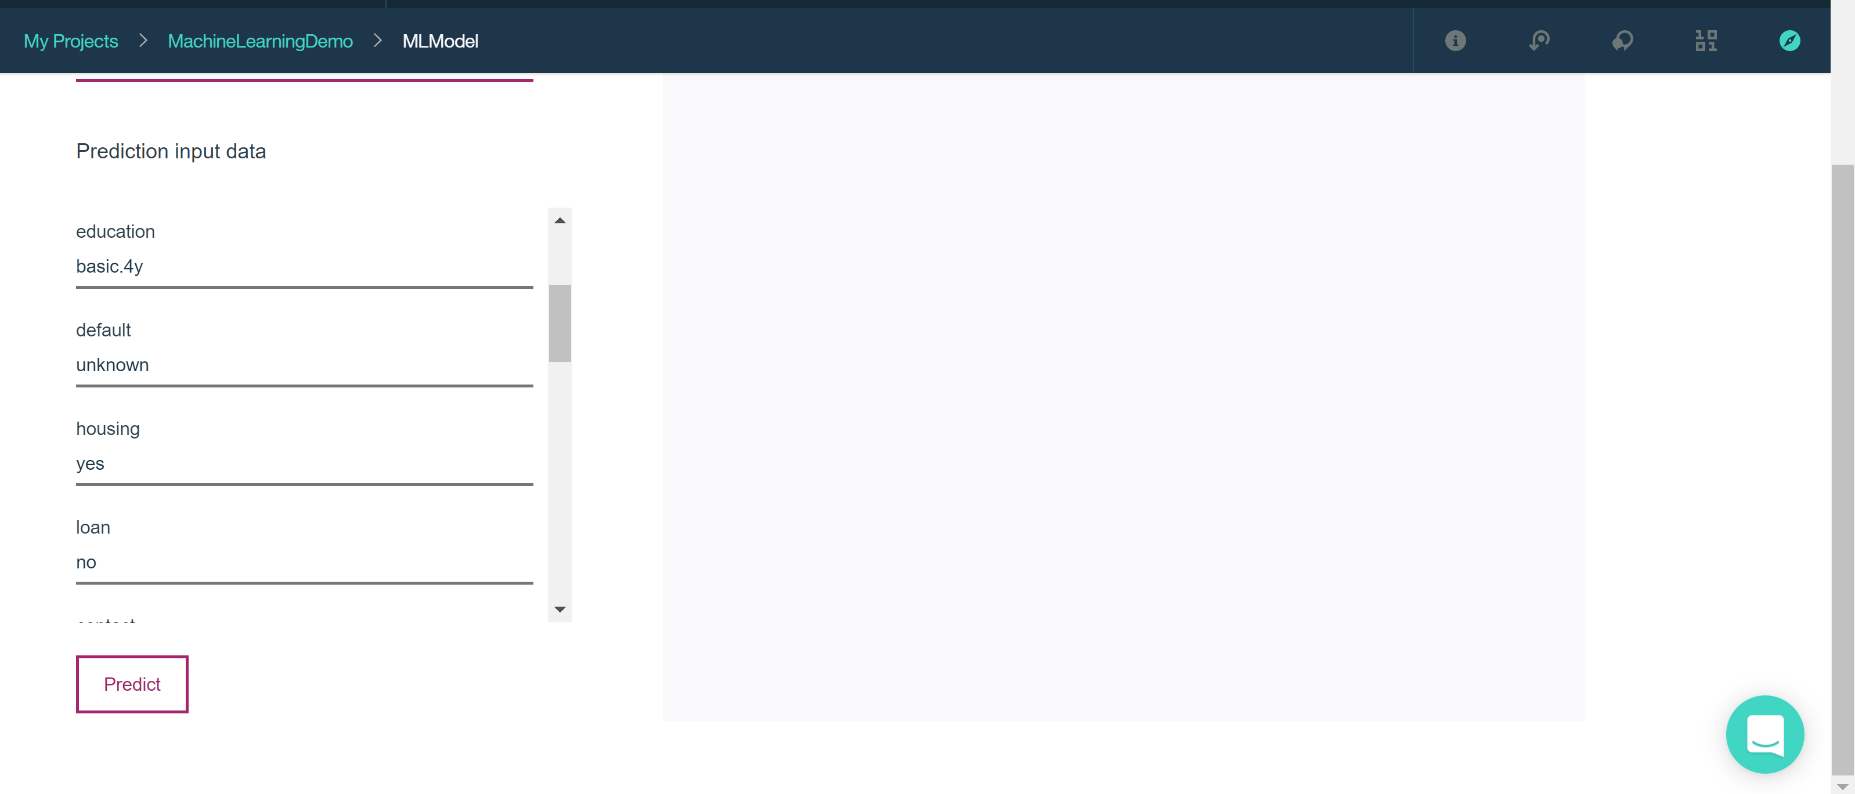

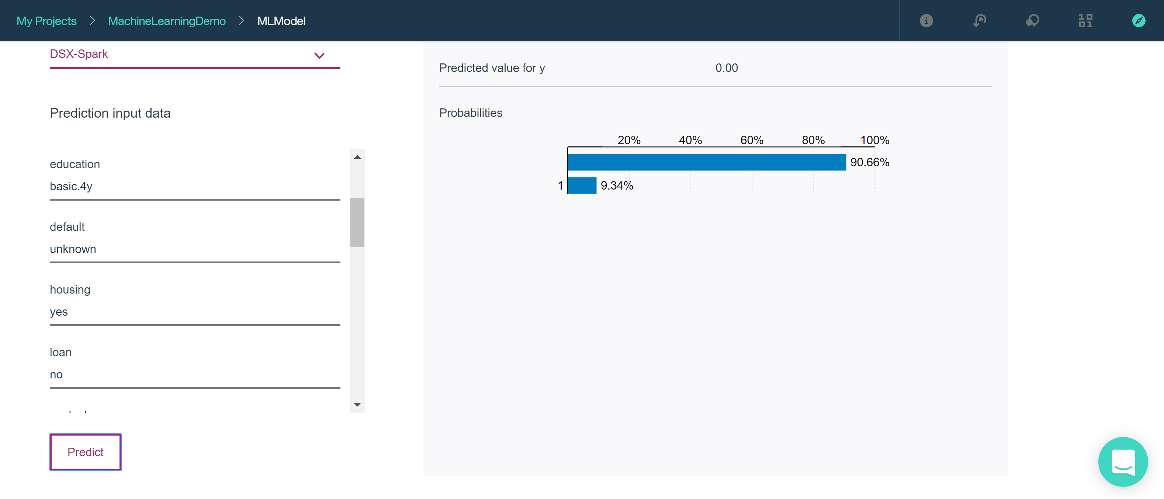

**Watson** is a [question answering](https://en.wikipedia.org/wiki/Question_answering) computer system capable of answering questions posed in [natural language](https://en.wikipedia.org/wiki/Natural_language).

* 1. Advantages of various Services

**Advantages of Amazon ML :**

User Friendly and easy to understand flow.

Good and interactive UI

Quick Modeling

Provides Evaluation Result

Selects the algorithm based on the Target Data

Customizable

**Advantages of h2o :**

Works on IPython Notebook.

Quick Modeling

**Advantages of IBM Watson:**

User Friendly and easy to understand flow.

Good and interactive UI

Quick Modeling

Selects the algorithm based on the Target Data

Can use R and IPython Scripts and notebooks

Customize Algorithm and data column selection possible

**Advantages of Azure:**

User Friendly and easy to understand flow.

Good and interactive UI

Quick Modeling

Can use R and IPython Scripts and notebooks

Customized Algorithms can be used

**Advantages of BigML:**

User Friendly and easy to understand flow.

Good and interactive UI

Quick Modeling

Easy Visualization of data

1. Citation

* <https://docs.microsoft.com/en-us/azure/machine-learning/>
* https://www.bigdatacloud.com/comparing-cloud-based-machine-learning-platforms-amazon-ml-vs-microsoft-azure-ml-vs-databricks-spark-cloud/
* <https://en.wikipedia.org/wiki/Watson_(computer)>
* <https://gallery.cortanaintelligence.com/Experiment/Tutorial-for-Data-Scientists-3>
* <https://h2o-release.s3.amazonaws.com/h2o/rel-slater/9/docs-website/h2o-docs/booklets/GLM_Vignette.pdf>
* <http://h2o-release.s3.amazonaws.com/h2o/rel-vajda/4/index.html>
* <https://developer.ibm.com/recipes/tutorials/build-model-by-using-ibm-watson-machine-learning-in-data-science/>
* <https://datascience.ibm.com/docs/content/analyze-data/ml-example-log-regress.html>
* <https://datascience.ibm.com/docs/content/analyze-data/ml-example-log-regress-02.html>
* <https://datascience.ibm.com/docs/content/analyze-data/ml-setup.html#setting-up-your-environment>
* <https://apsportal.ibm.com/docs/content/analyze-data/ml-pipelines.html>
* <https://apsportal.ibm.com/docs/content/analyze-data/ml-example-log-regress-02.html>
* <https://www.ibm.com/support/knowledgecenter/en/SSLVMB_22.0.0/com.ibm.spss.statistics.help/spss/base/idh_regs.htm>
* <https://www.ibm.com/communities/analytics/watson-analytics-blog/predicting-with-watson-analytics-a-quick-start-guide/>
* <http://s3.amazonaws.com/h2o-release/h2o/rel-nunes/2/docs-website/datascience/glm.html>
* <https://h2o-release.s3.amazonaws.com/h2o/rel-slater/9/docs-website/h2o-docs/booklets/GLM_Vignette.pdf>
* <http://docs.h2o.ai/h2o/latest-stable/h2o-docs/booklets/PythonBooklet.pdf>
* <https://github.com/h2oai/h2o-tutorials/blob/master/tutorials/glm/glm_h2oworld_demo.py>
* <http://docs.h2o.ai/h2o/latest-stable/h2o-docs/data-science/stacked-ensembles.html>
* <http://docs.h2o.ai/h2o/latest-stable/h2o-docs/data-science/gbm.html>
* <https://developer.ibm.com/clouddataservices/docs/ibm-watson-machine-learning/how-to/>
* <https://apsportal.ibm.com/ml/models/91a47669-31bc-409f-8ef1-96da4c329962/predictions?projectid=1c832d34-6394-45cd-9e6f-b77b68ecb7ac&mlInstanceGuid=137e468d-6bd3-4b8e-913b-265499556c7e&context=analytics>
* <http://heidloff.net/article/how-to-get-started-machine-learning-bluemix>
* <http://docs.aws.amazon.com/machine-learning/latest/dg/tutorial.html?icmpid=docs_machinelearning_console>